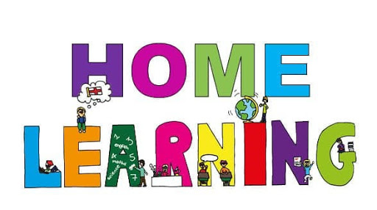

**Junior Infants**

If your child is well but needs to be absent in the short term from school for COVID-19 reasons e.g. if they have been asked to self-isolate, if they are awaiting a COVID test or test results; please find below some Art, Maths, English and PE activities to do during this time.

**Art –Home Learning**

**Make a snake mobile**

**Materials needed:**

* scissors
* template
* paints

**Instructions:**

* Print out or recreate the snake mobile template.
* Instruct and demonstrate to your child how to cut it out.
* Child then decorates/paints/colours the snake using whatever materials that you have at home.
* 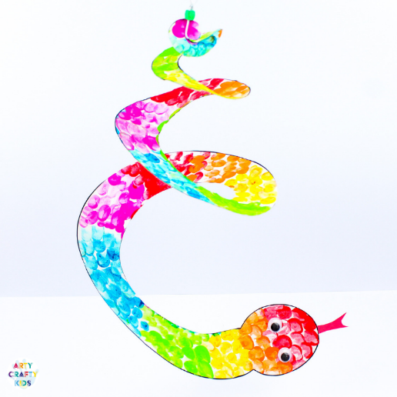Proudly hang your finished snake on display.

This snake has been coloured in using paint. The child used the method of finger printing to create this scaly effect. Lastly, they added googly eye stickers. Give it a go!

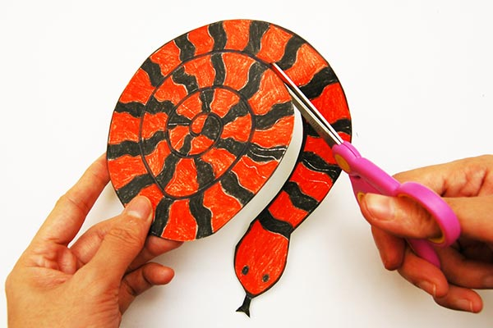

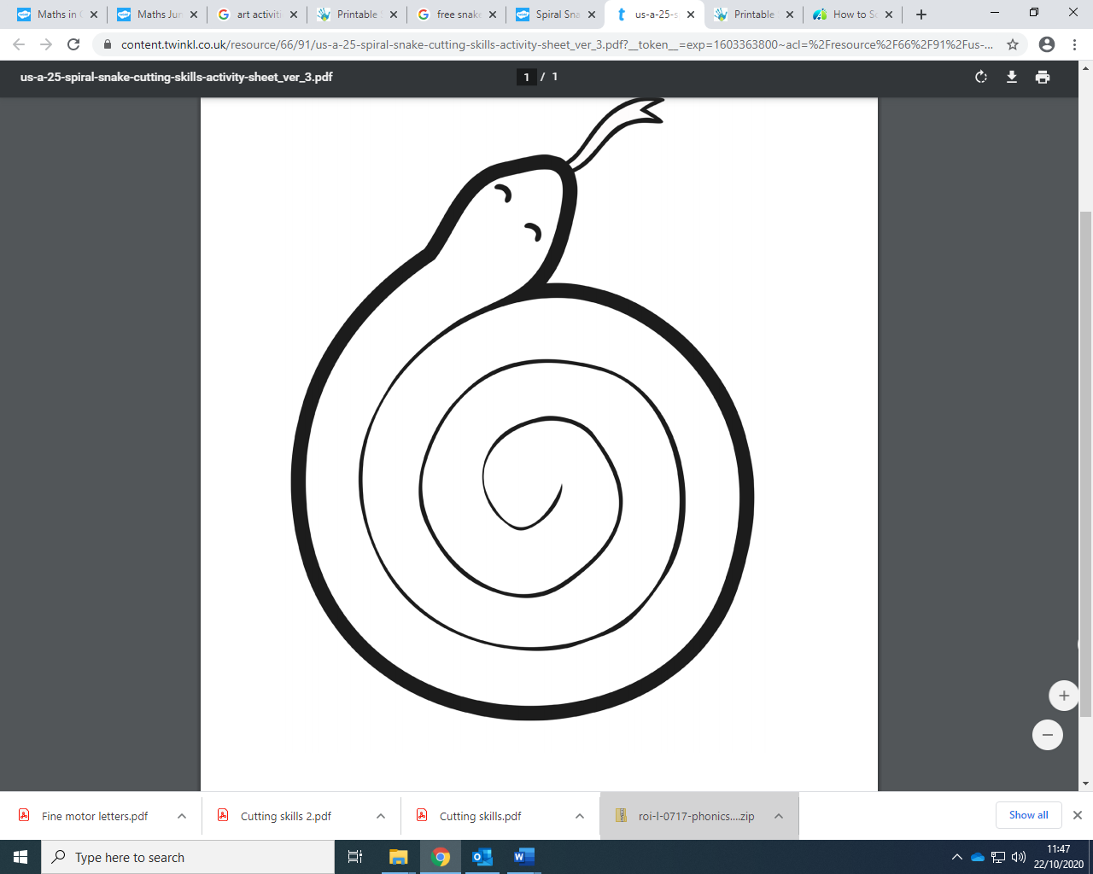

**Design your own Superhero mask**.

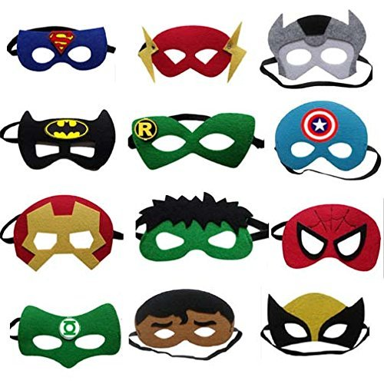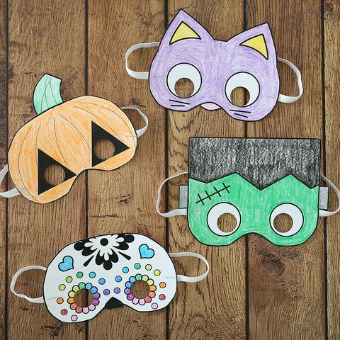

**Materials needed:**

* Mask template
* Embellishments (feathers, sequins, stickers)
* Glue and scissors
* Paint/colouring pencils/crayons

**Instructions:**

* Colour in/ paint and embellish your mask template.
* Then cut out your mask carefully.
* Attach it using string or elastics to your head.

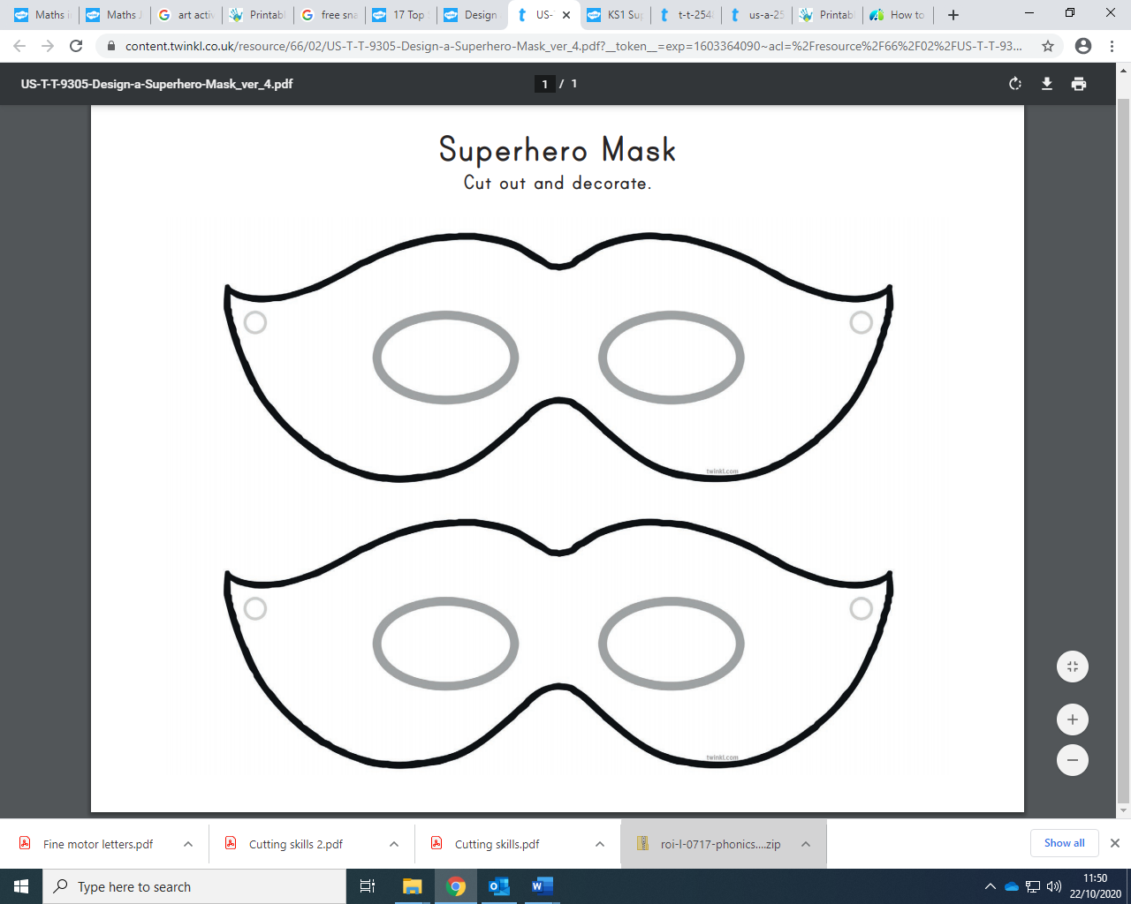

**Make a Self Portrait**

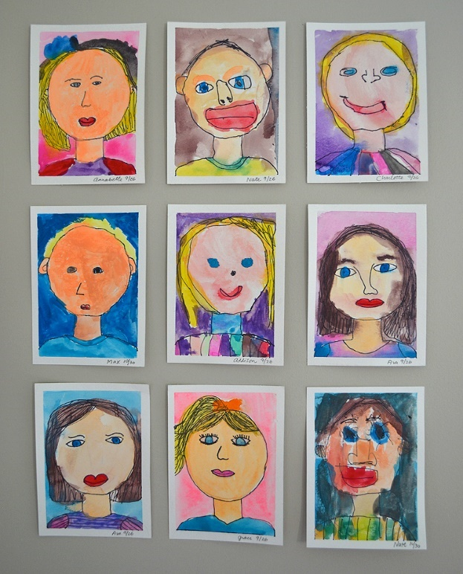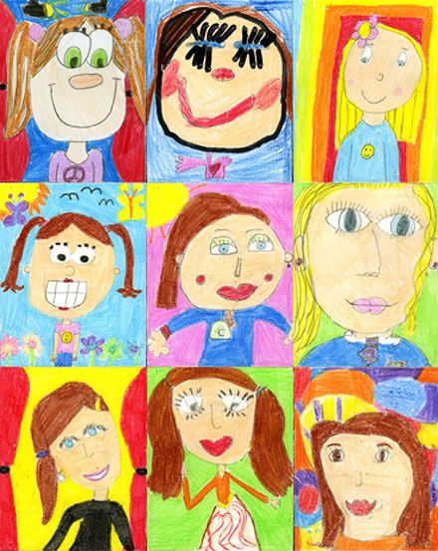

**Materials needed:**

* Photo frame template
* Colours (paints, crayons, colouring pencils)
* mirror

**Instructions:**

* Watch this demonstration <https://www.youtube.com/watch?v=3ouiumHlnmA>
* Use the mirror to draw your face inside the frame template
* Colour in your portrait
* Then cut out the frame carefully
* 

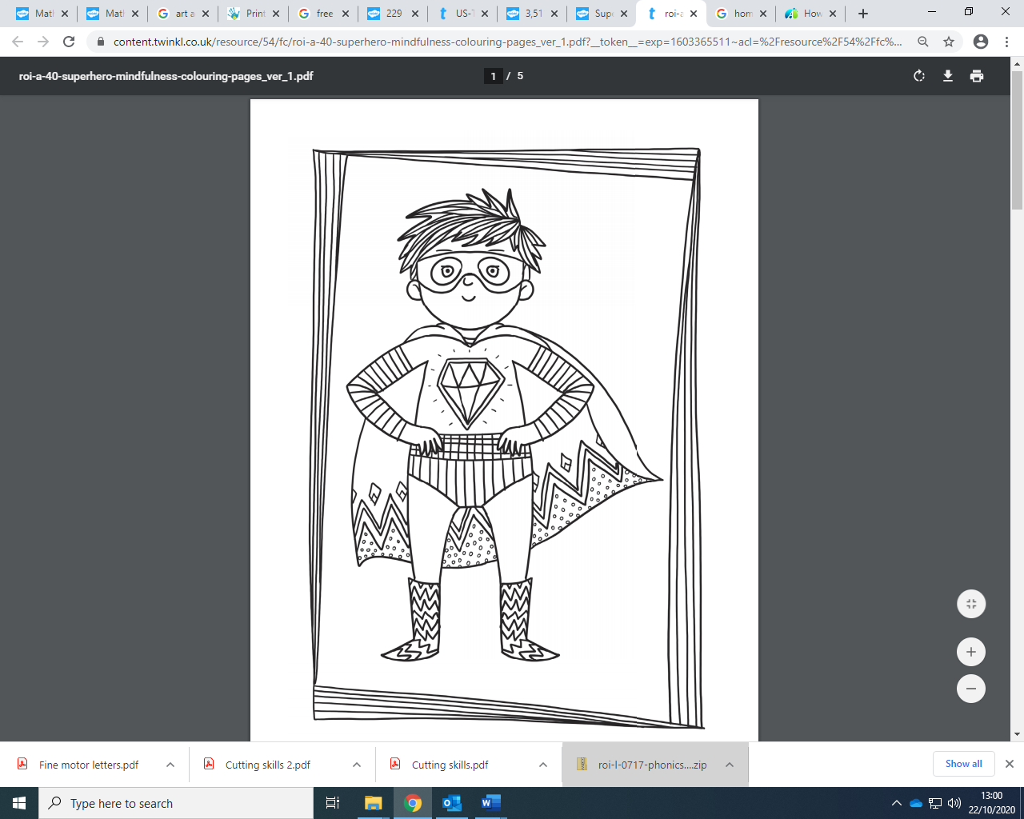**Mindfulness Colouring**

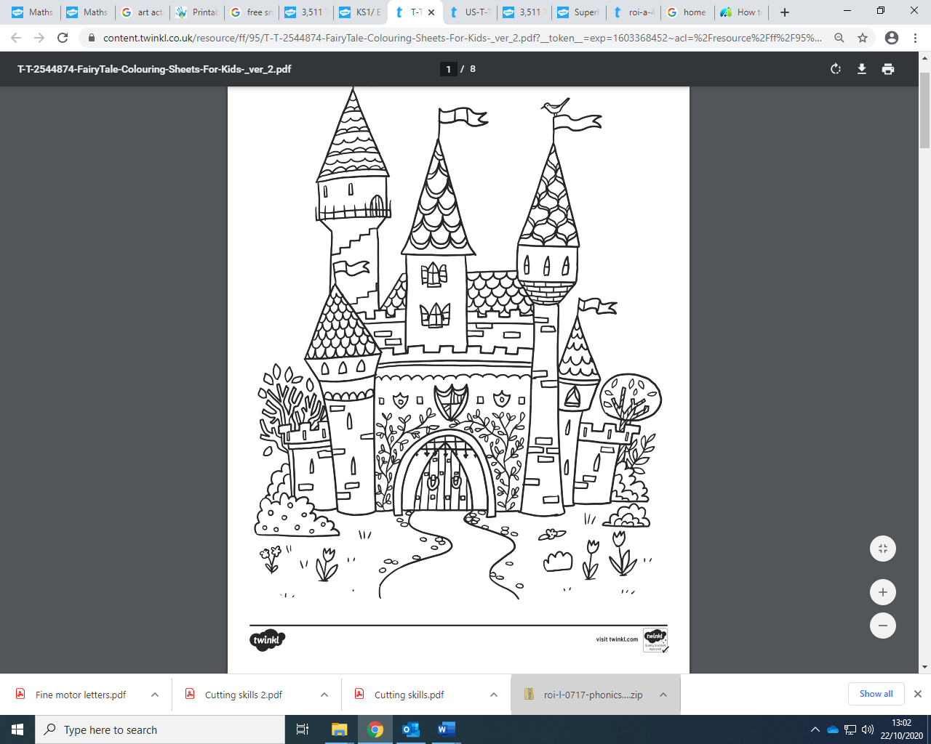

**Maths –Home Learning**

Helping your child

learn at home in

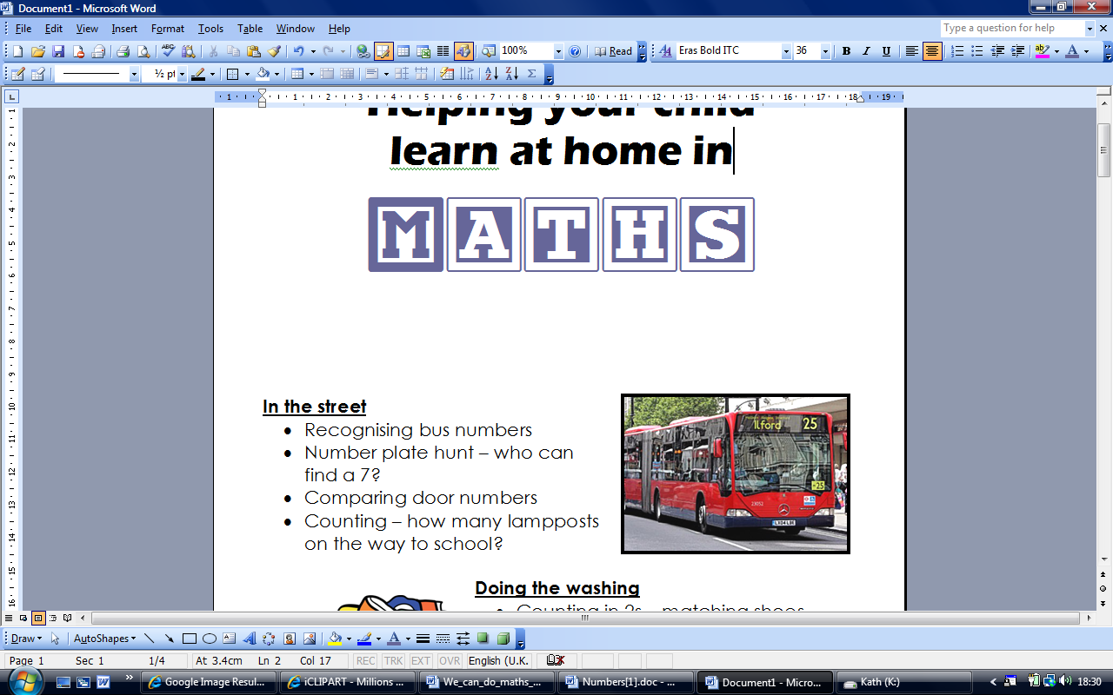

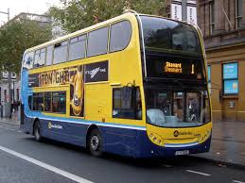

**In the street**

* Recognising bus numbers
* Number plate hunt. Who can find a 7? Add the numbers up.
* Comparing door numbers/ counting houses past
* Counting – how many lampposts on the way to the park?

**Doing the washing**

* Counting in 2s – matching shoes
* Sorting by colour and size.
* Matching/pairing up socks.
* Find four shoes that are different sizes. Can you put them in order?

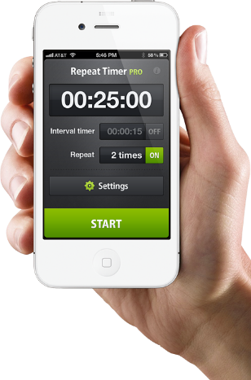**Time**

* What day is it yesterday, today, tomorrow?
* Use timers, phones and clocks to measure short periods of time.
* Count down 10/ 20 seconds to get to the table/ into bed etc.
* Recognising numbers on the clock. If you cover a number, what number was missing?

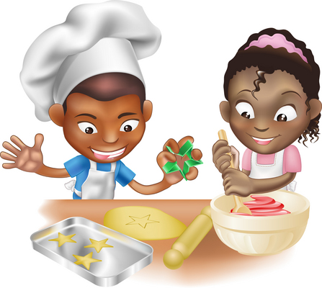**Food!**

* Can you cut your toast into 4 pieces? Can you cut it into triangles?
* Setting the table. Counting the right number of plates etc. How many more do we need?
* Can you make shapes/ patterns out of the knives and forks? Can you put them in the right place in the drawers?
* Helping with the cooking by measuring and counting ingredients.
* Setting the timer.
* Positional language at dinner time: what is on the rice, where are the carrots etc?

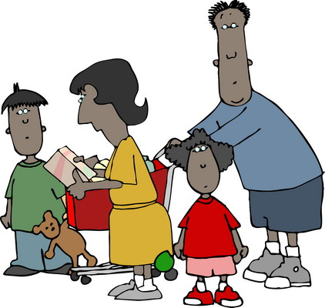

**Going shopping**

* Reading price tags
* Counting items into the basket
* Finding and counting coins
* Comparing weights – which is heavier

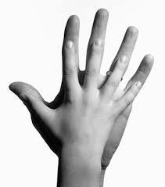**Measuring**

* Are you taller than a …?
* Marking height on the wall.
* Cut hand shapes out of paper. How many hands long is the couch? How long is the table? Which is longer?
* Who has the biggest hands in our family?
* How many steps from the gate to the front door?

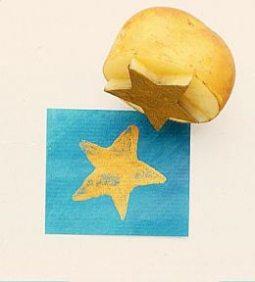**Shapes**

* Cut a potato into shapes (circles, triangle etc). Use with paint to make pictures and patterns.
* Cut out shapes from coloured paper/ newspaper and arrange into pictures.
* Shape hunt: Can you find a square in your house (windows etc), a circle …

**Playdough**

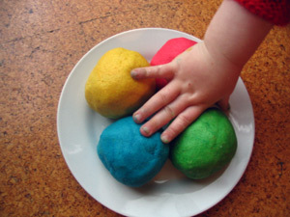Here is a simple recipe:

***1 cup of plain flour***

***1 cup of water***

***1 tablespoon cooking oil***

***2 teaspoons cream of tartar***

***Half a cup of salt***

***food colouring and essences (optional)***

*Put all ingredients in a large saucepan, and heat slowly, stirring all the time until it forms a ball. Keep it wrapped in clingfilm or in a covered tub to stop it drying out.*

Then ….

* Make numerals and shapes
* Sort shapes into groups, or order by size
* Make long and short wiggly snakes.

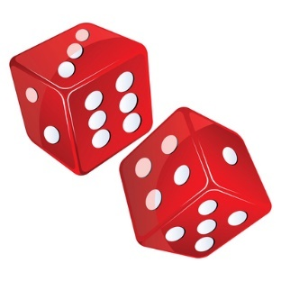**Games**

* Putting cards into piles
* Jigsaws (you can make your own by cutting up a magazine picture)
* Snap (matching pairs) or Happy Families (collect 4 of a kind)
* 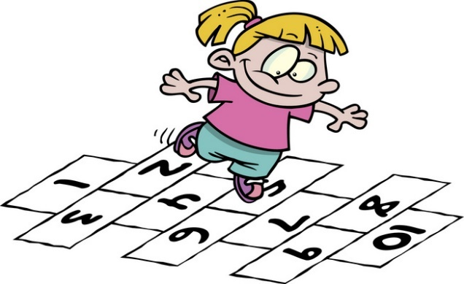Snakes and ladders or other simple dice games.
* Adding numbers on two dice.
* Bingo, with numbers or shapes
* Hopscotch

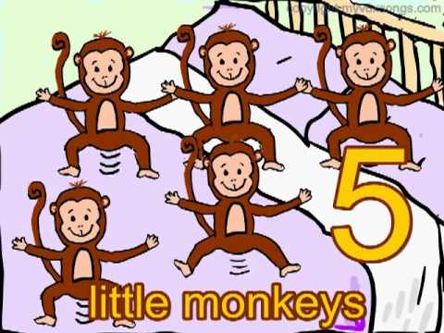**Number rhymes and songs**

*Eg: 5 little monkeys jumping on the bed*

*One fell off and bumped his head*

*Mummy called the doctor and the doctor said*

*“No more monkeys jumping on the bed!”*

*4 little monkeys jumping on the bed …*

Your child can teach you lots more or try this website which has the words and sings it for you:

<http://www.nurseryrhymes4u.com/NURSERY_RHYMES/COUNTING.html>



**Internet maths games:**

[www.mathszone.co.uk](http://www.mathszone.co.uk)

<http://www.bbc.co.uk/bitesize/ks1/maths/>

<http://www.familylearning.org.uk/online_math_games.html>

[www.sesamestreet.org](http://www.sesamestreet.org)

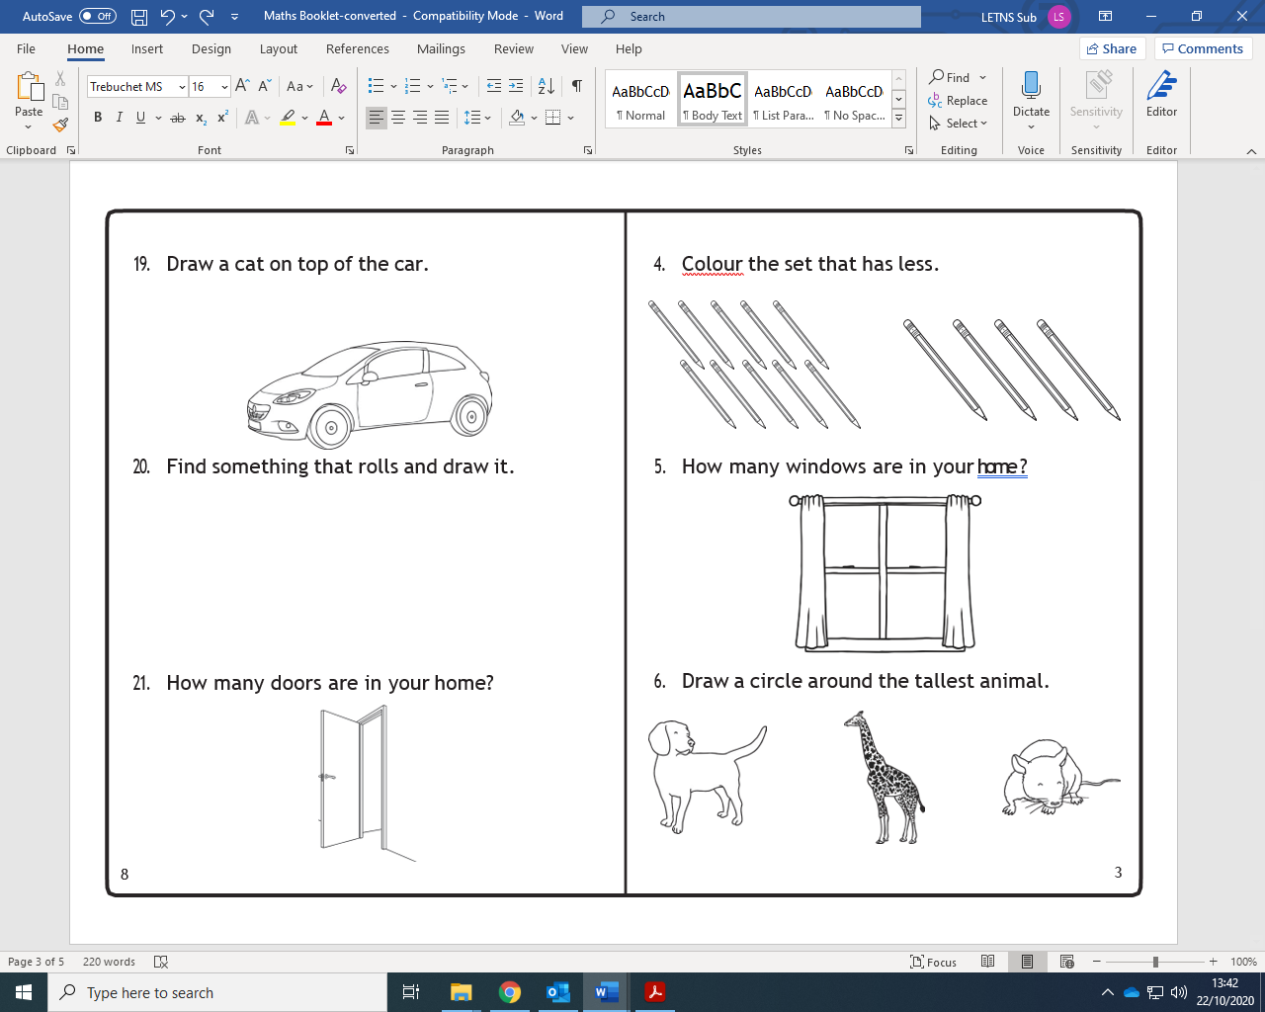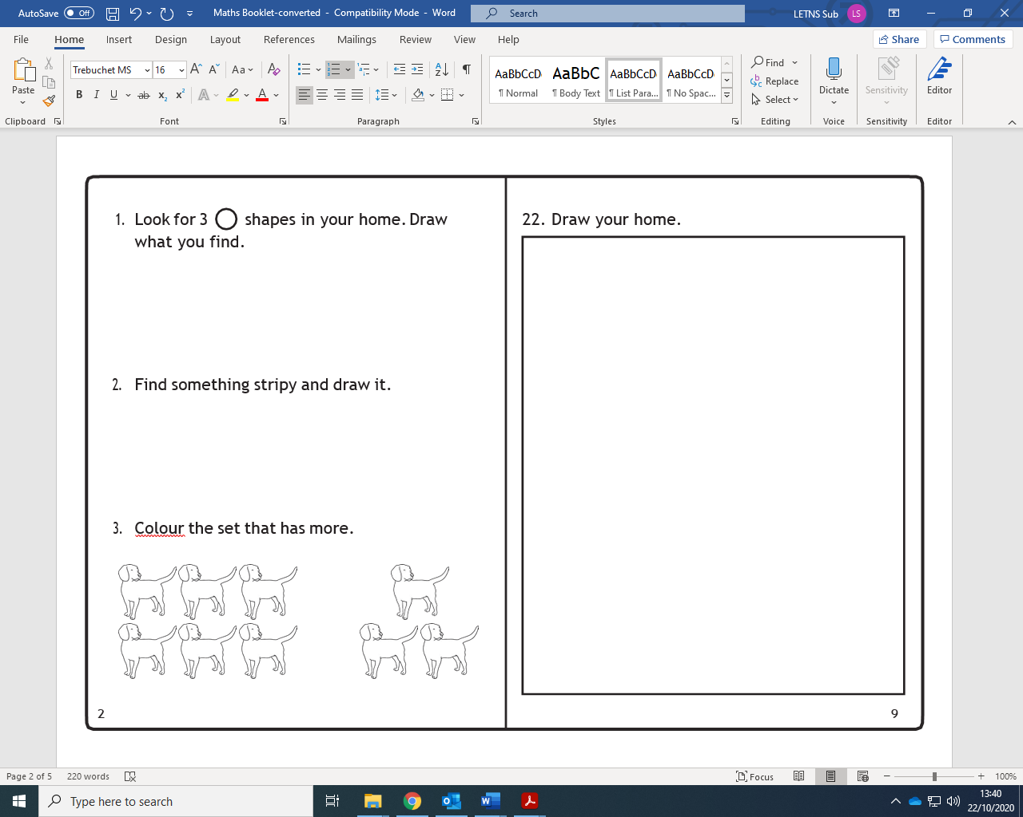

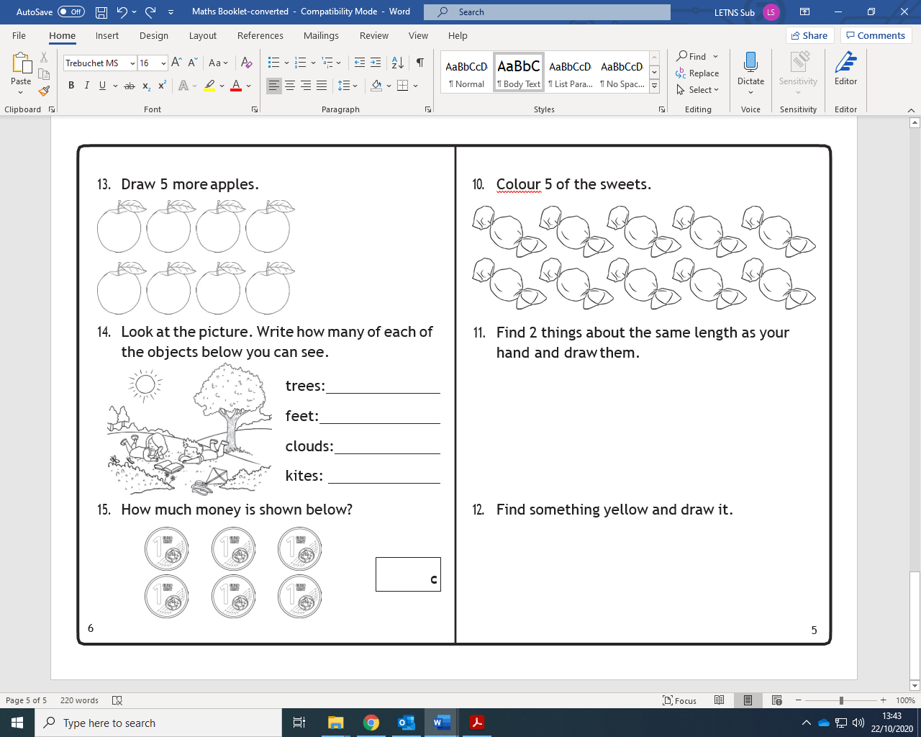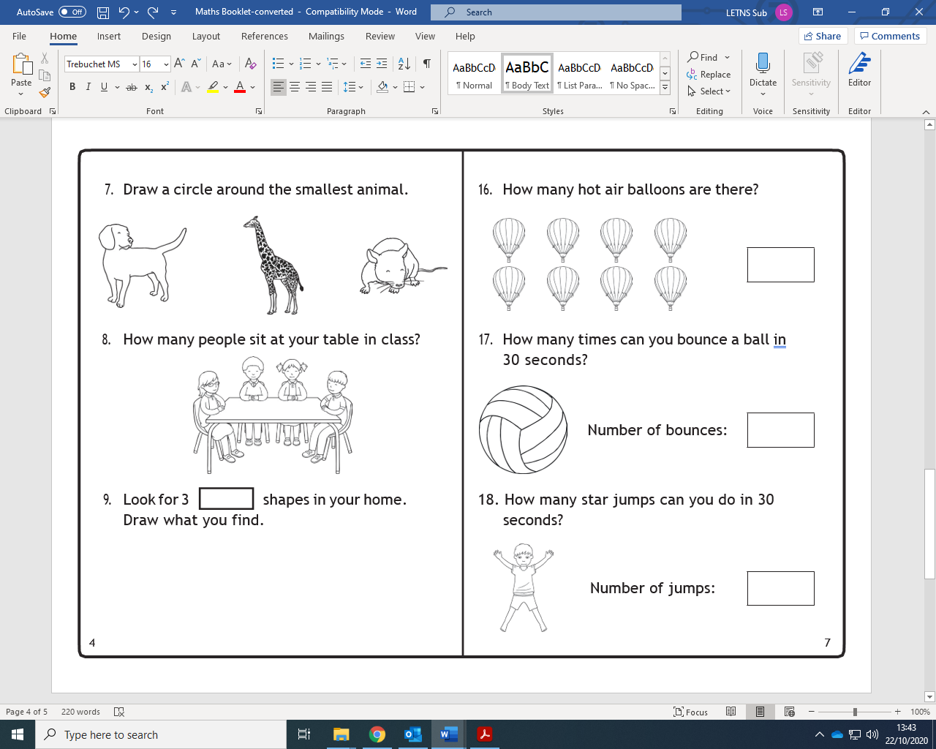

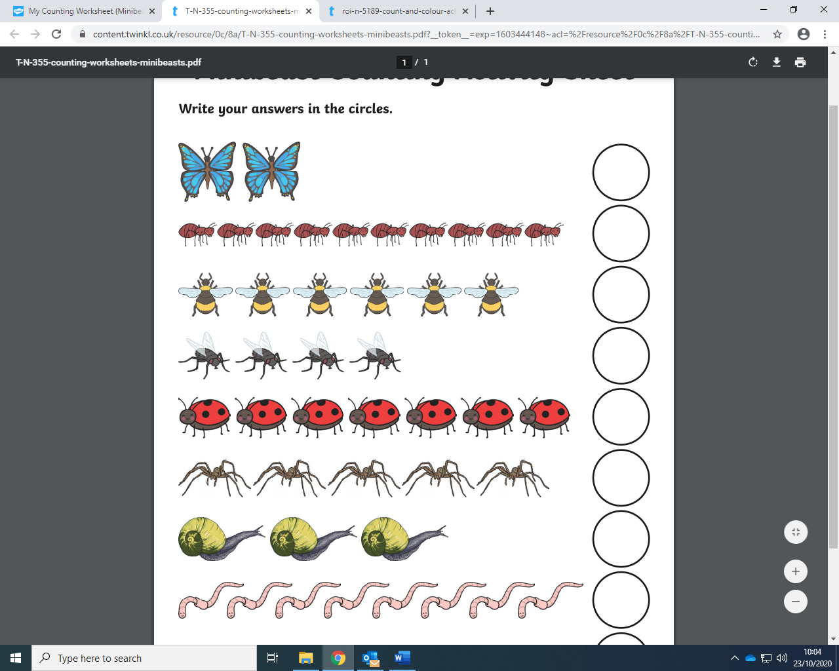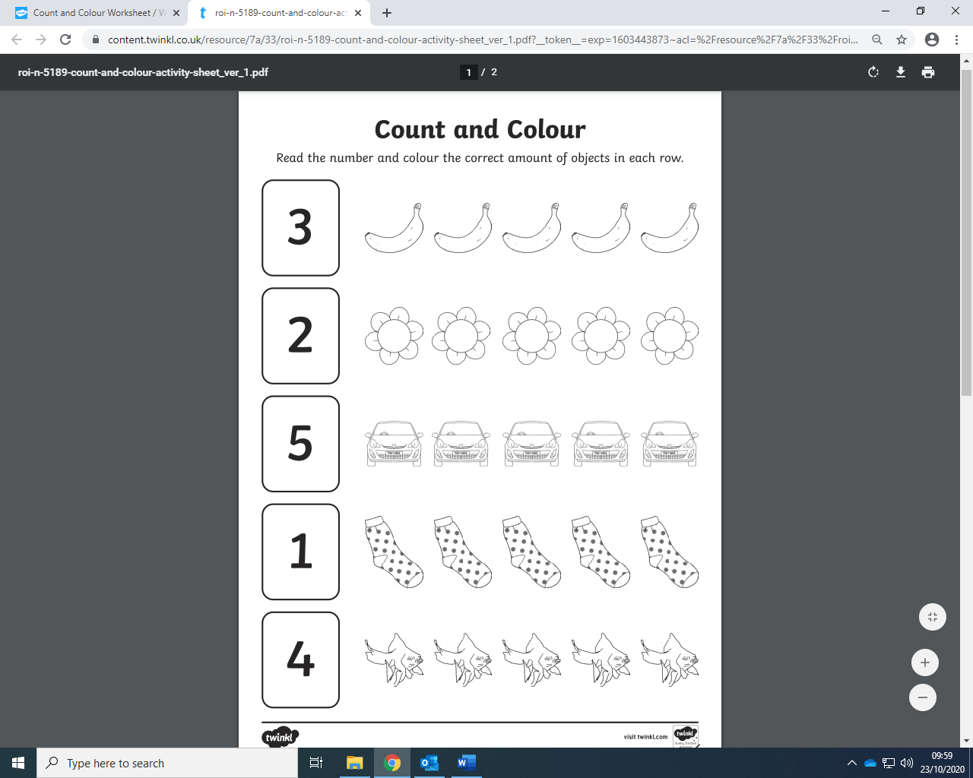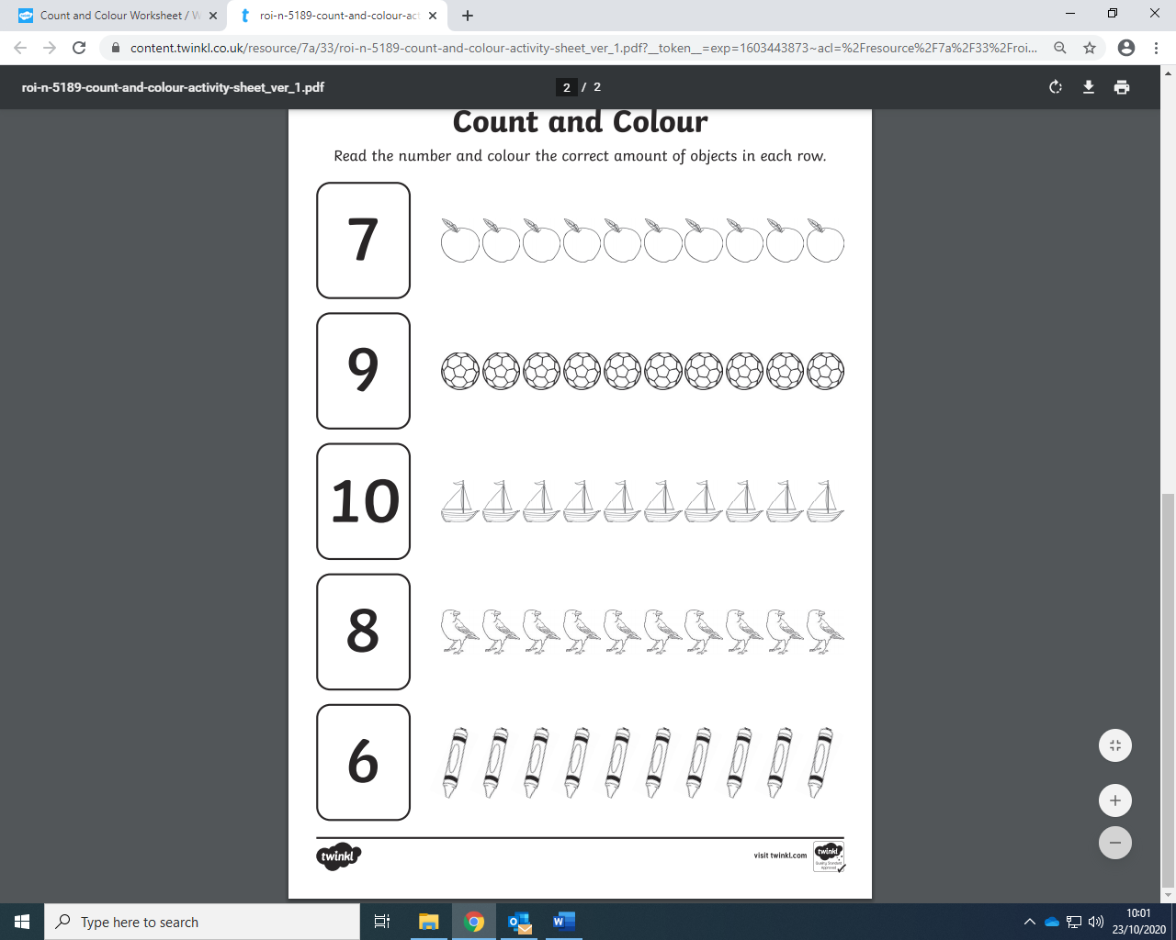

**English –Home Learning**

***Oral Language-***What am I?

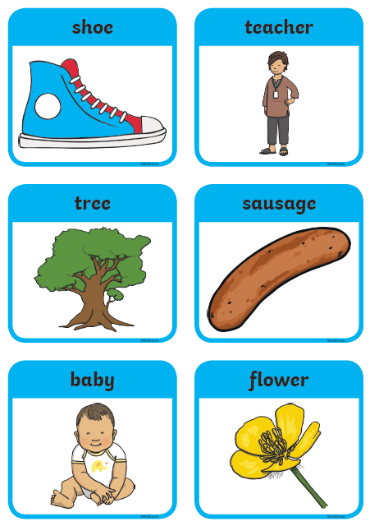Take turns with your child to describe the following objects. Tick as you go. E.g. ‘I have branches... I am found outside... I am green and brown…I’m a tree!’

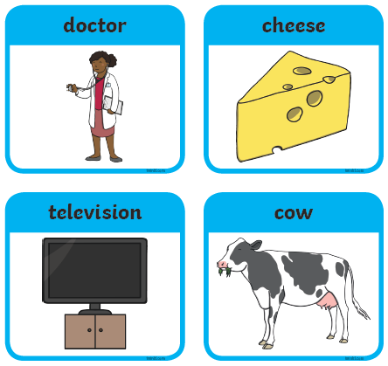

**Barrier game:**

Barrier games are great for developing listening skills.

**Instructions:**

***Print off the sheet below of the Lion.***

* Give the following instructions to the child:
* ‘Write your name at the top of the page’.
* ‘Colour the end of the lion’s tail brown’.
* ‘Colour the lion’s body yellow’.
* ‘Give your lion some more teeth’.
* ‘Colour the lion’s hairy mane brown like his tail’.
* ‘Colour the lion’s tongue red’.
* ‘Think of what the lion might have been eating for dinner and draw it on the ground beside the lion’.
* Draw a crown on the lion’s head to make him King of the Jungle’.

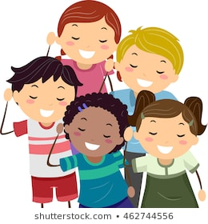

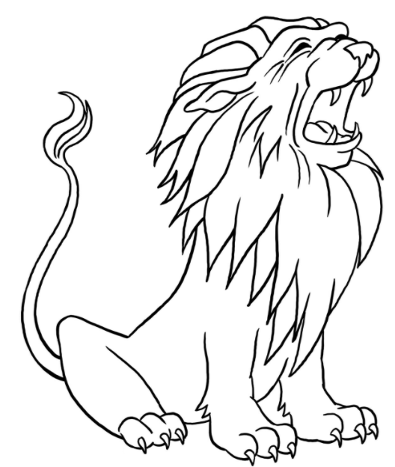

**Phonics**

**Nn sound**

**Can you circle all the n’s in this puzzle?**

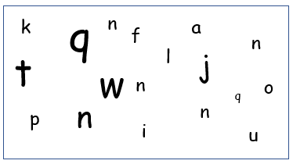

**Say the following ‘n’ words, then circle the odd one out. Then write the words.**

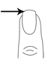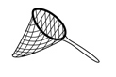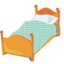

**______ ________ _______ _______**

**Phonics**

**Gg sound**

**Can you circle all the g’s in this puzzle?**

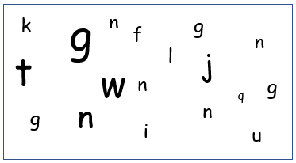

**Say the following ‘g’ words, then circle the odd one out. Then write the words.**

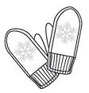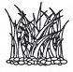

**______ ______ ______ ______**

**Phonics**

**Pp sound**

**Can you circle all the p’s in this puzzle?**

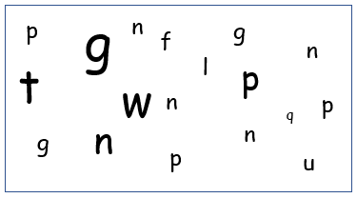

**Say the following ‘p’ words, then circle the odd one out. Then write the words.**

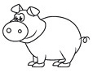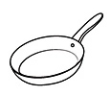

**______ ______ ______ ______**

**CVC words – Read, Write, Draw**

|  |  |  |
| --- | --- | --- |
| **Read** | **Write** | **Draw** |
| **cat** |  |  |
| **pig** |  |  |
| **van** |  |  |
| **dog** |  |  |

**CVC words – Read, Write, Draw**

|  |  |  |
| --- | --- | --- |
| **Read** | **Write** | **Draw** |
| **mop** |  |  |
| **bed** |  |  |
| **hat** |  |  |
| **ten** |  |  |

**Say aloud the three words in each set. Which word does not rhyme with the others? Circle it.**

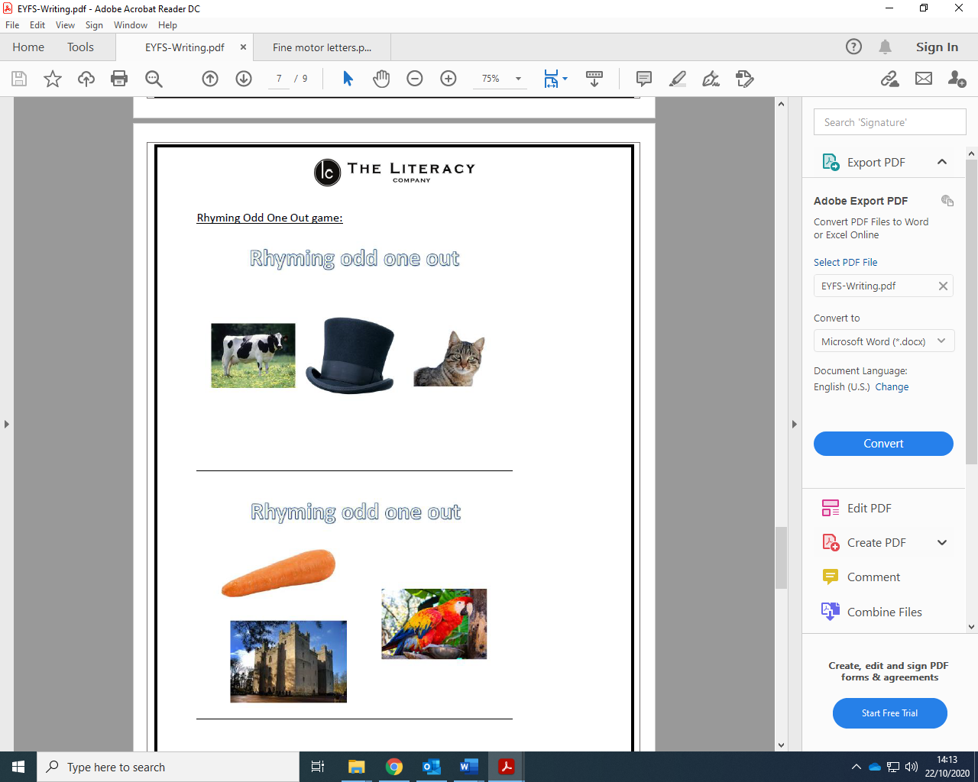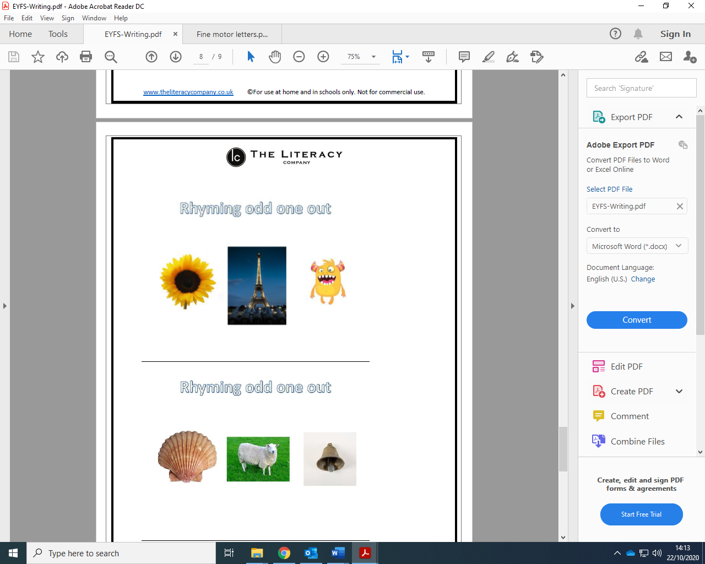

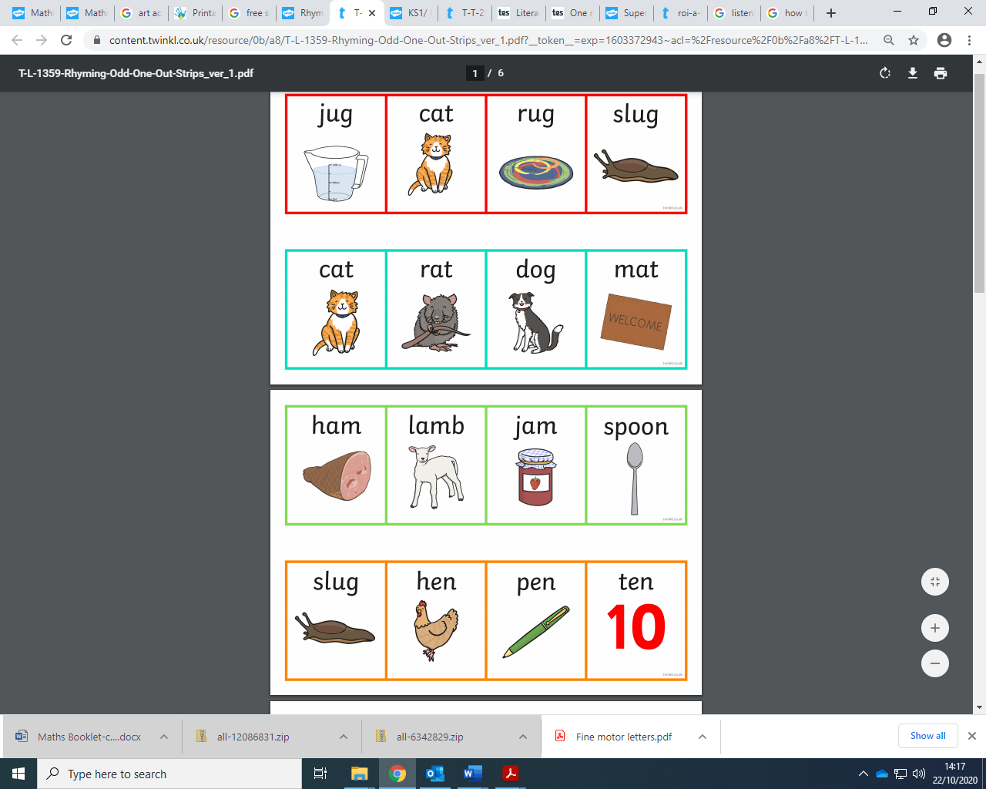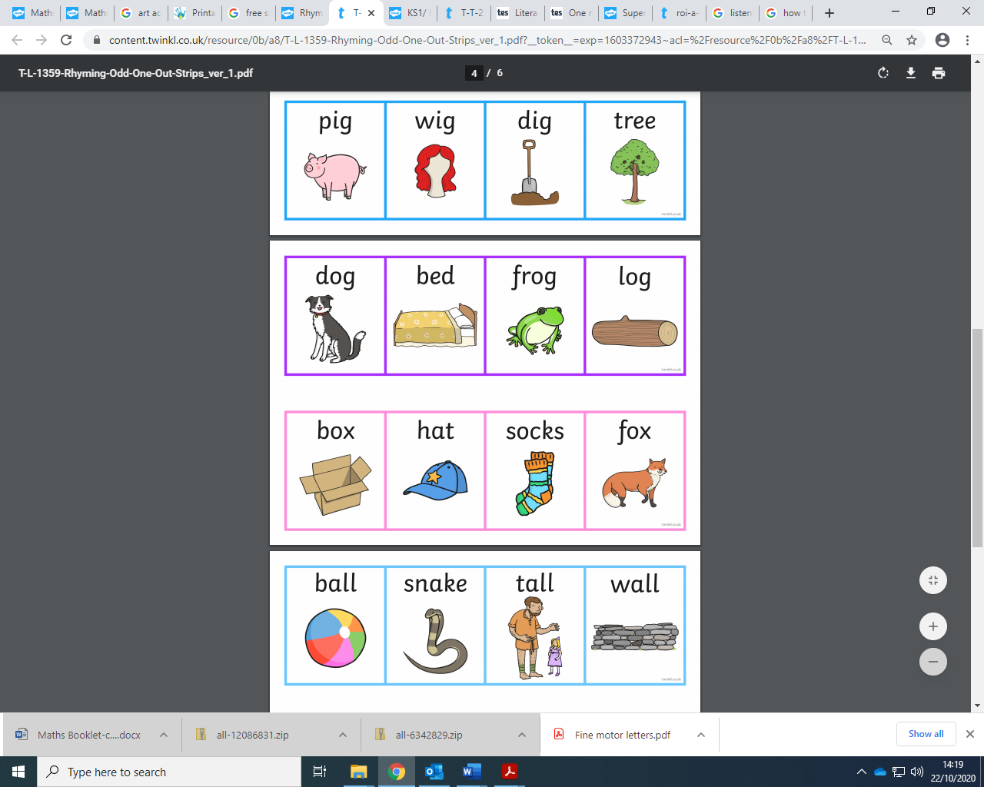

**Fine motor skills- pencil grip**

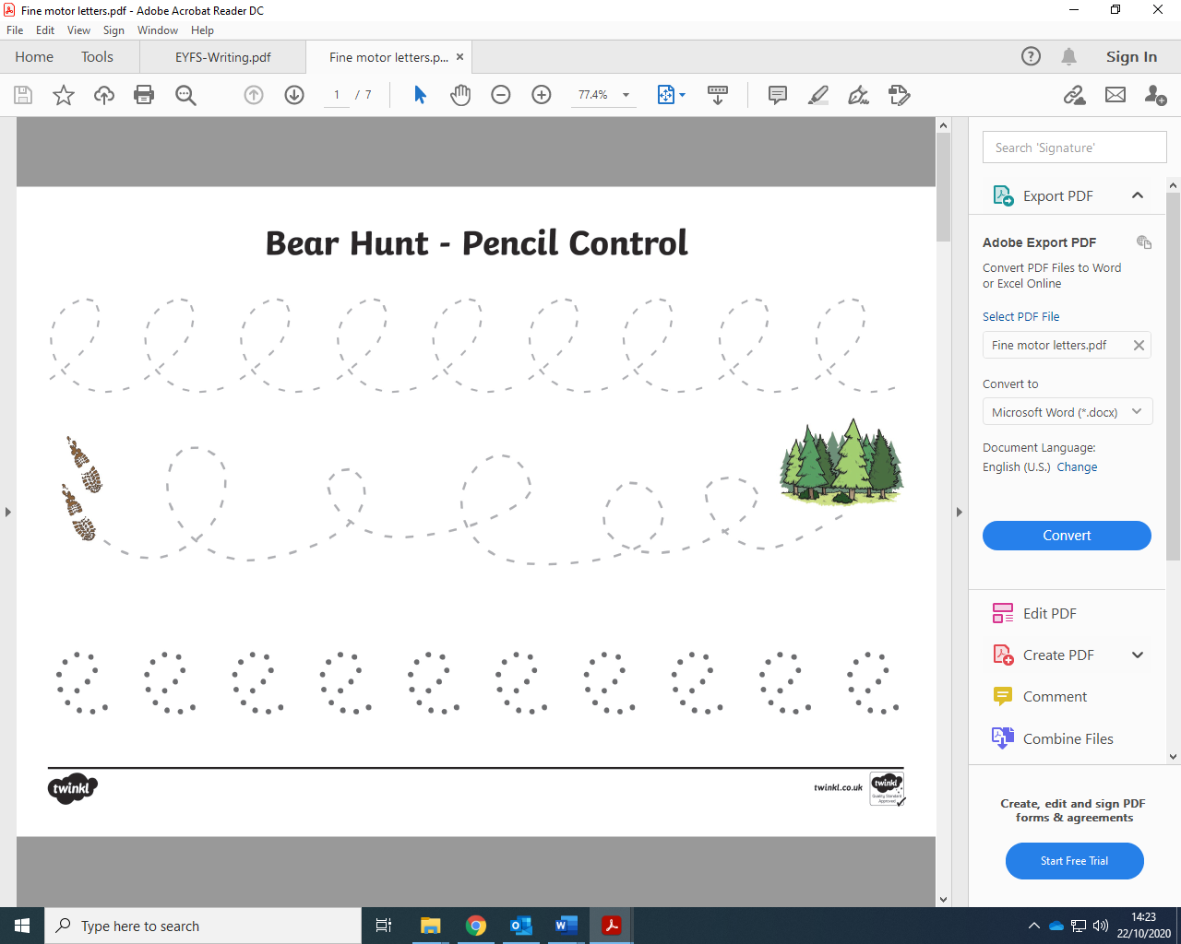

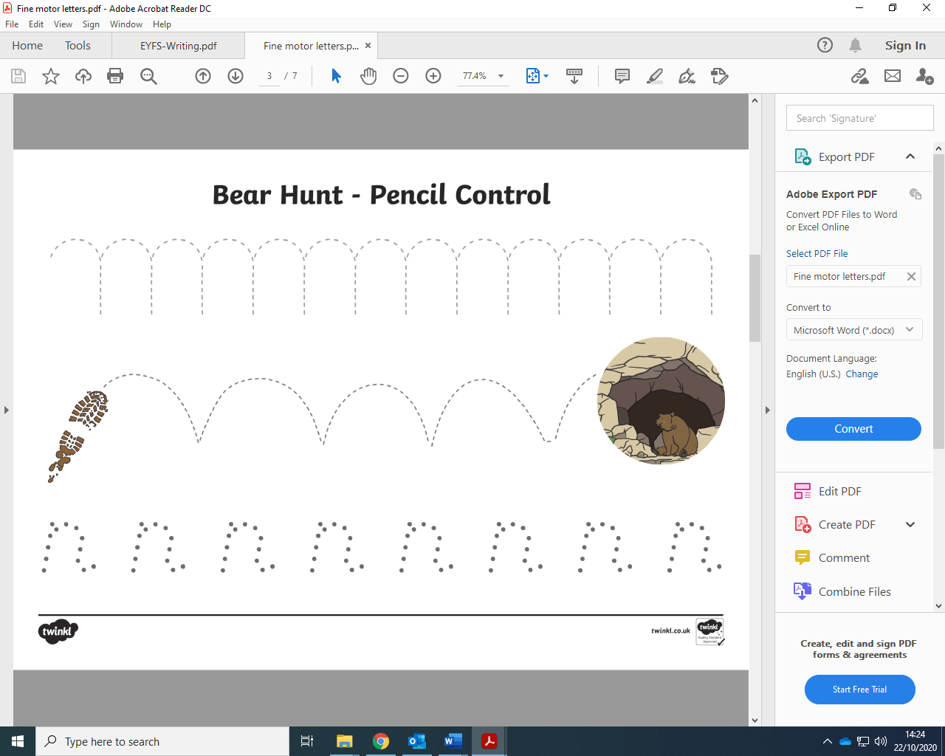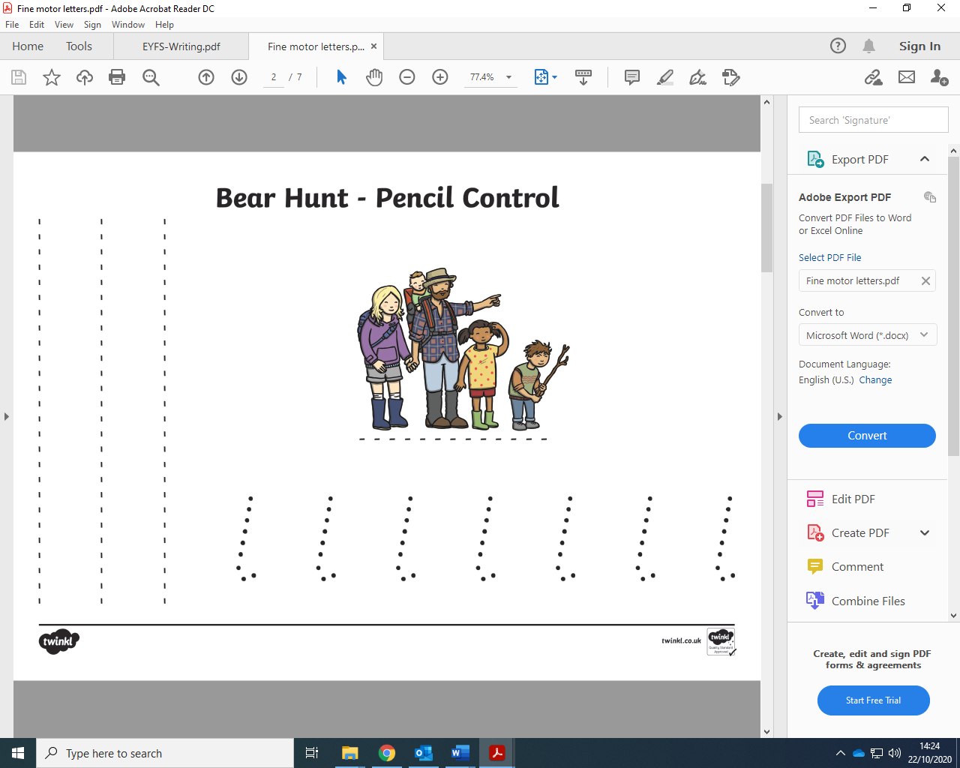

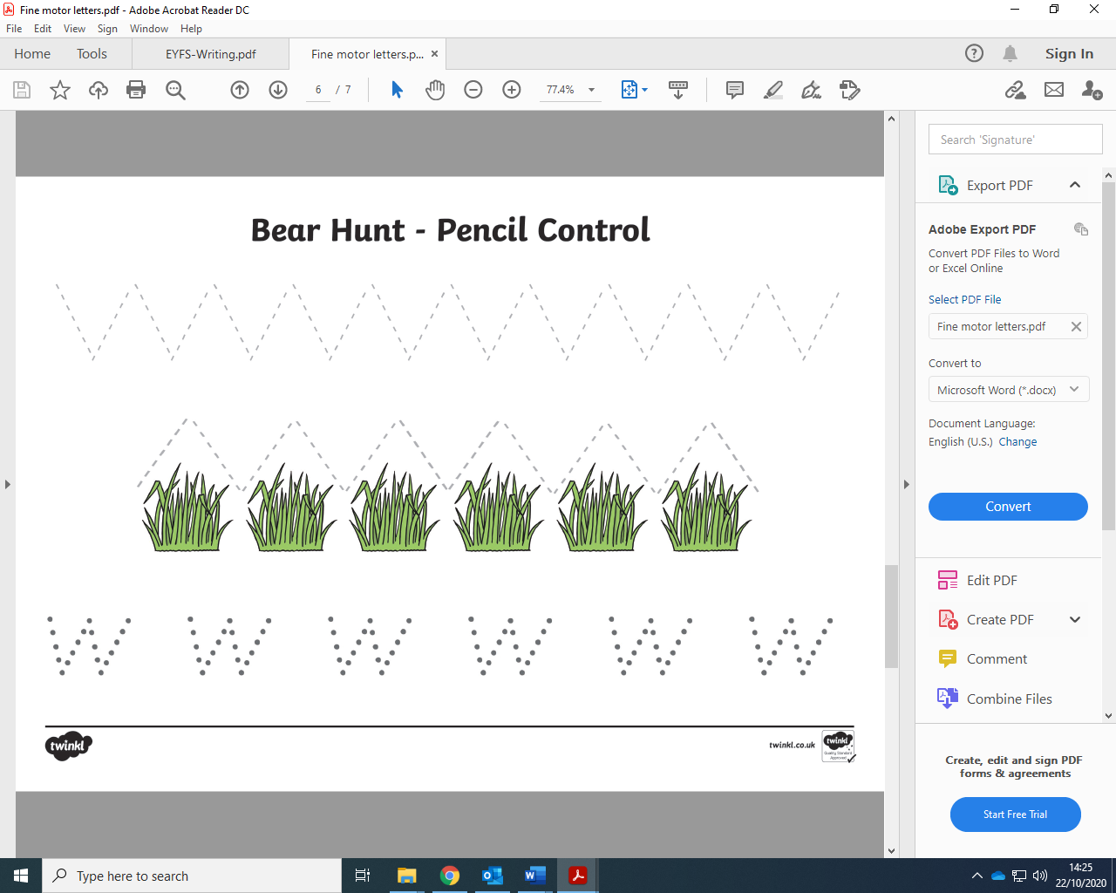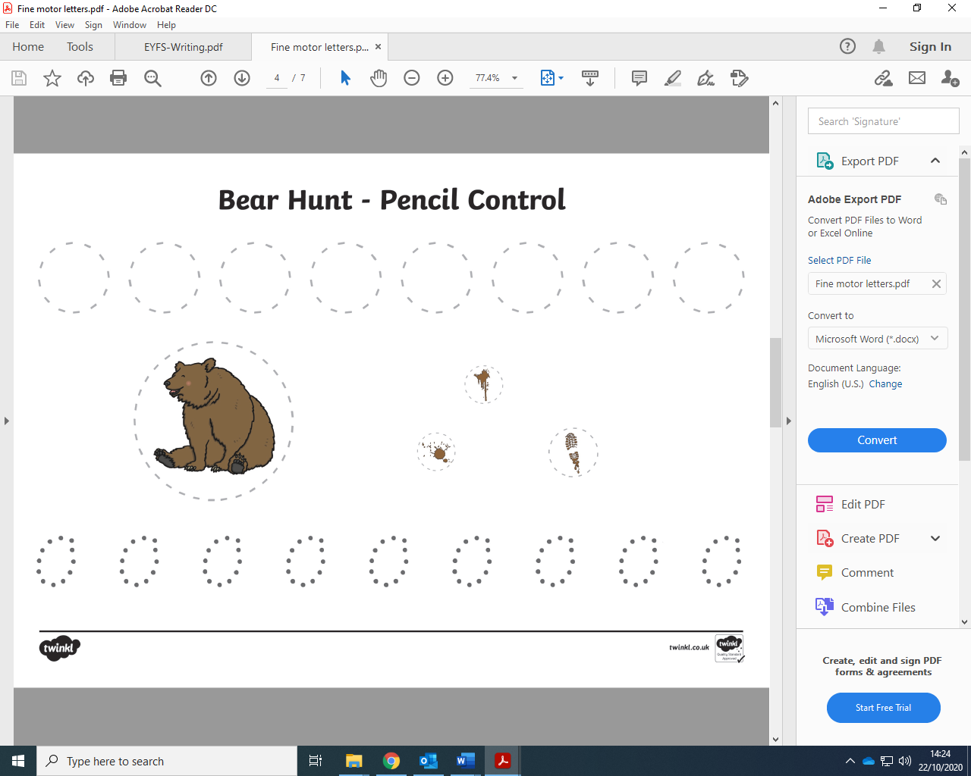

**PE –Home Learning**

P.E. with Joe

* https://www.youtube.com/playlist?list=PLyCLoPd4VxBtWi7RnRLz6qHgOqWiB_LrH

Daily Dance breaks

* <https://www.youtube.com/channel/UCqscMO1YfPB3-7dZZSxKPrQ>

Yoga for kids

* <https://www.youtube.com/user/CosmicKidsYoga>

Freeze dance

<https://www.youtube.com/watch?v=2UcZWXvgMZE>

Other ideas:

* Make up your own dance and present it to your family.
* Draw your own hopscotch with chalk and play.
* Jumping jacks – time yourself each day and see how many you can do.
* Keep the balloon up.
* Throwing and catching a bean bag.
* Play ‘Simon Says…’

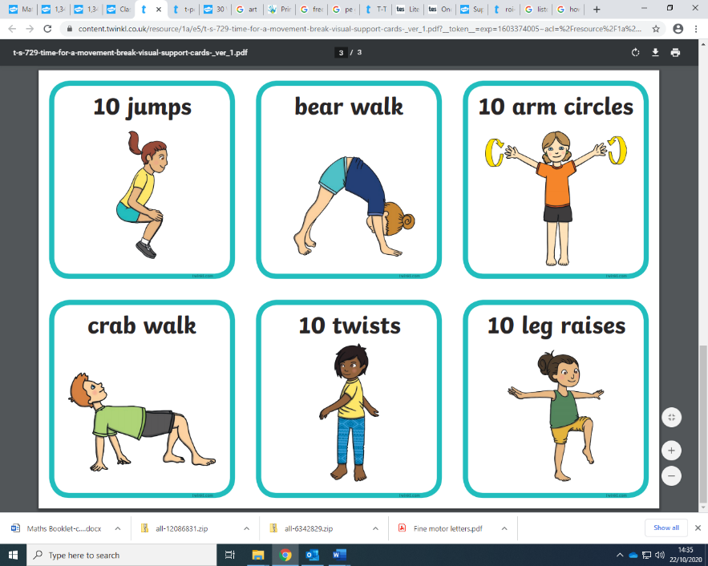

Can you do this routine every day?