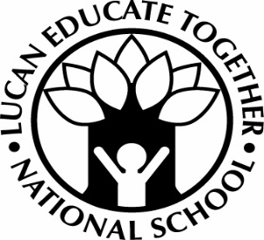

Lucan educate together national school
Mount Bellew Way, Willsbrook Road, Lucan, Co Dublin K78 C922 Tel: 01 628 1298

Application for junior infants for 2021/2022 School Year only

Please read the school’s Admission Policy and Annual Admission Notice prior to making an application

*Please note that your child must be 4 by the 31st May 2021 to enrol for the 2021/2022 school year

Child’s Name: |  |  |  |  |  | Male / Female
Date of Birth:* |  |  |  | PPS No:
Parent/Guardian
Name:
Address:
Telephone: | Home: |  | Work: |  |  |  | Mobile:
Email Address
Does your child have a sibling already attending  Lucan Educate Together? |  |  |  |  | Yes / No
If yes, sibling’s name: |  |  |  |  | Sibling’s current Class
Have you read and do you accept the Admissions policy for Lucan Educate Together? |  |  |  |  | Yes/No
Completed by (Name of Parent/Guardian): |  |  |  |  | Date:

Parents/Guardians are asked to attach a scan/photo of their child’s birth certificate to their application. Where offers of places are subsequently made on foot of an application parents/guardians will be required to provide an original birth certificate to the school for verification of date of birth.

Parents/Guardians should note that in accordance with the Education (Admissions to School) Act 2018 and in line with Section 14 of the Lucan Educate Together Admissions Policy that an offer of admission may not be made or may be withdrawn if it is established that information contained in the application is false or misleading.

It is the responsibility of the parent/guardian to provide up-to date contact information as detailed above and to advise the school of any changes to these details. The school is not liable for any issues arising where parents/guardians fail to do so.

