Home Learning for First Class
If your child is well but needs to be absent in the short term from school for COVID-19 reasons e.g. if they have been asked to self-isolate, if they are awaiting a COVID test or test results; please find below some ideas for work to do during this time.
LITERACY
Reading
- Read books at home every day.There are lots on epic to choose from. (See link in online activities)
- Record yourself reading a page aloud.
- Point out tricky words in everyday household objects.
- Go on a letter hunt, e.g. find all the ‘g’ letters in the house.
- Read, write, and draw tricky words.
- Spot the tricky word game.
(Worksheets and resources below)
Writing
- Create a list of tricky words after finding them in the game.
- Complete the book report below on the book you are reading.
- Pretend you are one of the three little pigs. Write a postcard to Mammy Pig explaining what is happening, how you feel, etc.
Story here: https://www.youtube.com/watch?v=QLR2pLUsl-Y
(Worksheets and resources below)
Oral Language:
- What am I? description game.
- Barrier game.
(Worksheets and resources below)
NUMERACY
- Online access to Busy at Maths is still available throughout the COVID-19 pandemic. You can pick up where you left off in class. http://my.cjfallon.ie
- Play Maths games. See worksheets below.
- Making sets sheet (can also be done at home with similar items, e.g. make a set of 5 beads, 2 socks, 4 spoons, etc.)
- Creating number patterns sheet.
- Opportunities for Maths in the home.
- Number rhymes.
GAEILGE
- TG4/Cúla 4 na nÓG – watch some Nuacht or cartoons in Irish www.Tg4.ie
- Story read alouds as Gaeilge: https://www.youtube.com/channel/UC6mUBHb5Usyt0bfsgKZB2Mg
- Games as Gaeilge: https://seideansi.ie/naionain-bheaga.php
ART & CRAFT | Fine Motor Skills
- Junk art – make something out of the things in your recycling bin.  - Draw and paint or colour the view from your bedroom window.  - Making a Shape Collage.  - Sketch a self-portrait in front of the mirror.  - Leaf Rubbings.  - Making a leaf squirrel.  - Sketch your favourite toy.  - Creating a Self Portrait.  (Ideas and resources below) | - Clothes Pegs activities.  - Threading/Lacing activities.  - Cutting activities.  - Pencil control activities.  (Worksheets and resources below)
P.E. Activities
- List of links and ideas for P.E. at the end.

*Please remember that there is no obligation to complete all this work. You know your child best and what activities would suit them. Pick and choose what works best for your child.

English – Possible Ideas
Oral Language
What am I? Take turns with child to describe the following objects. Tick as you go. E.g. ‘I have branches... I am found outside... I am green and brown…I’m a tree!’
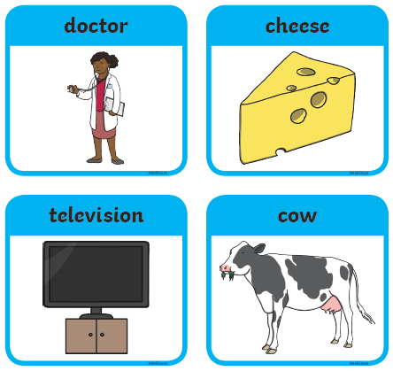
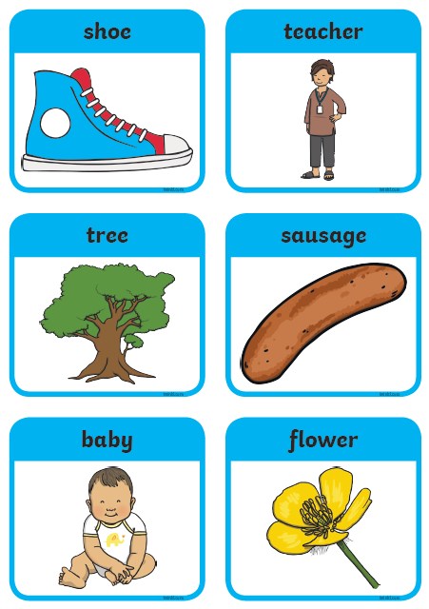
Barrier game:
Barrier games are great for developing listening skills.

Instructions:

- Print off the sheet below of the Lion.
- Give the following instructions to the child:
- ‘Write your name at the top of the page’.
- ‘Colour the end of the lion’s tail brown’.
- ‘Colour the lion’s body yellow’.
- ‘Give your lion some more teeth’.
- ‘Colour the lion’s hairy mane brown like his tail’.
- ‘Colour the lion’s tongue red’.
- ‘Think of what the lion might have been eating for dinner and draw it on the ground beside the lion’.
- Draw a crown on the lion’s head to make him King of the Jungle’.

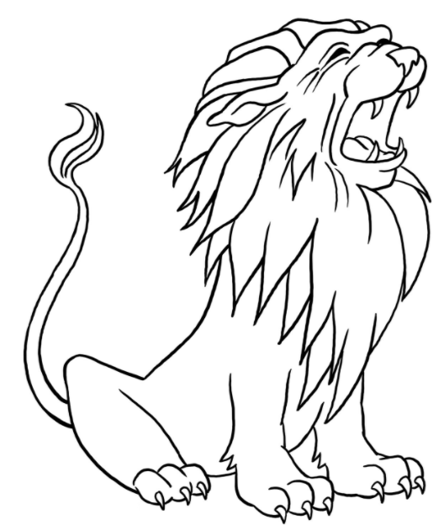

Phonics
Nn sound
Can you circle all the n’s in this puzzle?
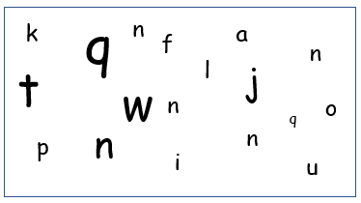

Say the following ‘n’ words, then circle the odd one out. Then write the words.

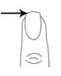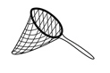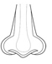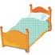
______ ________ _______ _______
Phonics
Gg sound
Can you cirle all the g’s in this puzzle?
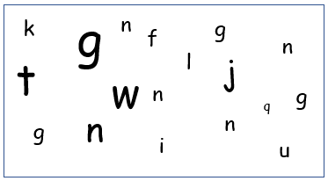

Say the following ‘g’ words, then circle the odd one out. Then write the words.

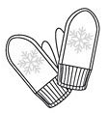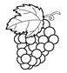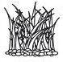
______ ______ ______ ______

Phonics
Pp sound
Can you cirle all the p’s in this puzzle?
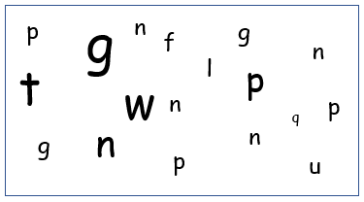

Say the following ‘p’ words, then circle the odd one out. Then write the words.

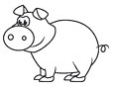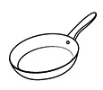

______ ______ ______ ______
CVC words – Read, Write, Draw
Read | Write | Draw
cat

pig

van

dog
CVC words – Read, Write, Draw
Read | Write | Draw
mop

bed

hat

ten
There are tricky words hiding in the bushes and trees of the jungle… can you spot them and circle them?

When you have spotted them, then write a list of the tricky words!

There are 15 in total.
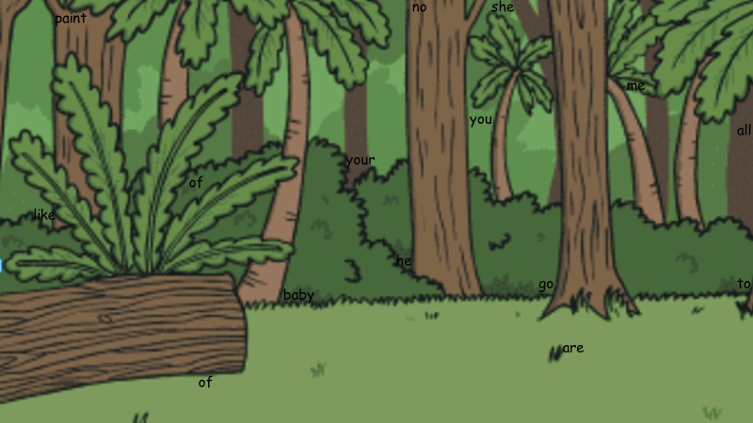
Writing

Tricky Words list

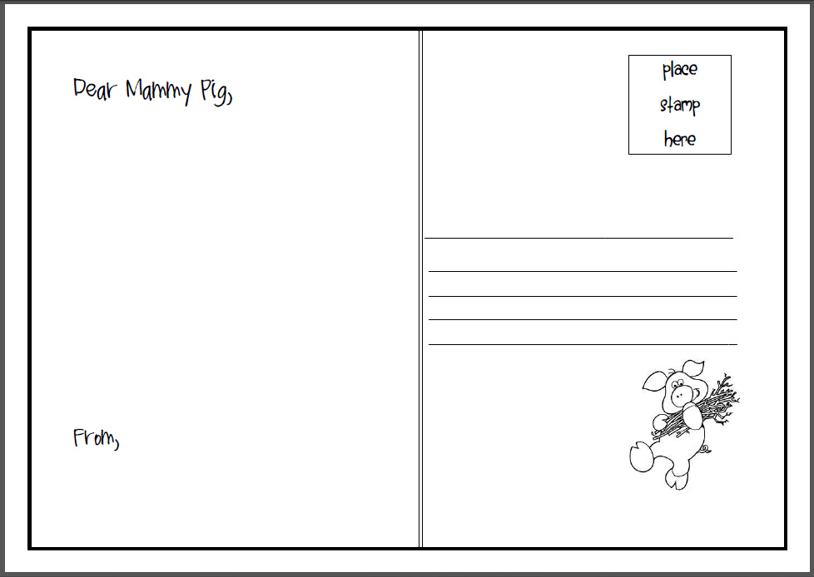
Maths: Revision of the Number 8
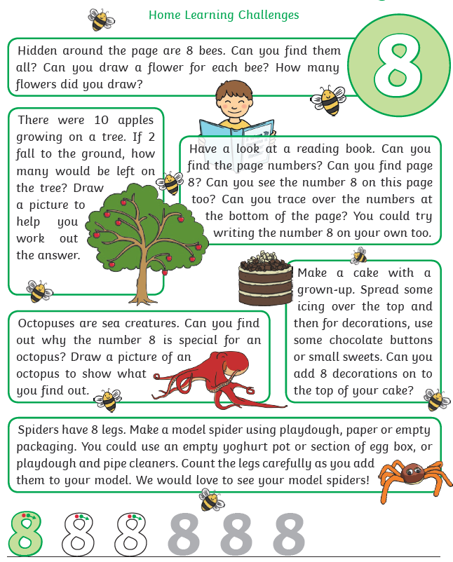
Maths: Revision of the Number 9

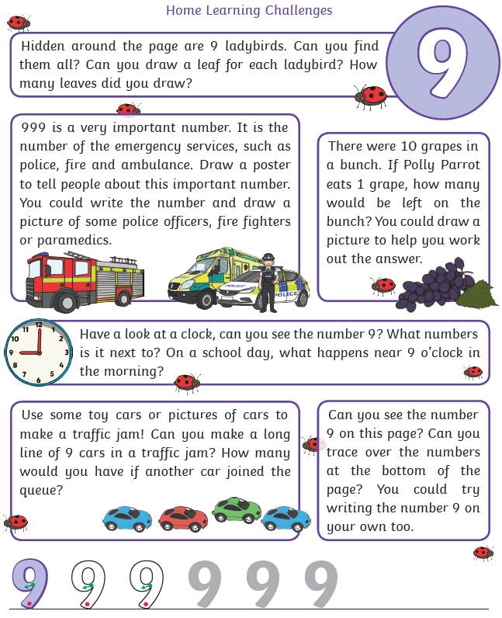
Making Sets: Draw the correct number of smiley faces in each circle.

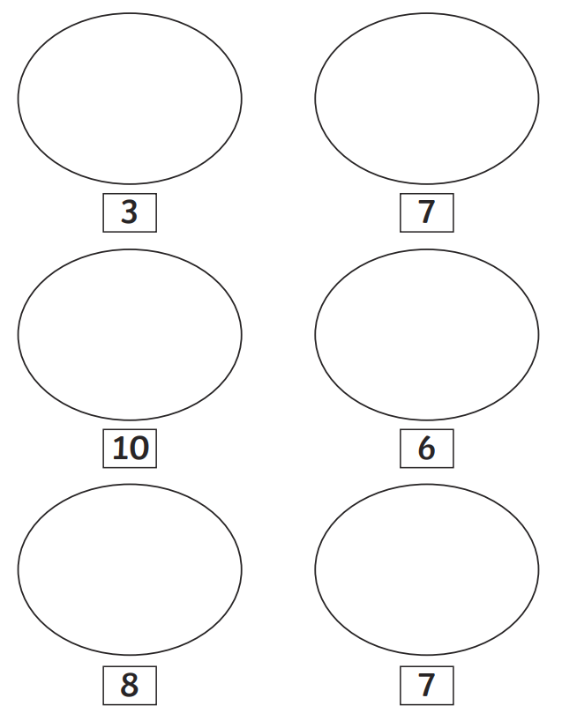
Patterns: Write the number that comes between.
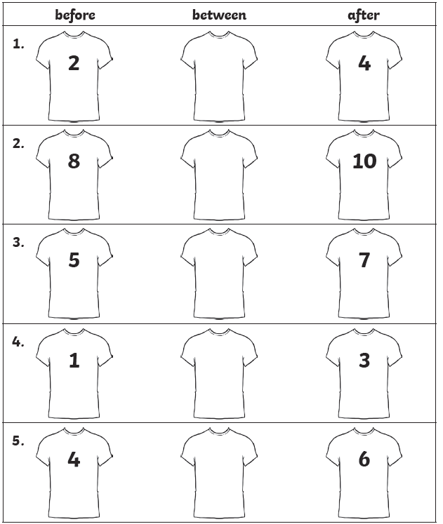

Opportunities for Maths in the Home

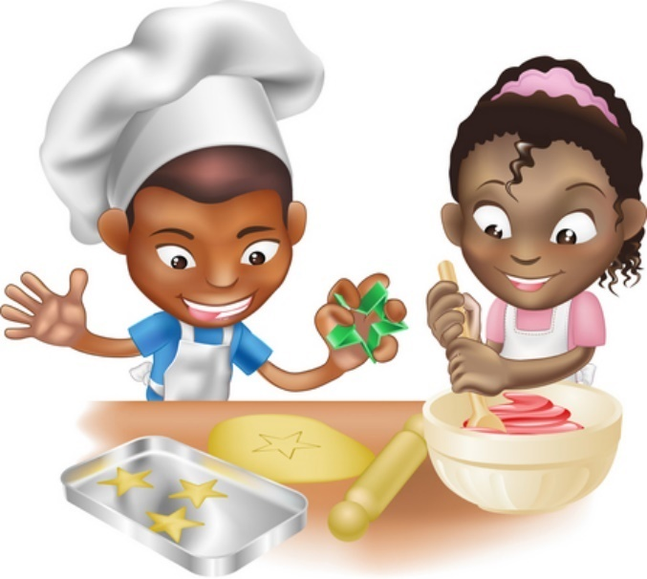
Food!
- Can you cut your toast into 4 pieces? Can you cut it into triangles?
- Setting the table. Counting the right number of plates etc. How many more do we need?
- Can you make shapes/ patterns out of the knives and forks. Can you put them in the right place in the drawers?
- Helping with the cooking by measuring and counting ingredients.
- Setting the timer.
- Positional language at dinner time: what is on the rice, where are the carrots etc?

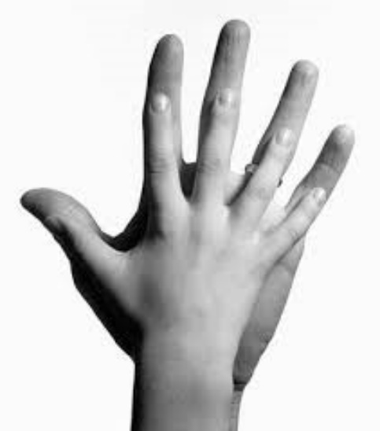
Measuring
- Are you taller than a …?
- Marking height on the wall.
- Cut hand shapes out of paper. How many hands long is the couch? How long is the table? Which is longer?
- Who has the biggest hands in our family?
- How many steps from the gate to the front door?

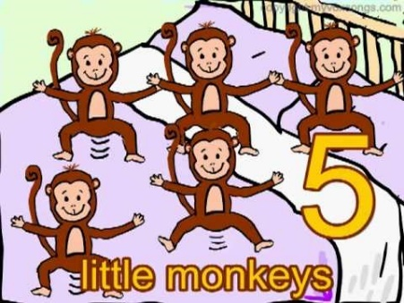
Number rhymes and songs
Eg: 5 little monkeys jumping on the bed
One fell off and bumped his head
Mummy called the doctor and the doctor said
“No more monkeys jumping on the bed!”
4 little monkeys jumping on the bed …

Your child can teach you lots more or try this website which has the words and sings it for you: https://www.bbc.co.uk/teach/school-radio/nursery-rhymes-counting-songs/zn67kmn

Art – Possible Ideas for Home Learning

Make a shape collage (Art, Maths, Geography)

Materials needed:
- coloured paper
- marker
- Pritt Stick
- Scissors
Instructions:
- Ask child to think of building in the local area. What kind of shapes are they? Big, small?
- Child cuts out these shapes in different colours of paper. A rectangle could be an apartment block, triangle a roof, etc.
- Child then makes a collage by gluing the shapes onto paper to form a streetscape.

The same idea could be achieved by simply drawing the different shapes onto one sheet.
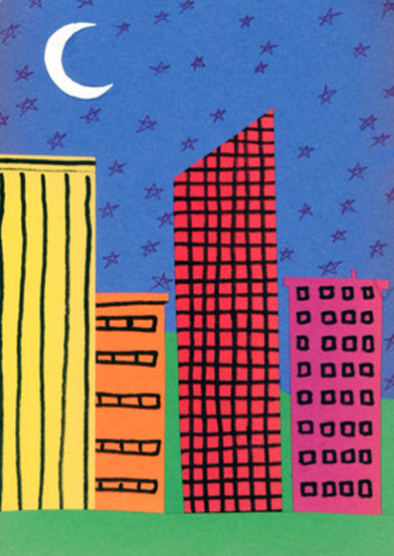
Leaf Rubbings
Simply place the leaf under the paper and colour over it with a crayon.

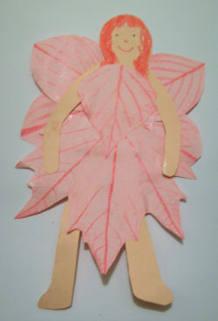
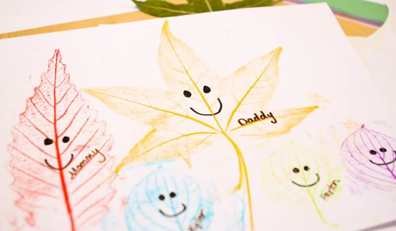
Making a Leaf Squirrel
Materials needed:
- Squirrel template or your own drawing of a squirrel.
- Autumn leaves (the more colours the better!)
- PVA glue (will work better than Pritt Stick).
- Paint/colouring pencils/crayons.
Instructions:
- Colour in your drawing/template of the squirrel with paints or colouring pencils/crayons.
- Then use PVA glue to stick the autumn leaves to your squirrel.
- It should have a fluffy tail like this:
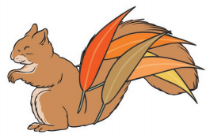
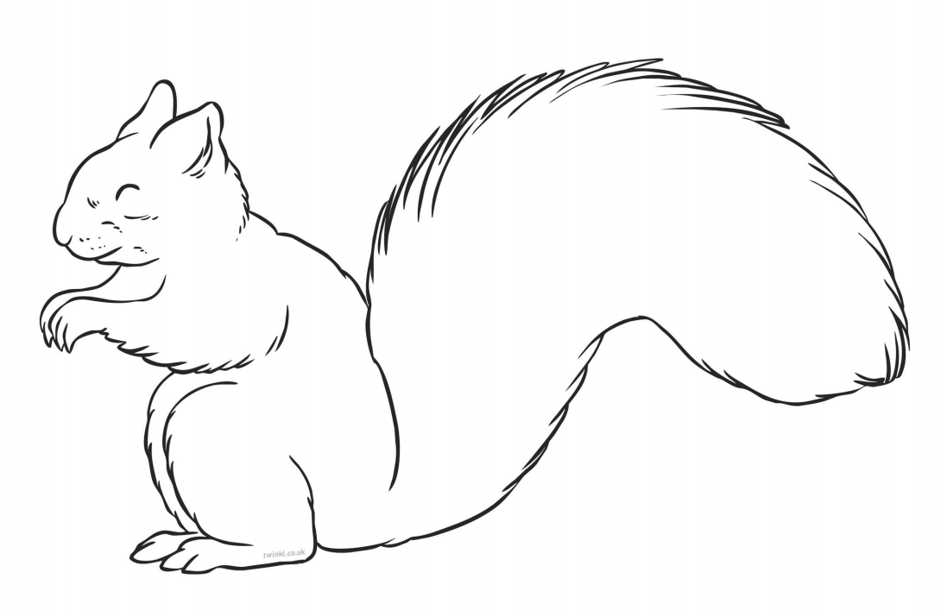
Self Portrait
Make a self portrait using pencils. Or use scraps of paper from magazines and newspapers!
Printable border and examples below.

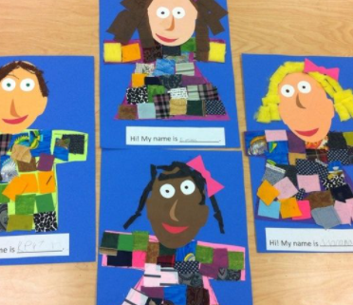
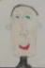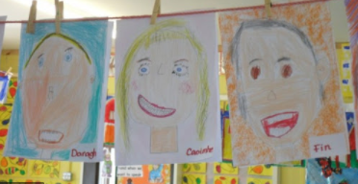

Fine Motor Skills – Possible Activities
Clothes pegs are great for developing fine motor skills. Children can use different coloured pegs to create patterns. Make it a challenge: see how many pegs you can clip on in 30 seconds, using your right hand, left hand, eyes closed, etc. Try beat your score from the last day!
Threading/lacing is also brilliant for children’s fine motor development. Straws can be cut up and be used to thread string through them (or if you have beads at home these would work great too!).
Cutting is very important for children’s fine motor development and encourages good pencil grip. Cutting paper, card, etc. will offer different levels of resistance. Children should also try to cut straight lines, edges, and curves.
Building blocks, playdough, sticking and colouring are other simple activities that enhance children’s fine motor development.
Please see printable resources at the end of this document.
Pegs
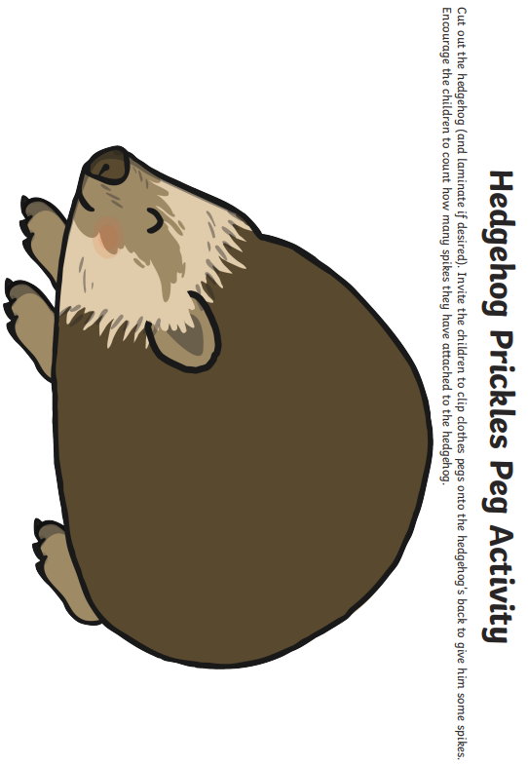
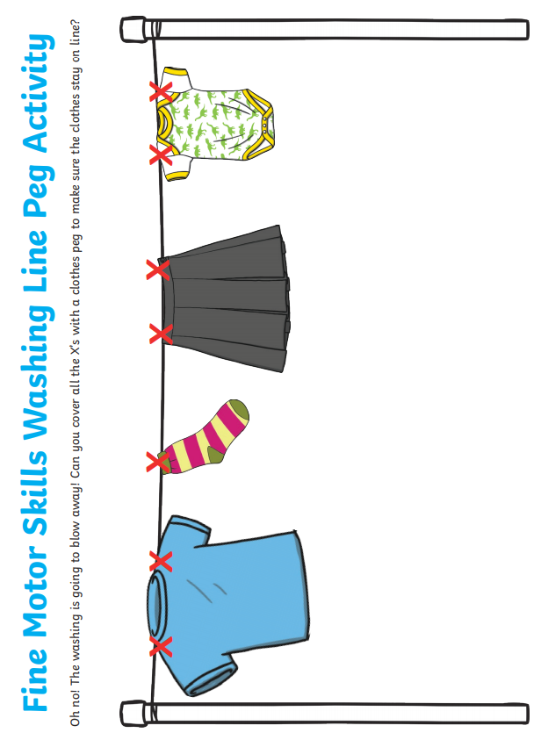

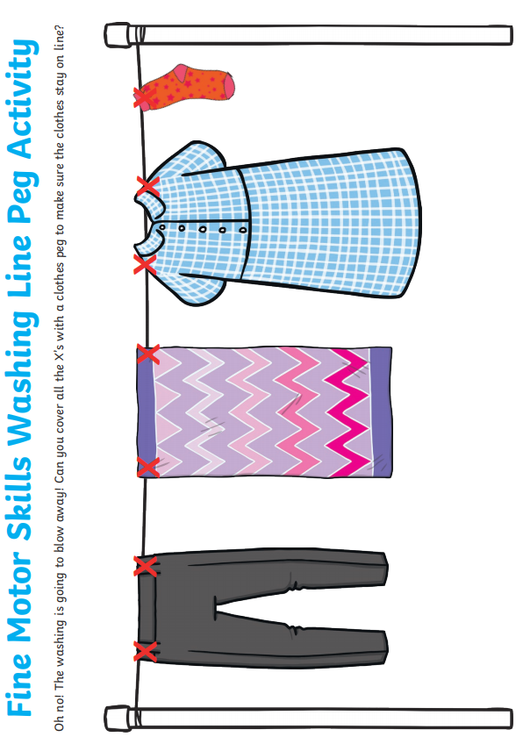
Threading

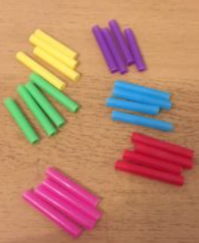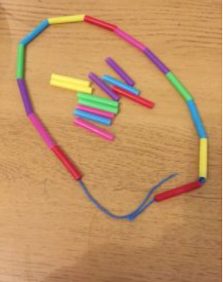

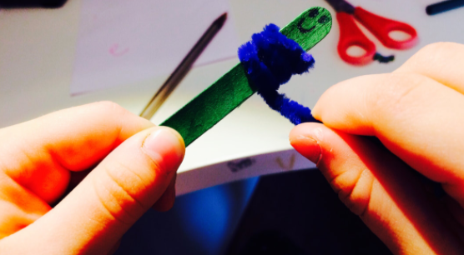
Cutting
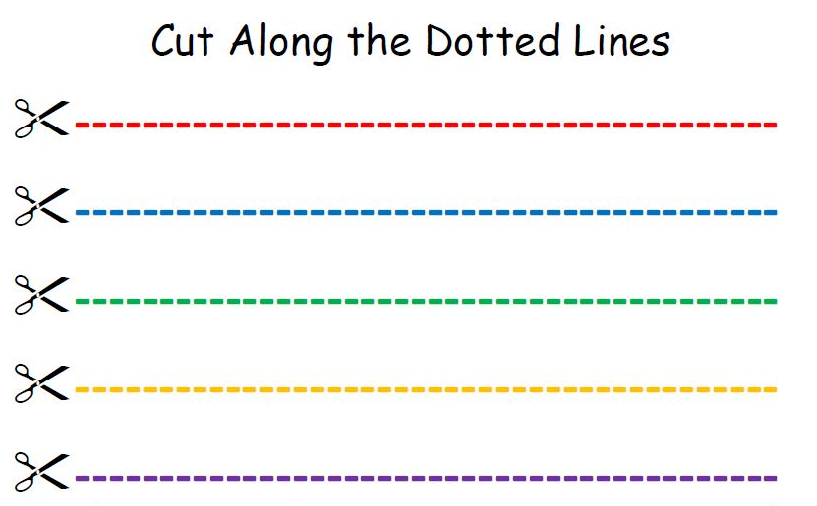
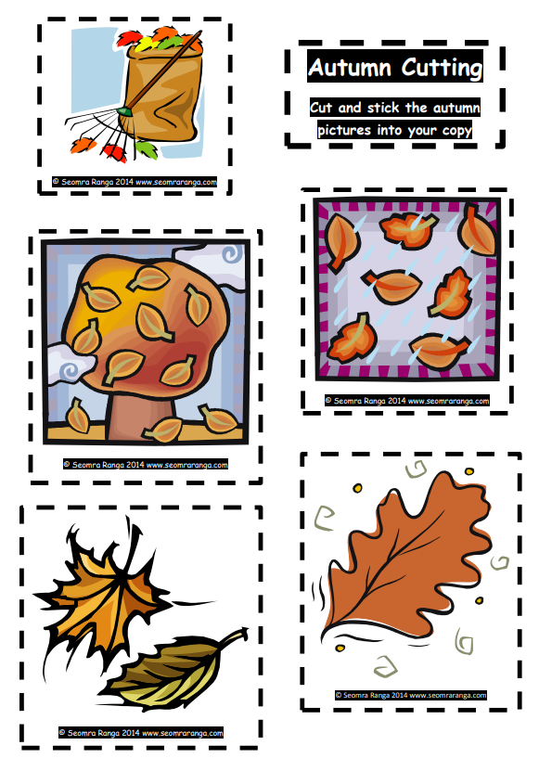

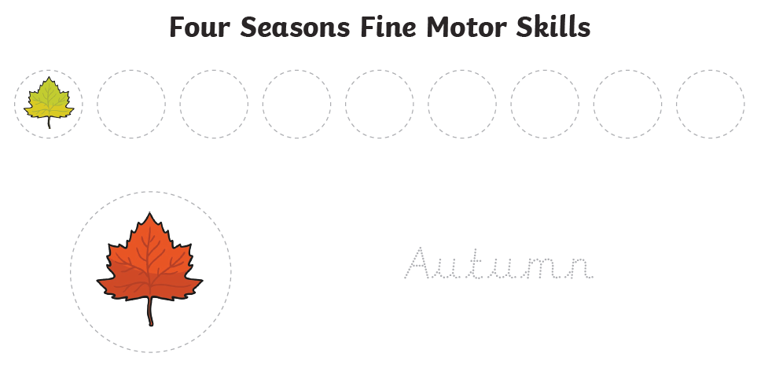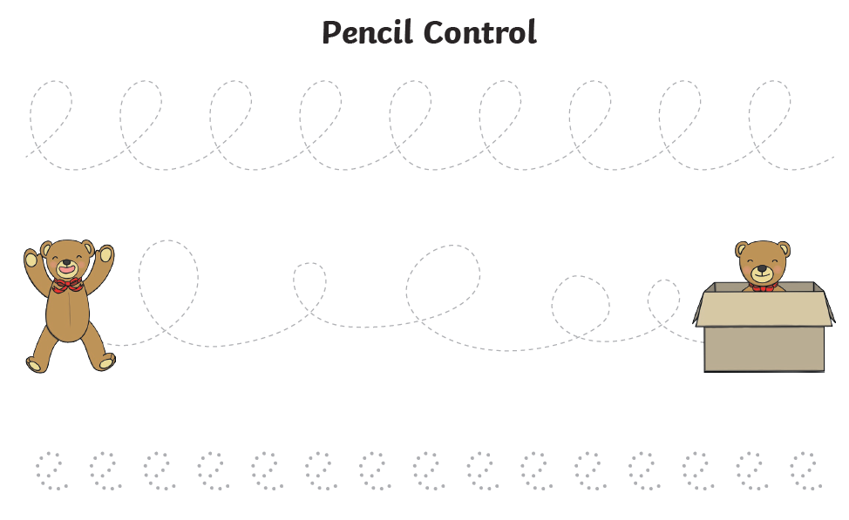

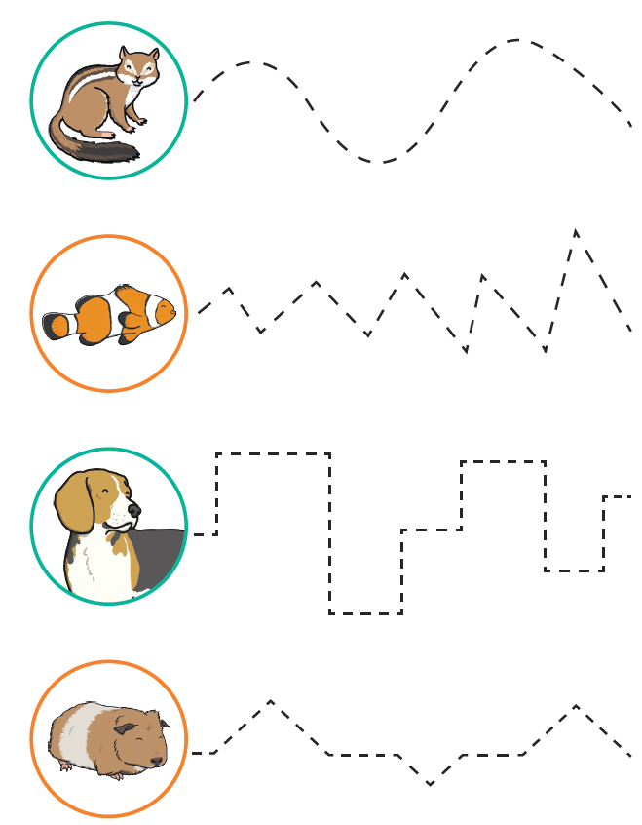
Possible ideas for P.E. at home
P.E. with Joe
- https://www.youtube.com/playlist?list=PLyCLoPd4VxBtWi7RnRLz6qHgOqWiB_LrH
Daily Dance breaks
- https://www.youtube.com/channel/UCqscMO1YfPB3-7dZZSxKPrQ

Yoga for kids
- https://www.youtube.com/user/CosmicKidsYoga

Freeze dance
https://www.youtube.com/watch?v=2UcZWXvgMZE

- Kick a ball against a wall.
- Draw your own hopscotch with chalk and play.
- Jumping jacks – time yourself each day and see how many you can do.
- Keep the balloon up.
- Throwing and catching a bean bag.
- Simon Says…

