Section One - Daily Work 8.6.2020 – 12.6.2020. (Please remember to keep up your reading everyday)
Monday 8.6.2020 | - SESE: Read the Booklet: Gardening for Biodiversity. (Pages 1-5)  https://www.meath.ie/system/files/media/file-uploads/2020-05/Garden%20Wildlife%20Booklet.pdf  Answer the following questions based on pages 1-5. (Remember to write neatly in your copybook.)  a) How many domestic gardens are there in Ireland?  b) Why is Mahonia a good shrub to have in your garden?  c) How many types of flies are there in Ireland?  d) Why are earth worms important in the garden?  2. Watch this short video on Biodiversity.  https://www.bing.com/videos/search?q=film+for+children+on+bio+diversity&docid=608019377173891947&mid=9469D19D322CAC9EA2E69469D19D322CAC9EA2E6&view=detail&FORM=VIRE  - New Wave Maths – Week 34 Monday & Monday Problem.  - New Wave English – Day 136  - Seesaw Activity. Post a photo of your answers on Seesaw.
Tuesday  9.6.2020 | - SESE: Read the Booklet: Gardening for Biodiversity. (pgs 6&7)  https://www.meath.ie/system/files/media/file-uploads/2020-05/Garden%20Wildlife%20Booklet.pdf  Answer the following questions based on pages 6-7. (Remember to write neatly in your copybook.)  a) Name four types of birds or insects that feed from a dandelion.  b) Name three reasons why Ivy is a good plant for biodiversity.  c) Drawn an ivy leaf and be sure to show its distinctive shape.  - New Wave Maths – Week 34 Tuesday & Tuesday Problem.  - New Wave English – Day 137  - Seesaw Activity: Play the ‘keeping safe online’ game posted today.
Wednesday  10.6.2020 | - SESE: Read the Booklet: Gardening for Biodiversity. (Pages 8-12)  https://www.meath.ie/system/files/media/file-uploads/2020-05/Garden%20Wildlife%20Booklet.pdf  Answer the following questions based on pages 8-12. (Remember to write neatly in your copybook.)  a) Give three tips of what to do when feeding birds.  b) Name four types of food that will attract birds to your garden and are suitable for birds.  c) Why should we not feed bread to birds?  d) Each Summer where do housemartins fly from to get to Ireland?  e) What is the length of this journey?  - New Wave Maths – Week 34 Wednesday & Wednesday Problem.  - New Wave English – Day 138  - Seesaw Activity: Look at the ‘Gratitude’ activity on Seesaw and post your response.
Thursday  11.6.2020 | - SESE: Read the Booklet: Gardening for Biodiversity. (Pages 13-18)  https://www.meath.ie/system/files/media/file-uploads/2020-05/Garden%20Wildlife%20Booklet.pdf  Answer the following questions based on pages 13 – 18. (Remember to write neatly in your copybook.)  a) Why is having more bees in your garden a benefit to biodiversity?  b) Name three plants that are good to have in your garden tin Winter to help pollination.  c) List three Summer flowers that aid pollination.  d) Give three tips for constructing a ‘bee hotel’.  - New Wave Maths – Week 34 Thursday & Thursday Problem.  - New Wave English – Day 139  - Seesaw Activity: Please do the new creative activity on Seesaw today.
Friday  12.6.2020 | - SESE: Read the Booklet: Gardening for Biodiversity. (Pages 19-22)  https://www.meath.ie/system/files/media/file-uploads/2020-05/Garden%20Wildlife%20Booklet.pdf  Answer the following questions based on pages 19 - 22. (Remember to write neatly in your copybook.)  a) Look a t the table of butterfly species and name four different types of species.  b) What are the advantages of creating a ‘log pile’ in your garden?  c) What is Ireland’s only native reptile?  - New Wave Maths – Week 34 Friday & Friday Review.  - New Wave English – Day 140  - Seesaw Activity: Please do the new creative activity on Seesaw today.  - Seesaw Activity: Post at least one item to the class blog on Seesaw today. Add a compliment or comment to some classmates’ blogs. We would like to see as many of your creative ideas as possible during the week. Photos , videos and information on your notebook in Seesaw are very welcome.
LETS INSPIRE!  Creative Schools Padlet | Section 2: Creative Schools - LETS INSPIRE PADLET!  Click on the padlet to see lots of ways that you can be creative!  Look out for some people that you know!  https://padlet.com/graceflaherty/8drns09sw823gr9p

Section three – Menu of Activities
Language | Numeracy | Be Creative! | Help at home | Miscellaneous!!
Write a letter to your future self in 2021. Tell in your letter to the future, how you are feeling about completing fifth class and starting sixth class. Write down your hopes for your final year in primary school. How do you think you will be at the end of sixth class? What subjects do you think that you will you want to do in secondary school? What might you like to remember about your final year in LETNS? What do you want achieve in sixth class? Store your letter away safely and look at it again this time next year. 6th Class 2020-2021 | 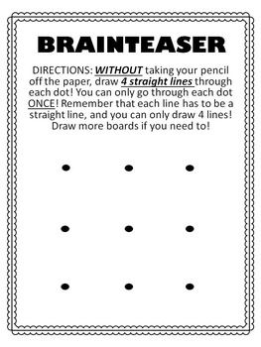 | Make a mosaic rainbow  You will need: Cardboard (an empty cereal packet) Some different coloured paper cut into small squares.  - Draw the shape of your rainbow out onto the cardboard and cut out.  - Using the mnemonic ‘Richard of York gave battle in vain’ to remember the order of the colours of the rainbow stick your small pieces of paper to your cardboard rainbow.  - Hang your rainbow in a window at the front of your house for others to enjoy. | Water the plants outside your house each evening. It has been very warm and the plants need extra watering. Look out for any small weeds that have begun to grow. Carefully remove them and put them in your compost bin. | DCU have created a number of PE lessons. Try this football skills one linked below  https://www.facebook.com/155235547878911/videos/681431199369594
 | Can you figure out these dingbats?  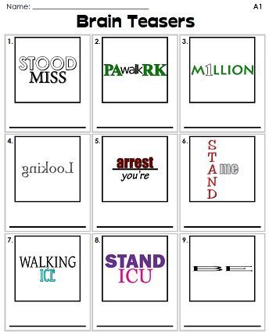 | Watch ‘Let’s go live with Maddie and Greg’. With the launch of Space X spacecraft which brought 2 NASA astronauts to the International Space Station last week we thought you might to learn more about living in space and how to make astronaut space food  https://www.youtube.com/watch?v=XYQ5PQU2BYs | Set up a restaurant in your house and ask your parents to come for dinner. Create a menu, cook the food and be the waiter for the evening!
https://www.loc.gov/item/webcast-9127/  The ‘Write. Right. Rite’ series: Listen to Jason Reynolds, the US National Ambassador for Young People’s Literature. In this video featured he challenges you to create an award for yourself. |  | https://www.meath.ie/system/files/media/file-uploads/2020-05/Garden%20Wildlife%20Booklet.pdf  Have a read of this booklet. It has lots of activities to protect our native species. Create a log pile for minibeasts, put up a bat box, create a wetland environment and many more ideas.  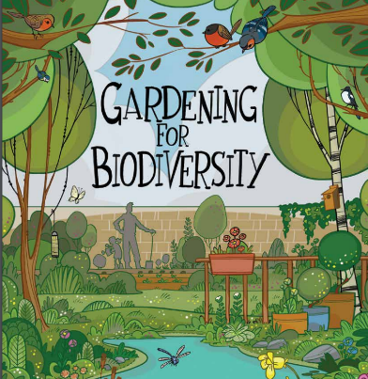 | Make some delicious flapjacks as a treat for your family. Thanks for the recipe Nina!  Ingredients:  350g Oats  150g butter, non-hydrogenated margarine or coconut oil  75g marmalade or jam  50g soft brown sugar  40g chopped nuts, seeds or dried fruit  Pinch of salt  Optional: ground cinnamon or vanilla Method:  • Preheat the oven to 170 degrees. Grease a square baking tin.  • Melt the butter and marmalade together in the microwave. Add the sugar and mix well until the sugar has dissolved.  • Quickly mix the melted butter etc with the oats, salt and dried nuts and fruit.  • Press very firmly into the baking tin.  • Bake for 20 minutes.  • Slice into squares while still warm then allow to cool completely in the tin.  • Store in an airtight container for up to 2 weeks. | https://www.youtube.com/watch?v=xQYCQ5ujqPU  Have you seen this? Watch the video to above to see how one teacher created a unique beehive. Amazing!
Have you heard of ‘The Ickabog’? J.K. Rowling has written another book. She is releasing a couple of chapters each week and is asking children around the world to illustrate it. See the site below to read the chapters and find out about the competition.  https://www.theickabog.com/  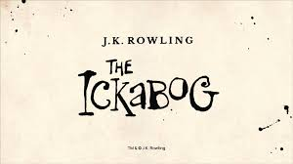 | Try https://www.topmarks.co.uk/maths-games/hit-the-button to practice your multiplication/division tables and knowledge of square numbers  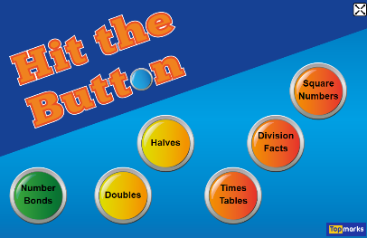 |  |  | Would you like to learn how to play tennis? Tennis Ireland have a series of lessons on youtube.  https://www.youtube.com/watch?v=mj7AnexLnhs&list=PLE6YutcDXPAVadZgFGJraMSP3IPBqLbJs  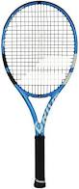
Gaeilge: Tune in to a 5th/6th class Gaeilge lesson on The Home School Hub at 11.00 am on RTÉ 2. You can also catch it at a later time on  https://www.rte.ie/player/ |  |  | Clean up after a meal. Put dishes in the dishwasher. Wash and dry the pots and pans.
For further activities and ideas please see https://padlet.com/graceflaherty/8drns09sw823gr9p

Section Four: Creative Project
For this project you will be creating a bug motel. This is a manmade structure that can provide shelter for insects. They can come in a variety of shapes and sizes. Many are used as nesting sites for solitary bees. These are bees that do not live in a hive with a queen and they make up a lot of our native bee species. There are a number of reasons why bees and other pollinators are so important to our landscape and crops but unfortunately 1/3 of our bee species are under threat.
https://padlet.com/ruth_mullins/ct4wsqchzd3b
I have included a link to a padlet above which contains various different videos and websites which demonstrate how to create your very own bug motel. Some can be made with natural materials you would find in your garden or on a walk, some can be made with recyclables and some are for the more DIY able. Remember you need to have adult supervision when using any tools! One of the sites on the padlet tells you what different insects like and dislike in their bug motels and another tells you where is best to place your bug motel when it is built.
Due Date: Friday 12th June
To complete your project:
- Take a picture or video clip of your bug motel
- Write or type up a procedure to show how you made your bug motel. See the example procedure below.
- Remember to include a title, a list of materials used and a list of step by step instructions. Tip: remember to use imperative (bossy) verbs (cut, roll, stick, etc), to write in the present tense and to number your steps or use chronological language (first, next, then, finally, etc)
- Upload both to Seesaw or email to us at therese.hesse@letns.org
- You will receive a certificate for this project with feedback on it.
Best of luck and know that the pollinators of Ireland thank you!
Example of how to lay out your Procedural writing when describing how you made your ‘Bug Motel’.
Remember you can do this written work in your copy and sent a photo on Seesaw or you can type it and e- mail it to me – the choice is yours! therese.hesse@letns.org
Title – has a title that tells the reader what this procedure is about.
Materials – have a list of materials needed for the procedure.
Procedure – How did you make the bug hotel? Step by step instructions.
Use the language of chronological order – first, secondly, after that, lastly, finally etc.
Contains the steps describing what to do.
Use your imperative or ‘bossy’ verbs here. (fold, join, attach etc)
The written procedure often has images (illustrations or photos) to help explain the steps.
Concluding statement.

