How to Make Sharon’s Home Made Lemonade:

Ingredients  - 500 ml water  - Juice and zest of 3 lemons  - Juice and zest of 1 orange  - 500 g caster sugar  - Sparkling Water  - Fresh Mint/Berries to decorate | 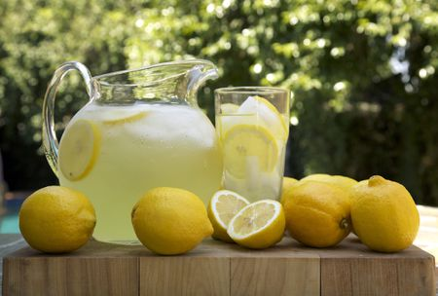
Equipment  - Saucepan  - Weighing Scales  - Measuring Jug  - Grater  - Bowl to collect the fruit juice  - Bowl to collect the zest of fruit.  - Juicer to squeeze the juice from the fruit  - Mixing Spoon  - Clean Bottle  - knife  - Chopping Board | 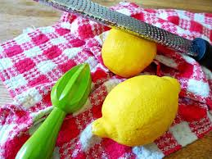
Method/Directions:
- Measure out 500 ml of water and place in a saucepan.
- Grate the skin (Zest) finely of 3 lemons and 1 orange using a fine grater.
- Place the water, lemon and orange zest in a large stainless steel saucepan and bring to the boil. Then allow it to simmer for two minutes.
- On a chopping board, use a knife to cut each lemon and orange into halves.
- Squeeze the juice from each half of fruit using a juicer.
- Collect all the juice in a bowl.
- Add the lemon and orange juice and sugar into the saucepan and return to the boil, stirring until the sugar has dissolved.
- Allow to cool, then pour into a very clean bottle.
- Dilute 1 part to 4 parts of sparkling water, add fresh mint leaves of some summer berries for a blush effect.
- Enjoy !

