Section One - Daily Work (Please remember to keep up your reading everyday)
Monday  8.6.2020 | - Transition to secondary school booklet: https://www.stanhopestreetprimary.ie/wp-content/uploads/2020/05/Big-Fish-to-Little-Fish.pdf Complete pages 2+3. PDF attached to this email also. This doesn’t have to be printed. You can complete the activities in your copybook.  - Work on your memory book: What are your memories of 3rd and 4th class? We had Winter Wonderland in 3rd. Do you remember going to the Crystal Maze that year for your tour? What were your favourite subjects and why? Did you do any projects you particularly enjoyed? What are your memories of swimming lessons with the school?
Tuesday  9.6.2020 | - Transition to secondary school booklet: https://www.stanhopestreetprimary.ie/wp-content/uploads/2020/05/Big-Fish-to-Little-Fish.pdf Complete pages 4+5. PDF attached to this email also. This doesn’t have to be printed. You can complete the activities in your copybook.  - Work on your memory book: What are your memories and experiences of being in the senior classes? Did you participate in cross country training? Did you represent the represent the school at any stage? What about the extra privileges and responsibilities you had as senior students? Using the basketball court, yard buddies, recycling, etc. What were your favourite subjects? Did you go on any outings your enjoyed? Did you have any workshops that you enjoyed and why?
Wednesday  10.6.2020 | - Transition to secondary school booklet: https://www.stanhopestreetprimary.ie/wp-content/uploads/2020/05/Big-Fish-to-Little-Fish.pdf Complete pages 6+7. PDF attached to this email also. This doesn’t have to be printed. You can complete the activities in your copybook.  - Work on your memory book: Write about your secondary school. What is it called? How will you get there each morning? Who do know will be in first year with you? Do you have siblings, cousins, friends there already? How are you feeling about moving on to secondary school? What are you most looking forward to about secondary school? Which subjects do you think you’ll enjoy?  - Complete your word for the graduation art project and upload to Seesaw or email to us at ruthandcatriona@letns.org.
Thursday  11.6.2020 | - Transition to secondary school booklet: https://www.stanhopestreetprimary.ie/wp-content/uploads/2020/05/Big-Fish-to-Little-Fish.pdf Complete pages 8+9. Have a chat with your parents about how to make sure you will be organised every day, make a list of ways that will help you. PDF attached to this email also. This doesn’t have to be printed. You can complete the activities in your copybook.  - Work on your memory book: Today maybe message your friends and teachers to ask them for a note, some good wishes or memories of you. You can message your friends with a note for them to include in their memory books too.
Friday  12.6.2020 | - Remember to post your project, image/video and procedure, Seesaw or email it to us at ruthandcatriona@letns.org!  - Work on your memory book: Add in any work, artwork, photos, etc that you or your parents have saved through the years.

Section Two – Menu of Activities
Language | Numeracy | Be Creative! | Help at home | Miscellaneous!!
Write a letter to your future self in 2026. Tell future you how you are feeling about completing primary school and starting secondary school. Write down your hopes for secondary school and how you think you will be yourself in 6 years time. What will you want to do at the end of secondary school? What might you like to study at college? What job do you want to get? Store your letter away safely and look at it again in a few years. | 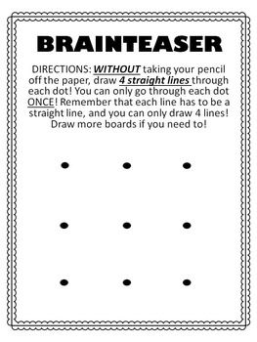 | Make a mosaic rainbow  You will need:  Cardboard (an empty cereal packet)  Some different coloured paper cut into small squares.  - Draw the shape of your rainbow out onto the cardboard and cut out.  - Using the mnemonic ‘Richard of York gave battle in vain’ to remember the order of the colours of the rainbow stick your small pieces of paper to your cardboard rainbow.  - Hang your rainbow in a window at the front of your house for others to enjoy.  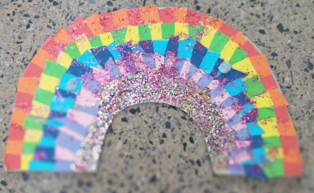 | Water the plants outside your house each evening. It has been very warm and the plants need extra watering. | DCU have created a number of PE lessons. Try this football skills one linked below  https://www.facebook.com/155235547878911/videos/681431199369594
 | Can you figure out these dingbats?  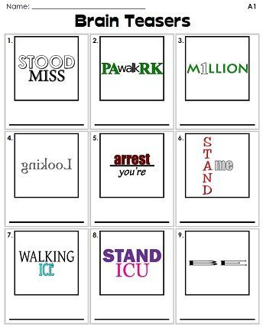 | Watch ‘Let’s go live with Maddie and Greg’. With the launch of Space X spacecraft which brought 2 NASA astronauts to the International Space Station last week we thought you might to learn more about living in space and how to make astronaut space food  https://www.youtube.com/watch?v=XYQ5PQU2BYs | Set up a restaurant in your house and ask your parents to come for dinner. Create a menu, cook the food and be the waiter for the evening!
https://www.loc.gov/item/webcast-9127/  The ‘Write. Right. Rite’ series: Listen to Jason Reynolds, the US National Ambassador for Young People’s Literature. In this video featured he challenges you to create an award for yourself. |  | https://www.meath.ie/system/files/media/file-uploads/2020-05/Garden%20Wildlife%20Booklet.pdf  Have a read of this booklet. It has lots of activities to protect our native species. Create a log pile for minibeasts, put up a bat box, create a wetland environment and many more ideas.  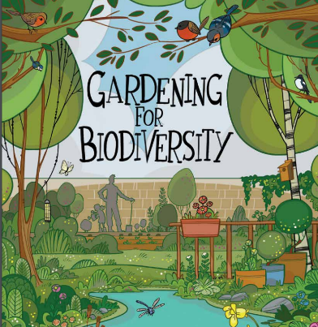 | Make some delicious flapjacks as a treat for your family. Thanks for the recipe Nina!  Ingredients:  350g Oats  150g butter, non-hydrogenated margarine or coconut oil  75g marmalade or jam  50g soft brown sugar  40g chopped nuts, seeds or dried fruit  Pinch of salt  Optional: ground cinnamon or vanilla Method:  • Preheat the oven to 170 degrees. Grease a square baking tin.  • Melt the butter and marmalade together in the microwave. Add the sugar and mix well until the sugar has dissolved.  • Quickly mix the melted butter etc with the oats, salt and dried nuts and fruit.  • Press very firmly into the baking tin.  • Bake for 20 minutes.  • Slice into squares while still warm then allow to cool completely in the tin.  • Store in an airtight container for up to 2 weeks. | https://www.youtube.com/watch?v=xQYCQ5ujqPU  Have you seen this? Watch the video to above to see how one teacher created a unique beehive. Amazing!
Have you heard of ‘The Ickabog’? J.K. Rowling has written another book. She is releasing a couple of chapters each week and is asking children around the world to illustrate it. See the site below to read the chapters and find out about the competition.  https://www.theickabog.com/  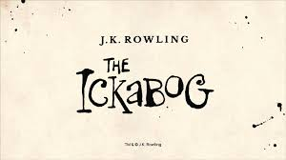 | Try https://www.topmarks.co.uk/maths-games/hit-the-button to practice your multiplication/division tables and knowledge of square numbers  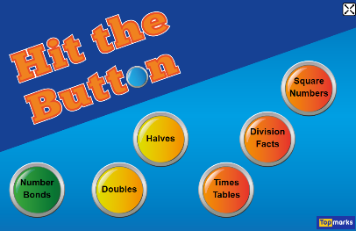 |  |  | Would you like to learn how to play tennis? Tennis Ireland have a series of lessons on youtube.  https://www.youtube.com/watch?v=mj7AnexLnhs&list=PLE6YutcDXPAVadZgFGJraMSP3IPBqLbJs  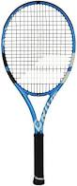
Gaeilge: Tune in to a 5th/6th class Gaeilge lesson on The Home School Hub at 11.00 am on RTÉ 2. You can also catch it at a later time on  https://www.rte.ie/player/ |  |  | Clean up after a meal. Put dishes in the dishwasher. Wash and dry the pots and pans.
For further activities and ideas please see https://padlet.com/graceflaherty/8drns09sw823gr9p

Section three: Creative Project
For this project you will be creating a bug motel. This is a manmade structure that can provide shelter for insects. They can come in a variety of shapes and sizes. Many are used as nesting sites for solitary bees. These are bees that do not live in a hive with a queen and they make up a lot of our native bee species. There are a number of reasons why bees and other pollinators are so important to our landscape and crops but unfortunately 1/3 of our bee species are under threat.
https://padlet.com/ruth_mullins/ct4wsqchzd3b
We have linked a padlet above which contains various different videos and websites which demonstrate how to create your very own bug motel. Some can be made with natural materials you would find in your garden or on a walk, some can be made with recyclables and some are for the more DIY able. Remember you need to have adult supervision when using any tools! One of the sites on the padlet tells you what different insects like and dislike in their bug motels and another tells you where is best to place your bug motel when it is built.
Due Date: Friday 12th June
To complete your project:
- Take a picture or video clip of your bug motel
- Write or type up a procedure to show how you made your bug motel. See the example procedure attached to this email
- Remember to include a title, a list of materials used and a list of step by step instructions. Tip: remember to use imperative (bossy) verbs (cut, roll, stick, etc), to write in the present tense and to number your steps or use chronological language (first, next, then, finally, etc)
- Upload both to Seesaw or email to us at ruthandcatriona@letns.org
We will reply with some feedback. Best of luck and know that the pollinators of Ireland thank you!

