Hi boys and girls

I hope you are all well and that you had a lovely weekend. Hopefully the sunshine will return soon but it’s nice to have a bit of rain to give all the plants and flowers a drink! It is hard to believe we only have three weeks left in fourth class! You are all doing such a great job, lets keep up the great work!

As I said in my Seesaw video that I posted on Friday, it was so great to receive so many wonderful projects on the Great Famine. The standard was so high! All the projects I received were really excellent. I can see all the effort, research and hard work that went into them. A huge effort was made by everyone with their presentation too. It was great to see how creative you all were with your projects. Well done!

I hope you all enjoyed Creative Week last week and enjoyed having a bit of a break from all the book work. Thank you so much to everyone who shared their fantastic creativity! You are such a creative class! I loved all of your creative posts - Mandala’s paper towel challenges, eggcellent experiments, lollipop crafts, lego safes, chocolate brownie cake, fruit faces, trampoline tricks, lots of baking and cooking such as - red velvet cupcakes, fairy cakes, cup cakes, strawberry pavlova, cookies. There was also Indian dancing, photography, German lessons, hurling tricks, playing guitar, responding to artwork, playing checkers, making green pea curry, painting cups, brilliant drawings from art hub, such as scratch art, an icecream picture, a Darth Vader picture. There were also tik tok dances and tik tok dance tutorials, henna flower tattoos to name but a few. It just shows the huge amount of talents that there are in our brilliant fourth class! Well done everyone!

Again this week I will be assigning less book work and giving you another week off Bua na Cainte, New Wave Maths, English in Practice and spellings, as instead, I would like to see your creative skills! In replacement of the work, I would like you to choose any creative activity that you wish and share your work on Seesaw each day. Please feel free to share more often if you wish and I am looking forward to seeing all your creativity shine! The teachers will gather all this at the end of the two weeks and collate it as one big Creative Schools Virtual display! I will gathering those together this week so keep the posts coming.

As I said last week you may be thinking . . .. what will I do? Well, don`t worry because the teachers at LETNS would like to inspire you! Look at the LETNS INSPIRE YOU Padlet link below. I hope it inspires you to imagine and create something new and exciting. There are lots of wonderful activities to choose from – art, drawing, cooking, science experiments, Spanish lessons, virtual tours of towns in Ireland, gardening, fitness, exercise and dance classes, hurling skills, animation, ballet, Harry Potter at home hub, photography to name just a few! Also, there are videos of LETNS teachers sharing their own creative content, why not try out some of the activities and then share it to your Seesaw journal!
Senior Classes Padlet link: https://padlet.com/graceflaherty/8drns09sw823gr9p
We will have another Zoom call during the week on Thursday at 11am. I will let your parents know the details during the week. Can’t wait to see you all then!

The Parents Association in our school send out a newsletter every month and for their final newsletter they are hoping to put together a little 'thanks' to all the parents helping and teaching their children at home. This is where you come in! This week as part of your Seesaw activities I want you to start thinking about 'What are you grateful to your parents for?' or What have you enjoyed learning with your Mam, Granny , Brother, Dad, Sister ? Your answers will be sent to the Parents Association for their newsletter. Start thinking about what you would like to say and I will post the activity on Seesaw during the week.

I also wanted to say a big Happy Birthday to Sophie who will be 11 tomorrow (Tuesday). Have a brilliant day Sophie! Harry and Kiera I hope you both enjoyed your birthdays last week too.

Have a great week! Get posting and get creative!

Muireann

Suggested Table of Work - 4th Class – 08/06/20-12/06/20

 | MONDAY | TUESDAY | WEDNESDAY | THURSDAY | FRIDAY
Date: | 08/06/20 | 09/06/20 | 10/06/20 | 11/06/20 | 12/06/20
Maths – Length 2 | See list of suggested activities below or/and  Page 133 Busy at Maths  See today’s Seesaw activity | See list of suggested activities below or/and  Page 134 Busy at Maths  See today’s Seesaw activity | See list of suggested activities below or/and  Page 135 Busy at Maths  Click on this link to access online tutorial  http://data.cjfallon.ie/resources/20691/BAM4_Tutorial_092/lessons/BAM4_Tutorial_092/index.html  See today’s Seesaw activity | See list of suggested activities below or/and  Page 136 Busy at Maths  Click on this link to access online tutorial  http://data.cjfallon.ie/resources/20691/BAM4_Tutorial_093/lessons/BAM4_Tutorial_093/index.html  See today’s Seesaw activity | See list of suggested activities below or/and Page 137 Busy at Maths  See today’s Seesaw activity  http://data.cjfallon.ie/resources/20691/BAM4_Tutorial_094/lessons/BAM4_Tutorial_094/index.html  See today’s Seesaw activity
Gaeilge - Léigh Sa Bhaile  -useful to access the book online and listen to the stories being read aloud – | Ag Siopadóireacht san Aerfort  Read page 106 and answer questions 1,2 & 3 in your copy | Ag Siopadóireacht san Aerfort  Re-read page 106 and answer questions 4 & 5 in your copy | Café san Aerfort  Read page 107  Answer questions 1 & 2 in your copy Practice reading aloud | Café san Aerfort  Read page 107  Answer questions 3 & 4 in your copy Practice reading aloud | Re-read page 107 An Teilifís and answer question 5. Practice reading aloud
Starlight  Poetry -  Make sure you are keeping up your reading and reading for at least 10 minutes each day. | Writing Skills – Word effects – Alliteration and Rhyme  Complete the activity F on page 185 | Writing Genre – Planning a poem with interesting sounds  Plan a poem (use a mind map) with alliteration or rhyme or both!  See G on page 185 to help you! | Writing Skills – Word choices – synonyms  Try the activity F on page 189  This will be useful for writing your poem | Writing Genre: Writing a poem with interesting sounds  Using the mind map you made on Tuesday.  Write you first draft of your poem  -Read the draft out loud  -Can you use more alliteration or other rhyming pairs of words  -Improve any of them by using more interesting synonyms  -Read your poem to someone at home and ask them for feedback | Write the final draft of your poem, adding an illustration of the animal your poem is about!  Take a picture of your poem or a video of yourself reading your poem and share it on Seesaw.
Other | Choose any of the creative activities from the Creative Schools Padlet and share your work on Seesaw!  https://padlet.com/graceflaherty/8drns09sw823gr9p | Choose any of the creative activities from the Creative Schools Padlet and share your work on Seesaw!  https://padlet.com/graceflaherty/8drns09sw823gr9p | Choose any of the creative activities from the Creative Schools Padlet and share your work on Seesaw!  https://padlet.com/graceflaherty/8drns09sw823gr9p | Choose any of the creative activities from the Creative Schools Padlet and share your work on Seesaw!  https://padlet.com/graceflaherty/8drns09sw823gr9p | Choose any of the creative activities from the Creative Schools Padlet and share your work on Seesaw!  https://padlet.com/graceflaherty/8drns09sw823gr9p
SUGGESTED MATHS ACTIVITIES – 08/06/20-12/06/20-Length

Notes for parents:Length
This week we will be learning about kilometres and metres as well as perimeter. Children need to know some the mathematical language associated with the metric system: length, centimetres (cm), metres (m), kilometre (km), measure, longer, shorter, total, decimals, fractions, metre stick, more/less than, long, longer, equal, distance, high, tenth, hundredth, decimal point, all around, perimeter, sides.
Tuesday-Activity 1:How far is a kilometre?
Discuss: How far is a kilometre? Explain to your child that a kilometre is 1000 metres long. Kilometres are used to measure longer distances than we have previously looked at. Discuss distances that are measured in kilometres, e.g. from Longford to Cork; from Dublin to London; from your house to a local attraction, e.g. a castle, park or lake.

Task 1: When travelling on a familiar journey in the car, ask your child to predict where you will be after 1km. Measure the distance on the car’s odometer. Discuss the outcome with your child – does a kilometre feel longer or shorter than s/he imagined? Extension 2: Walk a kilometre with your child. Time how long it took you to walk this distance.
Task 2: When travelling on a familiar journey in the car, ask your child to predict where you will be after 1km. Measure the distance on the car’s odometer. Discuss the outcome with your child – does a kilometre feel longer or shorter than s/he imagined? Extension 2: Walk a kilometre with your child. Time how long it took you to walk this distance.
Tuesday: Activity 2-The kilometre-a closer look
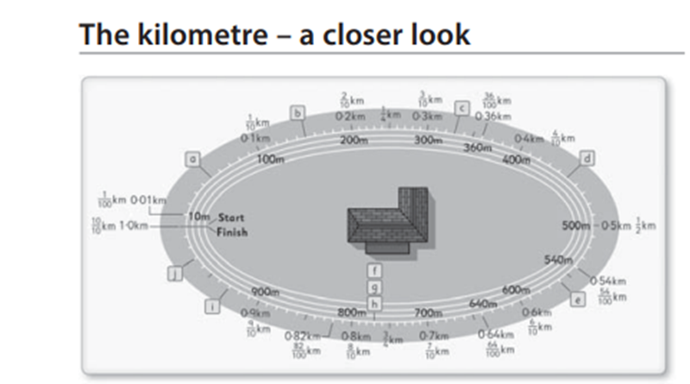
Help your child to practise reading the kilometre in metres in both fraction and decimal form by asking questions such as:
- How many metres are in 1 /4 / 1 /2 / 3 /4km?
- How many metres are in 7 /10 km?
- How many metres are in 0·19km?
- What is 540m in fraction and decimal form?
- How many metres are in 2km?
- What is 1 86/100km in decimal form?

Wednesday:Activity 3-Perimeter
Discuss: Explain to your child that the perimeter of an object is the total distance around all the sides.
- If the length of each square in the above picture is 1cm, the total perimeter of the shaded shape is 14cm.
- Using squared paper from a sums copy (the squares may not be 1cm exactly, but for the sake of the exercise, pretend that they are), draw patterns similar to the one above and invite your child to calculate the perimeter of each.
Task 1: Ask your child to create shape pictures on squared paper that have a perimeter of 9cm, 11cm, 12cm, etc.
Thursday: Activity 4 –Calculating Perimeters

Invite your child to find a simple rectangular photograph or picture frame. Using a ruler, ask him/her to measure the length of each side and then add them in order to find the perimeter.

Task 1: Encourage your child to find an easier/ quicker way of calculating the perimeter: The two long sides are the same length and the two shorter sides are the same length. So you could add one long side and one short side and multiply your answer by 2!
Task 2: Encourage your child to calculate the perimeter of a selection of household objects. As a challenge, invite him/her to calculate larger perimeters, such as the perimeter of a bedroom or garden.

TO ACCESS LÉIGH SA BHAILE AND BUSY AT MATHS
To access CJ Fallon you’ll need to register your name and email address. When you log in you can select the book required. Below are the steps for Léigh sa Bhaile, follow the same steps for Busy at Maths.
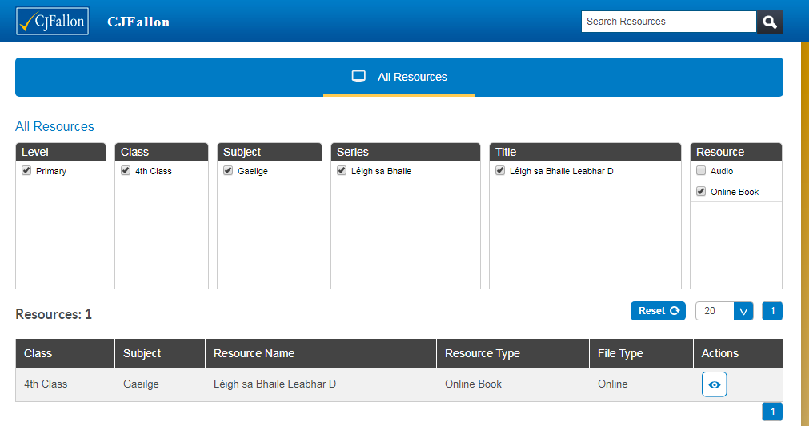
TO ACCESS NEW WAVE ENGLISH AND MATHS ANSWER BOOKS click the links below. This could be a good way for the children to correct and check their work. If they have any questions about any answers they can send me a message on Seesaw and I will explain it to them.
New Wave English in Practice
https://www.prim-ed.ie/contentfiles/41648_NWEIP_TG_4th_Class.pdf

New Wave Mental Maths
https://www.prim-ed.ie/contentfiles/41634_NWMM_TM_4th_Class.pdf

Alternative Reading activities for Amanda’s group. Creative week

Hi Guys, here are some ideas to help you get creative with reading. They will help you to think about the words you are reading, how they sound and the pictures they create in your imagination. Amanda

Monday | Tuesday | Wednesday | Thursday/Friday
As you read your book write down the 10 most interesting words you come across. Use different writing and colours for each word to suit it. | Choose an abstract noun or emotion/feeling and make a picture/painting based around it. Choose colours, lines and shapes that the word reminds you of.  See explanation of abstract nouns and some art examples below. | Find a word in your book that conveys a sound or noise and make a spatter painting to illustrate it. If you don’t have paint you can use crayons, markers or colouring pencils in creative ways.  e.g. crash, bang, whimper, explode | Make a collage or all your favourite words or interesting words you’ve come across lately. Be as creative as you can with colour and layout.

An abstract noun is a noun that refers to a concept such as an emotion, a feeling, a quality, or an idea. In other words, an abstract noun is not a physical object.

SOME ABSTRACT NOUNS – hope, love, fear, gratitude, jealousy, bravery, democracy, strength, health, beauty, freedom.

Look for some more online yourself.

Here are some examples of abstract noun pictures.

HOPE

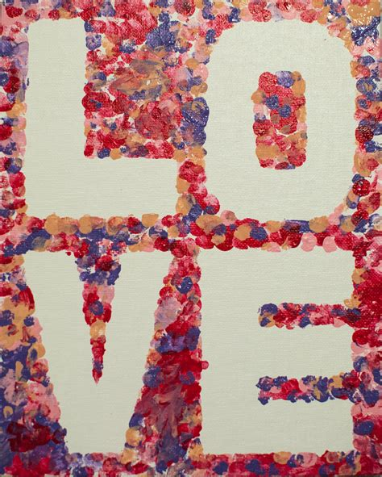
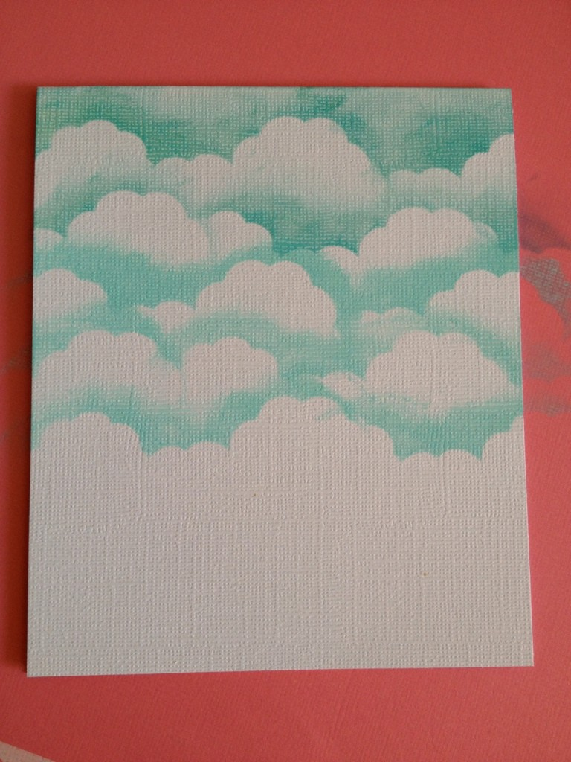
SILENCE

