PICK 5 THINGS FROM THIS LIST TO POST ON SEESAW
- Any of the activities assigned each morning this week (see table below)
- Any of your creative activities
- A photo of a piece of artwork you would like to share
- A video of yourself reading out a piece of your free writing
- A photo of your Bua na Cainte answers from this week’s story
- Any of your work on Division
- A video of you reading the poem from this week
- A photo of a page you have completed from your New Wave English or Maths
- A photo of some of your freewriting
- A video of yourself reading this week’s Léigh sa Bhaile story
- A photo of your completed Léigh sa Bhaile sentences
- A video of yourself reading your Irish sentences for this week
- A video of a talent you would like to share with the class

Suggested Table of Work - 4th Class – 02/06/20-05/06/20

 | TUESDAY | WEDNESDAY | THURSDAY | FRIDAY
Date: | 02/06/20 | 03/06/20 | 04/06/20 | 05/06/20
Maths – Division 3 | See list of suggested activities below or/and  Page 144 Busy at Maths  Click on this link to access online tutorial  http://data.cjfallon.ie/resources/20691/BAM4_Tutorial_097/lessons/BAM4_Tutorial_097/index.html  See today’s Seesaw activity | See list of suggested activities below or/and  Page 145 Busy at Maths  Click on this link to access online tutorial  http://data.cjfallon.ie/resources/20691/BAM4_Tutorial_098/lessons/BAM4_Tutorial_098/index.html  See today’s Seesaw activity | See list of suggested activities below or/and  Page 146 Busy at Maths  Click on this link to access online tutorial  http://data.cjfallon.ie/resources/20691/BAM4_Tutorial_099/lessons/BAM4_Tutorial_099/index.html  See today’s Seesaw activity | See list of suggested activities below or/and Page 147 Busy at Maths  See today’s Seesaw activity
Gaeilge - Léigh Sa Bhaile  -useful to access the book online and listen to the stories being read aloud – | Lá Grianmhar Cois Farraige page 119 Re-read and answer questions 1, 2,3, in your copy. Read the story aloud | Read page 119 – Lá Grianmhar Cois Farraige page 119  Answer questions 4 & 5 Practice reading aloud | Re-read page 120 An Teilifís  Answer questions 1,2 & 3 Practice reading aloud | Re-read page 120 An Teilifís and answer question 4 & 5. Practice reading aloud
Starlight  Poetry - Dreamer  Make sure you are keeping up your reading and reading for at least 10 minutes each day. | Read the poem Dreamer on page186 and answer questions on page 187 A | Re-read the poem on page 186 and answer B on | Complete the vocabulary exercise on C page 187 | Complete vocabulary D page188
Other | SESE: Project work  The famine project is due any day during this week.  Choose any of the creative activities from the Creative Schools Padlet and share your work on Seesaw!  https://padlet.com/graceflaherty/8drns09sw823gr9p | Choose any of the creative activities from the Creative Schools Padlet and share your work on Seesaw!  https://padlet.com/graceflaherty/8drns09sw823gr9p | Choose any of the creative activities from the Creative Schools Padlet and share your work on Seesaw!  https://padlet.com/graceflaherty/8drns09sw823gr9p | Choose any of the creative activities from the Creative Schools Padlet and share your work on Seesaw!  https://padlet.com/graceflaherty/8drns09sw823gr9p

SUGGESTED MATHS ACTIVITIES – 02/06/20-05/06/20 – DIVISION

This week we will be learning about division. Your child needs to know the mathematical language associated with division: sharing, share equally between/among, shared between, grouping, groups, sets, equal amount, repeated subtraction, divide, left over, remainder, how many times, divided by, exchange, divisible, factor, divisor, dividend, quotient. 20 ÷ 5 = 4 dividend ÷ divisor = quotient

Division strategy 1
Work through the following problem with your child: We want to share €358 among four plates.
€358 ÷ 4 = ?

There are not enough €100 notes to put one on each plate, so we must exchange the €100 notes for six €50 notes. That leaves us with 7 x €50 and 8 x €1. Share the €50 notes among the four plates.

That leaves us with 3 x €50 and 8 x €1. Exchange the 3 x €50 notes for 15 x €10. Share the €10 notes among the four plates.

That leaves us with 3 x €10 and 8 x €1. Exchange the 3 x €10 notes for 30 x €1 + €8 = €38. Share the €1 coins among the four plates. That leaves us with 2 x €1. Exchange the 2 x €1 coins for 4 x 50c.

Share the 50c coins among the four plates.

Division Strategy 2: Short division involving renaming
Work through the following problem with your child:
A tiler had 679 tiles to tile five identical bathrooms. How many tiles were needed for each bathroom? How many tiles were left over?

- If we share the 600 tiles between the five bathrooms, each bathroom will get one hundred with one hundred left over.
- Swap the one hundred for 10 tens. I now have 10 tens.
- I had seven tens to begin with. Now I have 17 tens altogether. Can I share 17 tens among the five bathrooms? Yes, 5 x 3 = 15.
- How many tens will each bathroom get? Yes, three.
- How many tens will I have left over? I will have two tens left over: 17 – 15 = 2.
- Swap the two tens for 20 units. I had nine units to begin with. Now I have 29 units altogether.

- Can I share 29 units among the five bathrooms? Yes.
- How many units will each bathroom get? Yes, five: 5 x 5 = 25.
- How many tiles will I have left over? Yes, four: 29 – 25 = 4.

- 4th Class Project Work.

A few weeks ago we were learning about The Great Famine-An Gorta Mór when we were reading our novel Under the Hawthorn Tree. It was set in Ireland in the 1840s which is devastated by the famine. We saw how when tragedy strikes their family, Peggy, Eily and Michael were left to fend for themselves. Following on from what we learned about the famine in class I thought you might like to create your own project/book/folder on The Great Famine.

As we are not in school, I would like you to present your project either
through a video presentation on Seesaw or
take pictures of your project and share it on Seesaw.
You can work on the project over the next month and share it on see saw between June 1st- 5th. Use the internet or books you may have at home to help you. Here are some brilliant websites and links that you will find useful.

1.This Scoilnet website has fantastic resources including:
- The Great Irish Famine Online
- The Hunger Times-A Short film aimed at children aged 10-13. It was the first time that a Famine story has been told on film through the eyes of children.
- There are links to other great resources for you to research too
https://www.scoilnet.ie/go-to-primary/theme-pages/history/famine/

2. Ask About Ireland.com
A fantastic website where you can find information, videos and phots all about The Great Famine.
http://www.askaboutireland.ie/learning-zone/primary-students/3rd-+-4th-class/history/history-the-full-story/ireland-in-the-19th-centu/the-great-famine-an-gorta/index.xml

3. DCU Libraries
This page provides links to lesson plans for primary and secondary classes on the Famine and primary sources freely available on the web; it also points to relevant resource packs in our Reserve Collection
https://dcu.libguides.com/c.php?g=496476&p=3415712

4.Twinkl
You may be aware of Twinkl by now, here is a link to a great lesson pack on The Great Famine.
https://www.twinkl.ie/resource/roi2-h-052-the-great-famine-lesson-pack

5. Mr.O Bróin`s website
Resources on the Famine from a school website. Very good information created by students. This website has links to lots of great information that can be used to research the Great Famine.
http://www.mrobroin.stcronans.ie/the_great_famine.html

6. Starlight
Page 104 Michael’s Workhouse Diary contains a first hand account of life in the workhouse that might be useful for ideas for your project

Your Project

These are some ideas you may like to think about. Please include the first 10 items from this list in your project book. (I think all the below topics are very important aspects of The Great Famine and I would be so impressed if you included them all!)

- Cover and contents page – you must have this as part of your project.
- What is a famine? Why was Ireland so affected by the Famine?
- Potatoes and Ireland. Why were people do dependent on potatoes?
- What Caused the Famine?
- The Blight 1845
- 1846
- Black 47.
- What did the Government do to help?
- Soup Kitchens
- Workhouses
- Eviction from houses
- Emigration
- Coffin ships
- Effects/Results of the Great Famine in Ireland

Remember to think about how you present your work. Writing should be on lined writing paper. Drawings can be on plain drawing paper(if you have some!). Use your own creativity and imagination to have a fact wheel, a lift the flap question and answer section, or a tracing of a Workhouse or Coffin Ship. You could also write a recount from the day in the life of a child during the famine . Good luck with your research and remember to do your best work. I can’t wait to see all your projects!

Muireann

TO ACCESS LÉIGH SA BHAILE AND BUSY AT MATHS
To access CJ Fallon you’ll need to register your name and email address. When you log in you can select the book required. Below are the steps for Léigh sa Bhaile, follow the same steps for Busy at Maths.
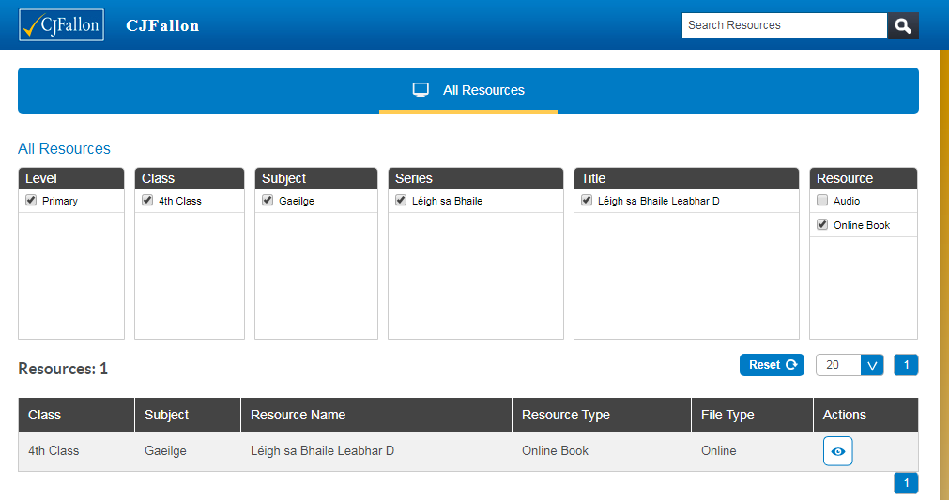
TO ACCESS NEW WAVE ENGLISH AND MATHS ANSWER BOOKS click the links below. This could be a good way for the children to correct and check their work. If they have any questions about any answers they can send me a message on Seesaw and I will explain it to them.
New Wave English in Practice
https://www.prim-ed.ie/contentfiles/41648_NWEIP_TG_4th_Class.pdf

New Wave Mental Maths
https://www.prim-ed.ie/contentfiles/41634_NWMM_TM_4th_Class.pdf
LEARNING SUPPORT GROUP – WORK FROM AMANDA
Alternative Reading activities for Amanda’s 4th class groups.
Hi all, here are some reading challenges for the week ahead. How many can you do? Enjoy yourselves and only do as much as you like. Amanda
Alternative Reading activities for Amanda’s 4th class groups.
Hi everyone, Try some of these activities. Hope you’re all doing well and not missing school too much! Amanda
 | 02/06/20 | 03/06/20 | 04/06/20 | 05/06/20
Reading | Record yourself reading a poem aloud.  www.poetry4kids.com  Listen to it back. | Read a sentence from your book backwards. Practice a few times and then see how fast you can read it. | Watch a cartoon or a children’s movie with the subtitles on and read along out loud. | Read some facts online about a famous explorer or inventor you are interested in.
Fun reading activities | Word scavenger hunt. Open a page in your book. Find a/an:  - Verb  - Adjective  - Noun  - Proper noun  - Preposition  - Colour  - Animal  - Pronoun  - Word with 10 letters  - Adverb  See below | Tongue twister Tuesday  Read a few tongue twisters from below. When you’re familiar with one, try to say it three times quickly. | Make up some questions about what you are reading. (You don’t have to write them down) Challenge yourself – don’t make them too easy! Remember to include questions about how characters might feel. | Tongue twister Thursday  Read a few tongue twisters from below. When you’re familiar with one, try to say it three times quickly.

