Georgia O Keefe (1887 – 1986) was an American artist who also took inspiration from the simple things that she saw in her environment. She is best known for her enlarged flowers and New Mexico landscapes.
She played an important part in the development of Modern Art in America.
She liked to experiment with the way shapes and colours are arranged, in order to express her ideas and feelings.
Here are two of Georgia’s enlarged floral paintings.
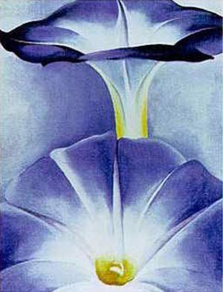 Blue Morning Glories (1935)
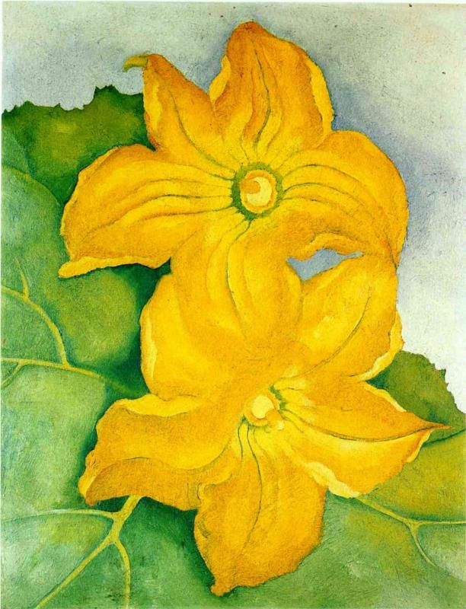
Squash blossoms 1925

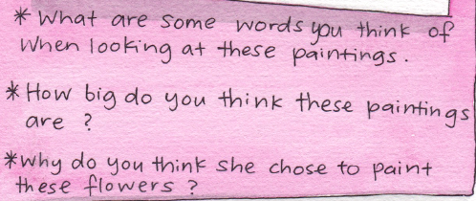

Now it’s your turn to create an enlarged floral drawing/painting inspired by your environment and the work of Georgia O’ Keefe.
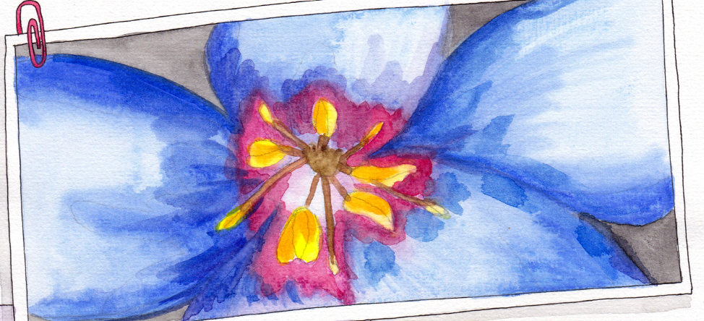
Instructions
- Pick a flower of your choice. You might find a flower in your garden or from the park (there are still some daisies and buttercups in the park. You could also use some clover or a dandelion or a flower from the hawthorn tree).
- Find the most interesting part and draw what you see onto your paper. Make sure you draw this part of the flower nice and big on your paper. Draw all the way to the edge.
- Add in any additional details (lines and dots…) if you see any.
- Colour your picture with paints, crayons, colouring pencils, whatever you have.

Procedural Reading in the Starlight book
We will read some procedures this week. A procedure tells the reader how to make something. It has a list of things and materials needed to make it, followed by a list of instructions.
- Read How to make a totem pole page 134 - 136 Starlight Bk
- Read How to Make a Fantastic Creature Kite page 140 – 142 Starlight Bk

English Spellings
This week, I would like you to pick 10 words from your spelling list and put those words into a sentence.
<al> , <au>, <aw>
- halt (to stop or pause)
- hawk (to drag something)
- sauce
- haul
- thaw
- salt
- flaw (a mark/a blemish/ a fault)
- drawn
- laundry
- dawdle
- already
- launch (take-off)
- auburn (a reddish brown colour hair)
- awkward
- alternative (different)
- audition
- altogether
- awesome
New Wave English
We finished at about page 24 in our New Wave English in school. You can continue on from there, doing one column/Day per day!
Gaeilge
This week in Irish, you will read page 68 and page 73 of your Léigh sa Bhaile. Below are two links for the audio of page 68 and 73. Listen to the audio and practice reading these pages aloud. You might decide to upload an audio onto seesaw of you reading one of these pages at the end of the week!
http://data.cjfallon.ie/audio/LeighsaBhaile-C-p68.mp3
http://data.cjfallon.ie/audio/LeighsaBhaile-C-p73.mp3

Maths homework
This week children, we will take a look at two pages only in chapter 26 of our Busy at Maths book: Division 3
Below you will find W.A.LT’s and links to tutorials for pages 137 – 138
- We Are Learning to understand division as equal sharing. You will solve simple sharing activities with remainders (page 137)
http://data.cjfallon.ie/resources/20684/BAM3_Tutorial_085/lessons/BAM3_Tutorial_085/index.html
- We Are Learning To understand division as repeated subtraction while working on remainders again (page 138)
http://data.cjfallon.ie/resources/20684/BAM3_Tutorial_086/lessons/BAM3_Tutorial_086/index.html

In your New Wave Mental Maths, you can continue on from where you finished off in school (we were on page 52), completing one column per day. So if you finished on a Thursday, continue on to the Friday Review. Try to complete the problems for each day also on whatever day you are doing.

