English Spellings
This week, I would like you to pick 10 words from your spelling list and put those words into a sentence. Write 2 sentences a day into your copies. I have given a meaning to some of the words that you might find difficult.
<y> for /i/
- abyss (a gigantic pit, too deep to be measured)
- myth
- lynx (a mammal in the cat family with soft, spotted fur, pointed ears, and a short tail)
- lyrics
- syrup
- idyllic
- pyramid
- symbol (an object or picture that represents something else, e.g The dove is a symbol of peace)
- cymbal (a percussion instrument that is round and made of metal)
- system
- Egypt
- typical
- syllable
- sympathy
- mystery
- rhythm
- acrylic (a kind of plastic used to make fibre, paint, and many other things.)
- physical

English Novel
This week we will focus on chapter 15 of your novel.
Read Chapter 12, 13, 14 and 15 of your novel The Lion the Witch and the Wardrobe
We will study chapter 15 this week: Deeper Magic from Before the Dawn of Time
Read this glossary of new vocabulary from chapter 15 and complete the vocabulary enrichment activity.
Vocabulary:
skirling making a high, shrill sound
vile disgusting
stead place
giddy causing dizziness slacking slowing

Vocabulary enrichment activity
Fill in the blanks with the words from the list above that make the most sense based on the story.

1. The whole __________ rabble ran past Susan and Lucy’s hiding place with wild cries and _______________ pipes and shrill horns.

2. Aslan told the girls that when a willing victim was killed in a traitor’s ______________, Death itself would start working backward.

3. The girls rode Aslan through wild orchards, past roaring waterfalls, up windy slopes, along _________ ridges, and down into wild valleys.

Comprehension – Answer the following questions based on Chapter 15.
1. What two things did Lucy notice after it seemed that hours had gone by?
2. What were the mice doing?
3. What sound did the girls hear, and then what did they see?
4. What had the Witch not known?
5. How did the girls feel after they had journeyed through Narnia on Aslan’s back?
7. When did they reach the Witch’s home?

Writing
In the novel, while the White Witch reigns, she imposes an enchanted winter on Narnia. Today we know that the seasons are caused by the earth's rotation around the sun! Make a list of five things that occur when winter comes and five things that occur for spring (i.e. list the signs of winter and spring in Ireland). Include some drawings in your list.

Maths homework
This week children, we will take a look at chapter 24 in our Maths book: Lines and Angles
Below you will find W.A.LT’s for pages 128 - 131.

- We Are Learning To identify vertical, horizontal and diagonal lines (page 128) (see definitions at the top of page 128)

- We Are Learning To identify parallel lines (page 129)
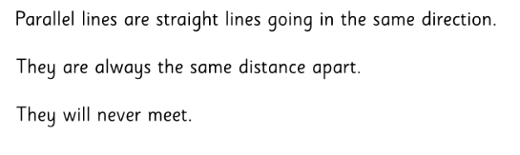

- We Are Learning To identify right angles
A right angle is the shape of a perfect corner, like the corner of a rectangular sheet of paper. Below are examples of right angles.
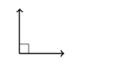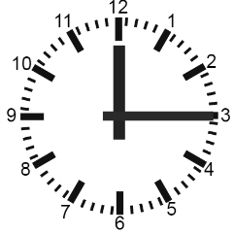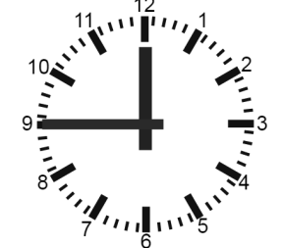

- We Are Learning To sort angles into those that are right angles and those that are not

Tables Learn $×$ 9
Irish homework
Téama: Éadaí
- Read the story Ar Maidin and answer the questions (questions and answers are in the past tense Inné, look at the grid on top of the questions) Nigh sí = she washed Bhain sí…di = she took off Chuir sí ...uirthi= she put…on.
- Write the poem Coc a Dúdal Dú in your copy and draw the picture
You can continue to read your Léigh sa Bhaile book this week children. Read page 49 -53.
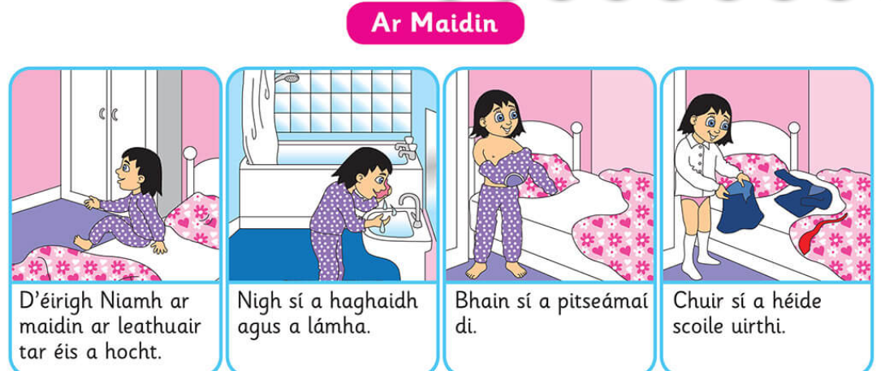
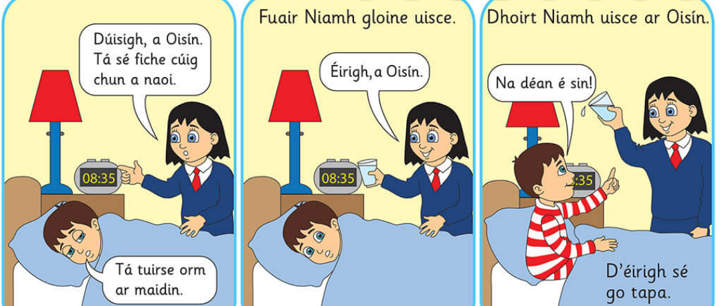

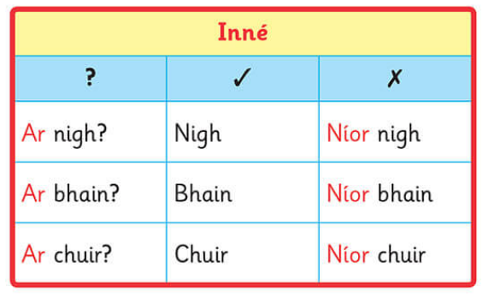
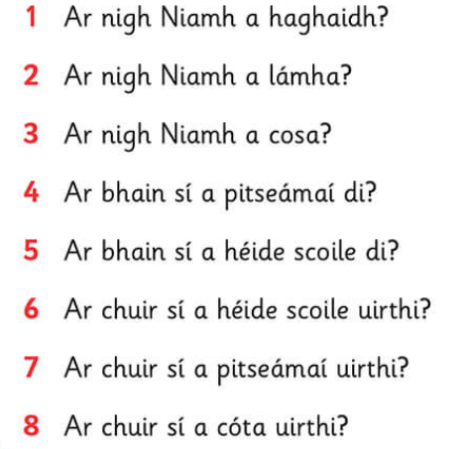

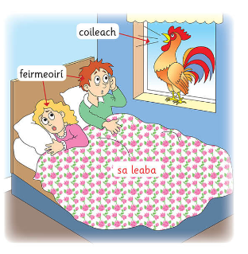
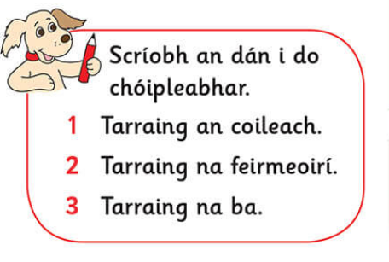

SPHE
Rainbow moments are all of those little moments during the day when good things happen. Maybe you played a fun game, watched a funny movie, created something interesting, had a nice lunch or dinner, noticed something beautiful in nature – there are lots of good things all around us, even at difficult times in our lives. We need to train our minds to notice the good things – our minds are already too good at noticing the bad stuff!
Write down three Rainbow Moments for the last 24 hours in the rainbow below.
Then try to do this every day for at least a week so that you get into the habit of noticing the good things. You can write these activities for the next five days on the following page.

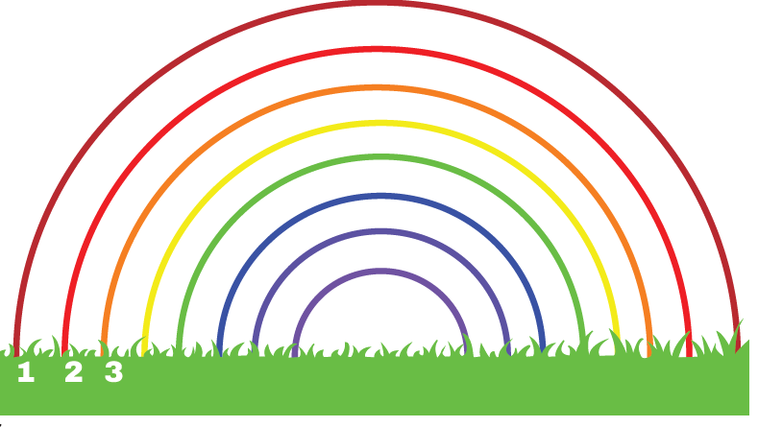

Art
Vincent Van Gogh was born in the Netherlands, but travelled across Europe. He went to France, Belgium and England. Van Gogh was interested in painters who were painting everyday life.
Earlier in his career, he used darker colours in his paintings. As he grew older, he liked using lighter colours. He used thick oil paint in his paintings to give his paintings texture.
We are going to take a look at one of his paintings The bedroom. We'll then work on drawing our very own bedroom just like he did.
Have fun drawing your room the way it is now! Or you can design your own dream bedroom. Add in cool stuff like a fun bed, a glittery wall, neon rainbows or hanging planets! The ideas are endless… Or you can even simply just draw your favourite things in your room!
The Bedroom 1889 by Vincent Van Gogh
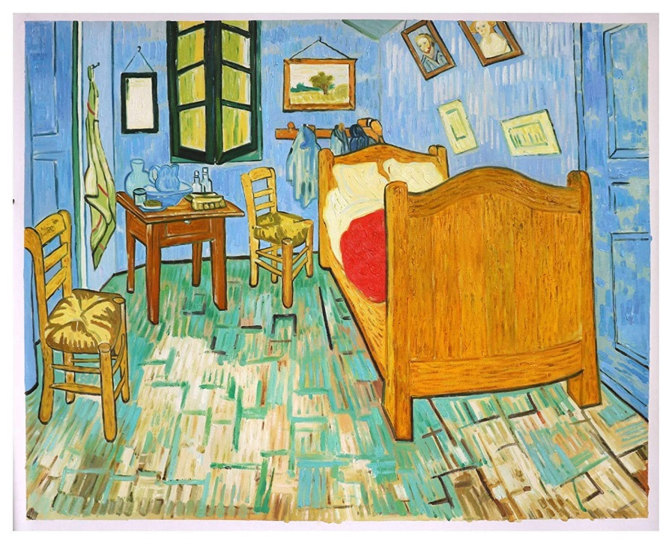

- Draw a rectangle in the middle of your page. Leave three fingers of a space from the edge of your page. Draw 4 lines from each corner of the rectangle to the corner edges of your page.

- Fill up the room with things you find in a bedroom (bed, window, wardrobe etc.). You can draw your bedroom as it is right now or you can draw your dream bedroom.
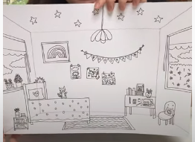
- Colour your bedroom. Use whatever colours you have at home!
