14th June 2020
Hello Children!
June 15th is the start of Active Week in LETS. So the focus for the week will be about being active at home with less formal work being given.
You are asked to complete a Challenge Chart this week. To do this you choose four activities a day, completing a total of 60 minutes of activity every day for the week. You might need some ideas to keep active for the week. With this in mind, here is a padlet link with ideas to keep you active. https://padlet.com/shaunagriffin27/a9htnk3sdmn3tc8q
You can keep track of your activities by filling in this challenge chart every day. I have posted the chart to Seesaw too. 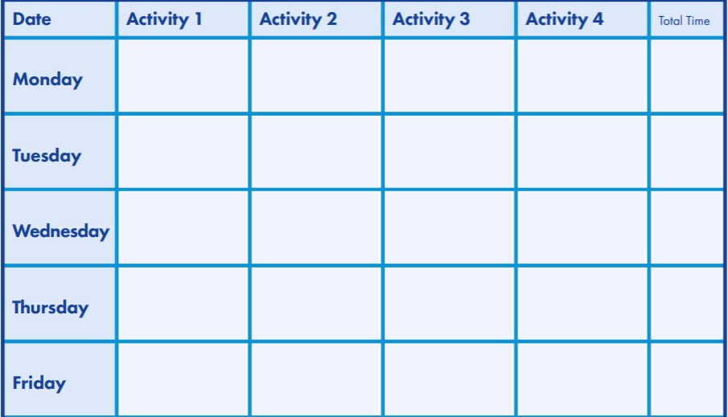
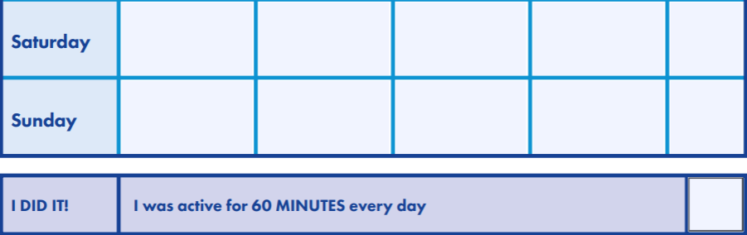
There will also be two Active Week related activities on the Seesaw App. So keep an eye out for those during the week!
Have an active and fun week everyone!
Deirdre
English Spellings
Pick 10 words from your spelling list and put those words into a sentence.
<ear>, <eer>, <ere>
- deer
- hear
- steer
- peer
- rear
- cheer
- here
- clear
- mere
- gearbox
- fearful
- sneering
- interfere
- dreary
- disappear
- smeary
- appearance
- atmosphere

Creative Writing
Fake News
Your task is to make up some fake news. You pretend to be a journalist. Make up an article for our 3rd Class Newspaper (Name yet to be decided). Whether it is a dinosaur walking by LETNS and popping into Super Valu or secret portals in Esker taking people to Minecraft world, you create a headline that will grab a reader’s attention. Write a paragraph detailing all the “facts” of your news report.
Write out your article, record yourself reading out your article and upload to Seesaw. The crazier the better! Are you up to the challenge newscaster? Can you keep a straight face during recording and maintain your professionalism?
Try and think of a name for our #FakeNews Newspaper!
Gaeilge
Bua na Cainte
Page 118 Bí ag scríobh
Page 119 Freagair na Ceisteanna
- Cé a chuaigh go dtí and siopa? = Who went to the shop?
- An ndeachaigh Mamó go dtí an siopa? Did Mamó go to the shop?
- Ar fhan Mamó sa bhaile = Did Mamó stay at home?
- Ar fhan Daidí sa bhaile = Did Dad stay at home?
- Cé a bhí i bhfeighil an tí? = Who was in charge of the house?
- Cé a scuab an t-urlár? = Who brushed the floor?

SPHE
The Parents Association are creating a newsletter to say thank you to your parents for all their support over the past few months. They need your help to put together the right words. Last week I gave an assignment on Seesaw for you to describe how you are grateful to your parents and family. If you did not get a chance to respond to that activity or did not see it, I am assigning another version of it here and I will put it on seesaw too. If you already responded last week, you don’t need to again. (Unless you want to)
So think about what you are grateful to your parents for! They have done so much to help and support you in your life but especially over the past few months of home-schooling.
As I said the newsletter is to say thank you to your parents for all their help and support to you over the past few months, and I will be sending your work to one of the teachers in our school who will then pass it on to the PTA to put together the newsletter.
1. What are you grateful to your parents for?
2. What have you enjoyed learning with your family?
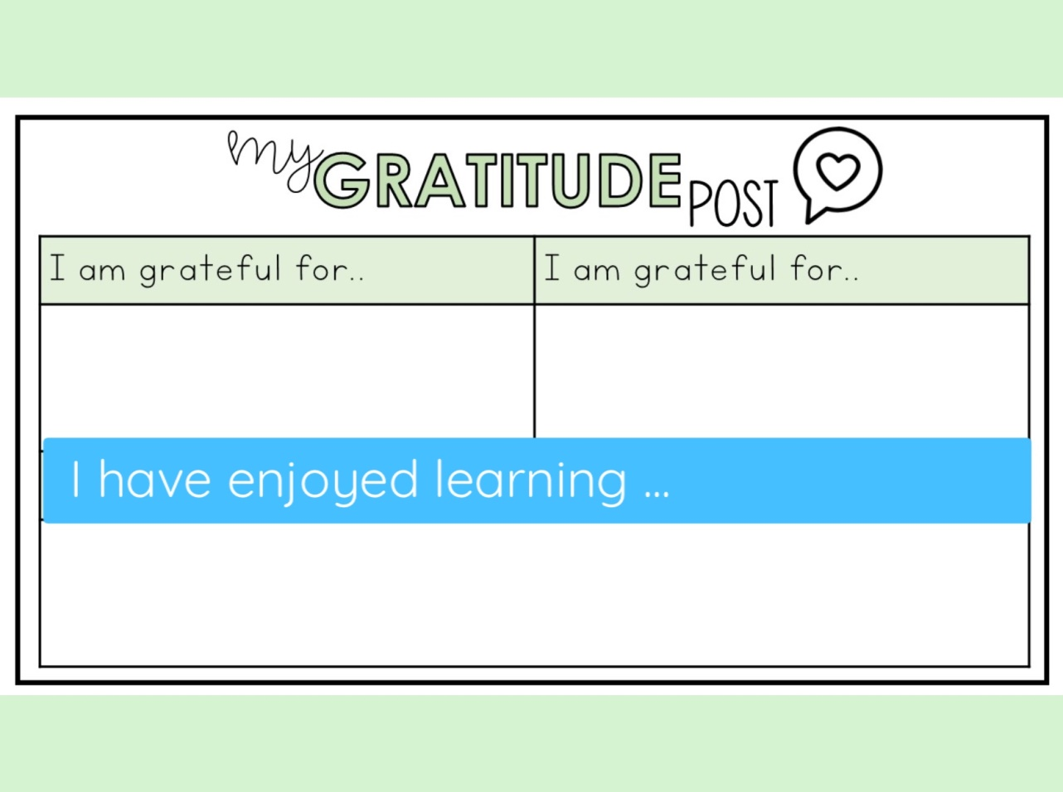

Busy at Maths
Complete Chapter 28 page 147 – 150
New Wave English and Maths
The focus this week is on being active children, but if anyone needs more bookwork, you can continue doing one column per day in your New Wave Maths and English (completely optional).

Run or Walk a marathon by the end of the school term!
Children and families walk/run a marathon in the last 3 weeks of school. It breaks down into different ways to successfully complete the 42km.

Activity Plan:
- 7 Days a week – need to cover 2km daily – shorter distances taken regularly over 3 weeks
- 5 Days a week – need to cover 2.8km (aim for 3km)* each activity day -
medium length distances taken regularly over 3 weeks
- 3 Days a week – need to cover 4.6km (aim for 5km)* each activity day
*you will exceed 42km
Check out this website!
https://www.sdcc.ie/en/services/sport-and-recreation/sports/sit-less-move-more/marathonfamilies/

