Hi Guys, I hope you’re enjoying creative fortnight. I’ve been doing some drawing and colouring myself. Here are some more creative ideas to make reading fun. Enjoy! Amanda

Creative week 2
Monday, 8th June | Tuesday, 9th June
Make a reading nook for yourself. Find a quiet place in your house. Fill it with comfortable things like cushions, beanbags, soft toys, pillows or a quilt. Maybe make a tent overhead with a sheet or a blanket. Put all your favourite books in there and maybe some illustrations on the wall. It should be a cosy and peaceful place to read. | Make a monster bookmark for yourself. Follow the link below for the instructions.  https://www.youtube.com/watch?v=GjQfNdJn-zk
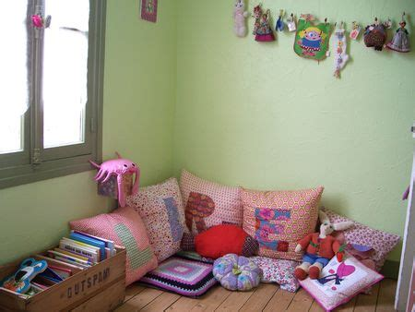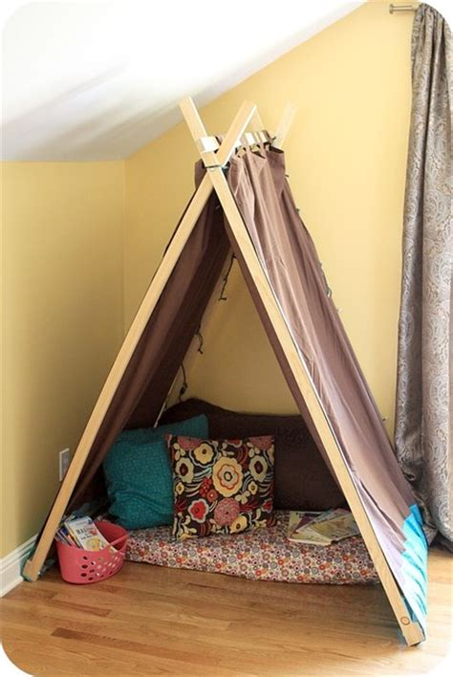 | 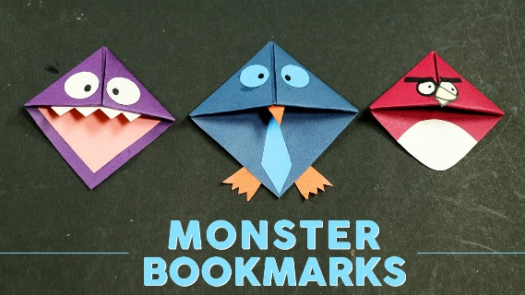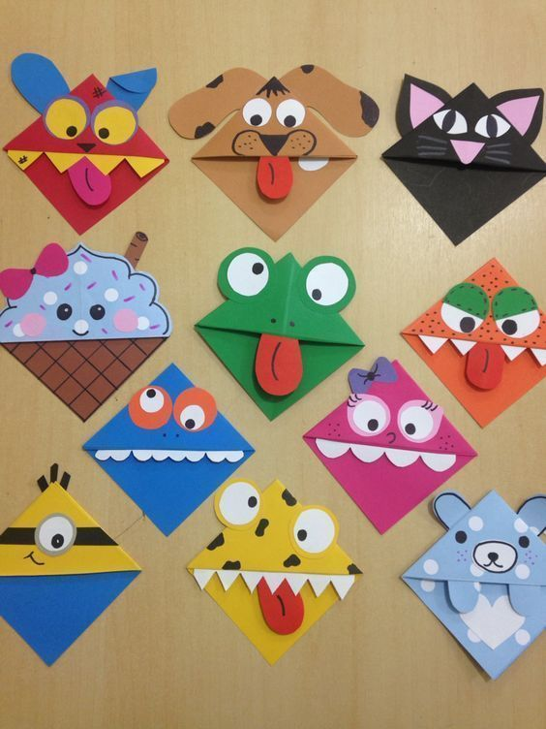

Wednesday, 10th June | Here’s my recreation of Little Women
Use photography to design or recreate a book cover for your favourite book.  Gather items that suit the story. Include yourself in the picture if you like.  Don’t forget to include the title and author | 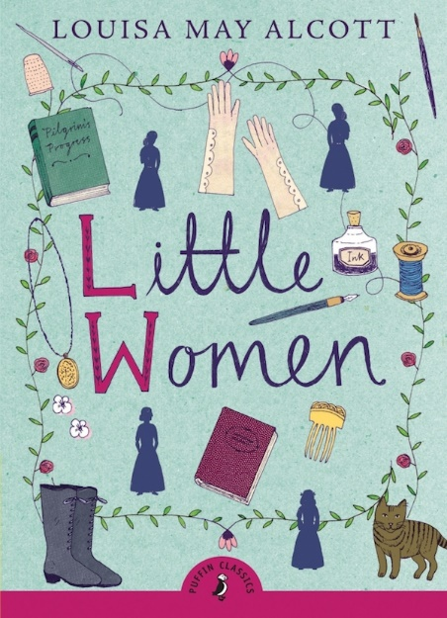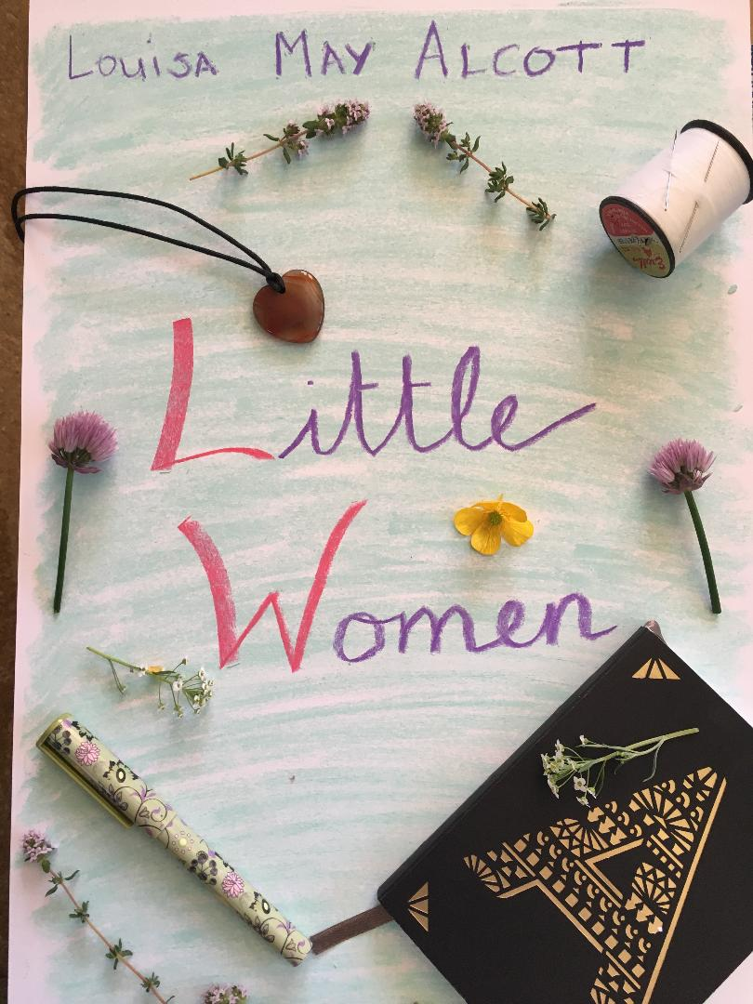

Thursday, 11th June

Draw a picture of a favourite book character. Maybe you could include some extras that say what your character is like. e.g. if your character has a pet or loves ice-cream put it in the picture.

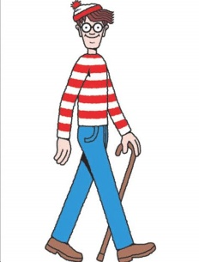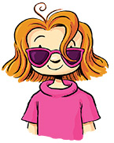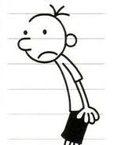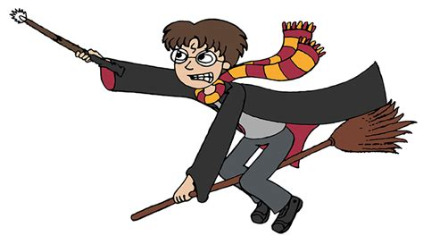

Friday, 12th June CREATE A GROWING BOOKSHELF

As you (or the whole family) read, add a drawing of the the book spine to your art display. Add to it throughout the Summer. See some examples below.

