Alternative Reading activities for Amanda’s group. Creative week 1

Hi Guys, here are some ideas to help you get creative with reading. They will help you to think about the words you are reading, how they sound and the pictures they create in your imagination. Amanda

Tuesday, 2nd June | Wednesday, 3rd June | Thursday, 4th June | Friday, 5th June
As you read your book write down the 10 most interesting words you come across. Use different writing and colours for each word to suit it. | Choose an abstract noun or emotion/feeling and make a picture/painting based around it. Choose colours, lines and shapes that the word reminds you of.  See explanation of abstract nouns and some art examples below. | Find a word in your book that conveys a sound or noise and make a spatter painting to illustrate it. If you don’t have paint you can use crayons, markers or colouring pencils in creative ways.  e.g. crash, bang, whimper, explode | Make a collage or all your favourite words or interesting words you’ve come across lately. Be as creative as you can with colour and layout.

An abstract noun is a noun that refers to a concept such as an emotion, a feeling, a quality, or an idea. In other words, an abstract noun is not a physical object.

SOME ABSTRACT NOUNS – hope, love, fear, gratitude, jealousy, bravery, democracy, strength, health, beauty, freedom.

Look for some more online yourself.

Here are some examples of abstract noun pictures.

HOPE

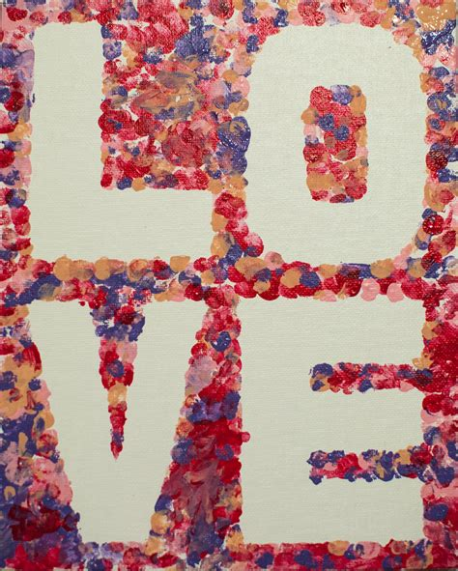
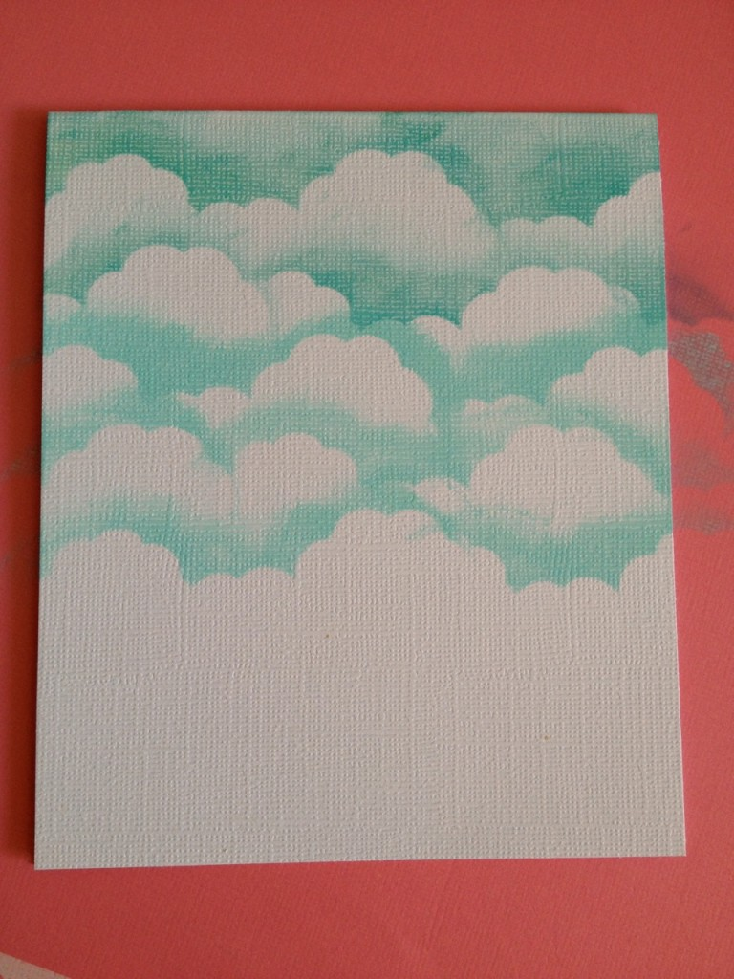
SILENCE

