Food From Around the World
In English, we are learning about “All Types of Food”. There are children of many nationalities in our class . Please teach us about your native foods. This will allow us to compare and contrast the type of food/cooking in different countries.

Perhaps you could upload a video/Photo of your food on Seesaw:
Name of food: ______________________
Where did the food originally come from? _______________________
Describe your food? (Is it spicy/bitter/sweet ?) _______________________
Please colour in the location(s) of where your food is from:

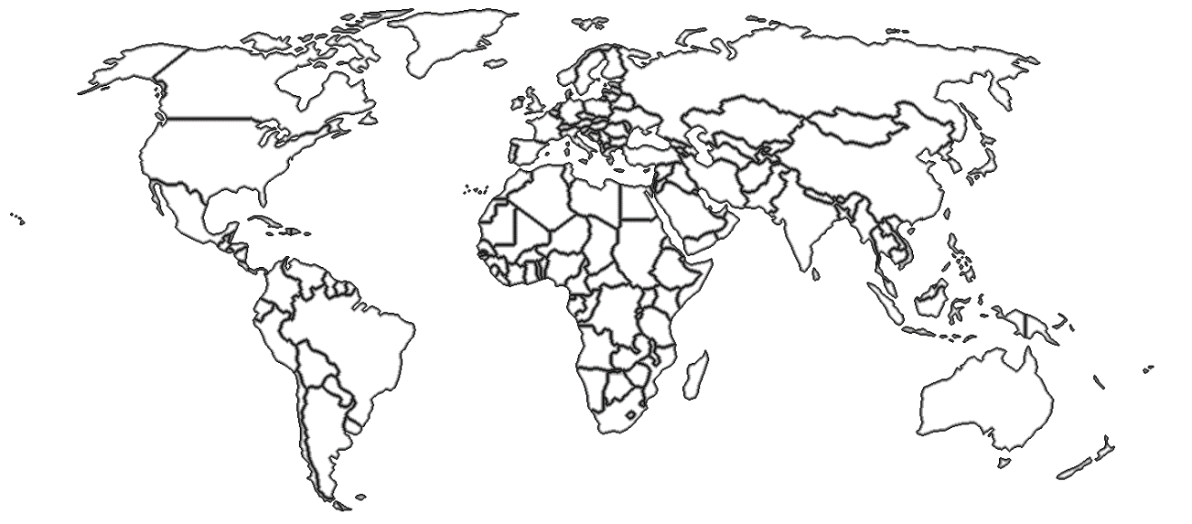

Please draw or print a picture of your food below:

Plan a procedure on how to make your food:

Title: How to make………

Equipment:

Ingredients:

Step 1. First ….

Step 2: Next, …..

Step 3: Then…..

Step 4: After that…..

Step 5: Finally, …..

Please return your project by Thursday 28th of May.

