Section One - Daily Work (Please remember to keep up your reading everyday)
Tuesday  2.6.2020 | - SESE: Read An Taisce’s biodiversity booklet https://www.antaisce.org/sites/antaisce.org/files/natures_way_pollinators_2011.pdf (PDF attached) Answer the following questions based on Part 1: What is Pollination? in your copybook.  - What is pollination?  - Is pollen spread by the wind or by insects?  - Can you name some pollinators found in Ireland?  - Work on your memory book: If you like you can begin by writing a short introduction, your name, age, the date and the purpose of your memory book. Decorate the front cover or the front page.
Wednesday  3.6.2020 | - SESE: Read An Taisce’s biodiversity booklet https://www.antaisce.org/sites/antaisce.org/files/natures_way_pollinators_2011.pdf (PDF attached) Answer the following questions based on Part 2: Who are the Pollinators? in your copybook  - How many species of bee are found in Ireland?  - What is the most important bee in a bumblebee colony called?  - What type of bee produces honey?  - Where do solitary bees build their nests?  - How can you tell a hoverfly from a bee?  - What sugary treat would we not have without pollinating midges?  - Work on your memory book: Today maybe add a timeline of your years in primary school, what year did you start in, who was your teacher each year, did you change schools along the way, did any new children join your class and in which years, did any children leave your class along the way and in which years?
Thursday  3.6.2020 | - SESE: Read An Taisce’s biodiversity booklet https://www.antaisce.org/sites/antaisce.org/files/natures_way_pollinators_2011.pdf (PDF attached) Answer the following questions based on Part 3: Why do we need them? and Part 4: Threats/Reasons for decline in your copybook  - Why do we need pollinators?  - List 4 reasons for the decline in our pollinator species.  - What activities can threaten pollinating creatures?  - List 4 ways we can try to attract bees and other pollinators.  - Work on your memory book: How about writing about your time in junior and senior infants? Perhaps your parents can help you out with a memory of your first day at school. Which classmates do you recall form your first days in school? Can you recall any funny details from these years? Where did you go on your school tours? What was your favourite activity during these years? Do you recall any assemblies or Winter Wonderland performances? Add some photos if you have them.
Friday  4.6.2020 | - Record your 15 second skills and talents video in landscape and upload to Seesaw or email to us at ruthandcatriona@letns.org.  - Remember to post one piece of work or an activity to the class blog this week!  - Work on your memory book: What about 1st and 2nd class? Do you remember any of your birthday parties with your classmates? Do you have any artwork from these years you can add to your memory book? Remember to add in photos. Where there any special occasions in these years? What were your favourite toys to bring into school for golden time?

Section Two – Menu of Activities
Language | Numeracy | Be Creative! | Help at home | Miscellaneous!!
Write an email or letter to the Mayor of South Dublin, Vicki Casserly, asking her and South Dublin County Council to support pollinating insects. Could she help ensure our parks and roundabouts have more areas of wild grass and flowers? Can the county council use less weed killers and pesticides?  Use what you have learned about writing a persuasive letter.  Remember to write in the present tense, use emotive adjectives and adverbs, include facts and show your belief in your argument.  Address:  c/o SDCC, County Hall Tallaght  E-Mail:  vcasserly@cllrs.sdublincoco.ie  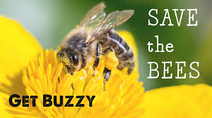 | Data  During the day and on your daily walks or cycles try to make note of how many pollinating insects you see and where they are more abundant. These can be butterflies, moths, flies, hoverflies or bees. Record these numbers over the week. Is there a place or places where you noticed was more popular for pollinators? Why was that do you think?  If you want to get more involved with monitoring bumblebee populations, see the link below  https://www.biodiversityireland.ie/projects/monitoring-scheme-initiatives/bumblebee-monitoring-scheme/get-involved/ | Have you seen this?  https://www.youtube.com/watch?v=hqIbEHNqbPs  Wes Tank raps the Dr Seuss book ‘Fox in socks’. Can you create a rap using a book you have at home? | Ask your mum and dad what else you could do to take responsibility and help out more at home. Tell your mum and dad you want to take responsibility and do two extra jobs around your house and they get to choose what the jobs are! | Make a speaker for your phone/your parent’s phone  You will need:  A kitchen roll insert  Two plastic (disposable) cups  A scissors  A mobile phone.  Lie the kitchen roll insert on the table so it is lying long ways. See pictures below.  Hold the mobile phone upright on the uppermost surface and draw the width of the phone onto the carboard tube.  Use your scissors to cut along the line you drew and a short line perpendicular to it on either end.  Hold the circular face of the kichen roll insert to the side of one of the plastic cups and draw around it onto the cup.  Cut this circular shape out of the cup.  Repeat with the other cup.  Fit one end of the insert into one of the holes cut into the cup, repeat with the other end of the insert.  Fit your phone into the cut you made in the centre of the insert.  Play your favourite song and listen to your amplified music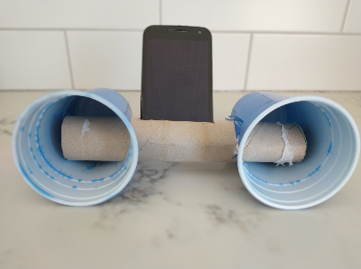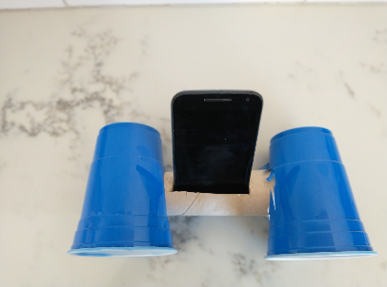
 | 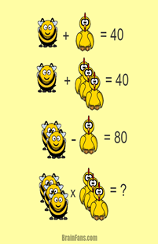  Can you work out the value of the bee and the chicken? | Marbling (Caution messy! Cover the surfaces you use before you begin)  You need:  An A4 sheet cut into quarters  A large plastic tub or basin half filled with water  Marbling paints or nail varnishes  Pour paints or nail varnishes on to the top of the water in your tub. They should float on the surface.  If you wish you can drag a toothpick or thin stick through the water to move the colours into each other.  Lie your piece of paper on the surface of the water.  When you lift it up the paints or varnishes should have transferred to the surface of the paper.  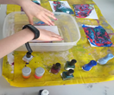 | Clean the fridge  Remove items from the fridge one shelf at a time. With a damp cloth wipe the shelf down and then return items again. When one shelf is finished, empty and clean the next shelf.
https://www.loc.gov/item/webcast-9171/  The ‘Write. Right. Rite’ series: Listen to Jason Reynolds, the US National Ambassador for Young People’s Literature. In the video featured he challenges you to create a very special recipe. |  | Make a homemade harmonica  You will need:  2 lollipop sticks/2 small nail cardboard files  2 elastic bands  1 piece of paper  Pen and scissors  1 toothpick or thin stick cut in half  Trace around one of your lollipop sticks and cut the shape out of your piece of paper. (ours is in green in the picture)  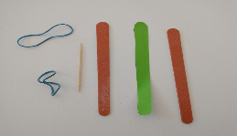  Place the piece of paper on top of one of the lollipop sticks and put the other lollipop stick on top of the paper.  Secure the three layers together at one end with an elastic band.  Slide one half of the toothpick between the bottom lollipop stick and the paper close to the elastic band.  Place the second half of the toothpick between the bottom lollipop stick and the paper close to the other end.  Secure the three layers with the second elastic band.  Trim the edges of the toothpick close to the lollipop sticks. (Make sure to cut the pointy parts off)  To play your new harmonica put your mouth to the side of it, as pictured just below, and blow.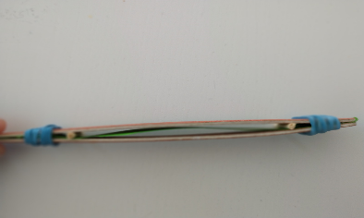  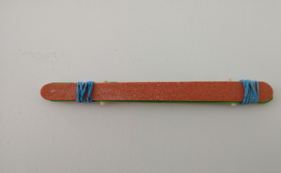 | Help to plan the meals for the next week with mum and dad. Make a list of the meals beside each day of the week.  Check your presses and fridge to see what foods you have to make the meals on your plan.  Once that is done help to write the shopping list for the foods you need buy for the week ahead. | Ciaran Kilkenny, a Dublin footballer, has been giving coaching sessions on twitter. See the video in the link below and get practicing!  https://twitter.com/i/status/1249642975476551680
Sometimes the most interesting and enjoyable stories are the ones people tell us.  Ask an adult to tell you about your early days at school. Write it in your memory book  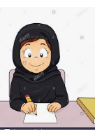 | 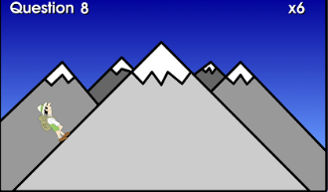  Why not practice your times tables at  https://teachingtables.co.uk/  You decide whether you want to do a steady climb up the mountain or if you’re feeling brave enough you can take the table Mountain Challenge but be careful a single mistake sends you right back to the very bottom!! |  |  | Oti Mabuse, from Strictly Come Dancing, has lots of dance tutorials on her you tube channel.  Try this one from The Greatest Showman:  https://www.youtube.com/watch?v=EJmpCH9p2X8
Gaeilge: Tune in to a 5th/6th class Gaeilge lesson on The Home School Hub at 11.00 am on RTÉ 2. You can also catch it at a later time on  https://www.rte.ie/player/ |  |  | Clean up after a meal. Put dishes in the dishwasher. Wash and dry the pots and pans.
For further activities and ideas please see https://padlet.com/graceflaherty/8drns09sw823gr9p

Section three: Creative Project
For this project you will be creating a bug motel. This is a manmade structure that can provide shelter for insects. They can come in a variety of shapes and sizes. Many are used as nesting sites for solitary bees. These are bees that do not live in a hive with a queen and they make up a lot of our native bee species. There are a number of reasons why bees and other pollinators are so important to our landscape and crops but unfortunately 1/3 of our bee species are under threat.
https://padlet.com/ruth_mullins/ct4wsqchzd3b
We have linked a padlet above which contains various different videos and websites which demonstrate how to create your very own bug motel. Some can be made with natural materials you would find in your garden or on a walk, some can be made with recyclables and some are for the more DIY able. Remember you need to have adult supervision when using any tools! One of the sites on the padlet tells you what different insects like and dislike in their bug motels and another tells you where is best to place your bug motel when it is built.
Due Date: Friday 12th June
To complete your project:
- Take a picture or video clip of your bug motel
- Write or type up a procedure to show how you made your bug motel. See the example procedure attached to this email
- Remember to include a title, a list of materials used and a list of step by step instructions. Tip: remember to use imperative (bossy) verbs (cut, roll, stick, etc), to write in the present tense and to number your steps or use chronological language (first, next, then, finally, etc)
- Upload both to Seesaw or email to us at ruthandcatriona@letns.org
We will reply with some feedback. Best of luck and know that the pollinators of Ireland thank you!

