Section One - Daily Work (Please remember to keep up your reading everyday)
Monday  25.5.2020 | - New Wave Maths – Monday & Monday Problem  - Busy at Maths - Fraction/Decimals and Percentages 3 pg. 132 q 1 a+b, q2a-c, q3  http://data.cjfallon.ie/resources/20714/BAM6_Tutorial_078/lessons/BAM6_Tutorial_078/index.html  http://data.cjfallon.ie/resources/20714/BAM6_Tutorial_079/lessons/BAM6_Tutorial_079/index.html  - New Wave English – Day 114  - English - Starlight read pg. 182 Read the poem and answer the questions in your copy, p 183 Section A choose 3 Section B choose 3.  - Word of the Day: inventing (Write out definition and put it into a sentence) https://kids.wordsmyth.net/we/  - Gaeilge- Seomra na Ríomhairí, Sin E lch 124: Léigh an scéal agus freagair na ceisteanna uimhir 1- 3.  - Dialann: scríobh 5/6 abairtí, úsaid an aimsir caite agus an aimsir fháistineach. Write 5/6 sentences using past and future tenses. Please make an effort to use a selection of new verbs
Tuesday  26.5.2020 | - New Wave Maths – Tuesday & Tuesday Problem  - Busy at Maths - Fraction/Decimals and Percentages 3 pg. 133 q 1 a, b, c, d, q 2 (a, b, c)  http://data.cjfallon.ie/resources/20714/BAM6_Tutorial_080/lessons/BAM6_Tutorial_080/index.html  http://data.cjfallon.ie/resources/20714/BAM6_Tutorial_081/lessons/BAM6_Tutorial_081/index.html  - New Wave English – Day 115  - English – Starlight reread pg. 182 , pg. 183 Section C Vocabulary and pg. 184 Section D Vocabulary  - Word of the Day: railings (Write out definition and put it into a sentence) https://kids.wordsmyth.net/we/  - Gaeilge – Seomra na Ríomhairí, Sin E lch 124: Léigh an scéal agus freagair na ceisteanna uimhir 4-6  - Dialann: scríobh 5/6 abairtí, úsaid an aimsir caite agus an aimsir fháistineach. Write 5/6 sentences using past and future tenses. Please make an effort to use a selection of new verbs
Wednesday  27.5.2020 | - New Wave Maths – Wednesday & Wednesday Problem  - Busy at Maths - Fraction/Decimals and Percentages 3 pg. 134 q1 a, b, c ,d, q2 a, b, c  http://data.cjfallon.ie/resources/20714/BAM6_Tutorial_082/lessons/BAM6_Tutorial_082/index.html  http://data.cjfallon.ie/resources/20714/BAM6_Tutorial_083/lessons/BAM6_Tutorial_083/index.html  http://data.cjfallon.ie/resources/20714/BAM6_Tutorial_084/lessons/BAM6_Tutorial_084/index.html  - New Wave English – Day 116  - English – Starlight pg. 184 Section E Grammar: Subject and predicate  - Word of the Day: sewn (Write out definition and put it into a sentence) https://kids.wordsmyth.net/we/  - Gaeilge – Na Briathra Neamhrialta: Ith - no. 1-5 Scríobh amach na freagraí í do chóipleabhar (Write the answers in your copy)  - Dialann: scríobh 5/6 abairtí, úsaid an aimsir caite agus an aimsir fháistineach. Write 5/6 sentences using past and future tenses. Please make an effort to use a selection of new verbs
Thursday  28.5.2020 | - New Wave Maths – Thursday & Thursday Problem  - Busy at Maths Fraction/Decimals and Percentages 3 pg. 135 q 1 and 2 choose any 8 parts to do  - New Wave English – Day 117  - English – Starlight pg.185 Section F Writing Skills: Mind Mapping Ideas  - Word of the Day: uniform (Write out definition and put it into a sentence)https://kids.wordsmyth.net/we/  - Gaeilge - Na Briathra Neamhrialta: Clois - no. 1-5 Scríobh amach na freagraí í do chóipleabhar (Write the answers in your copy)  - Dialann: scríobh 5/6 abairtí, úsaid an aimsir caite agus an aimsir fháistineach. Write 5/6 sentences using past and future tenses. Please make an effort to use a selection of new verbs
Friday  29.5.2020 | - New Wave Maths – Friday Review  - Busy at Maths - Fraction/Decimals and Percentages 3 pg. 136 q 1 a, b, c, d, q 2 a, b, c, d,  - New Wave English Day 118  - English - Starlight pg. 185 Section G Writing Genre: Mind Mapping a Poem  - Seanfhocal don seachtain: ‘Nil aon tinteán mar do thinteán féín’ There’s no place like home. Draw a picture that illustrates this seanfhocal and put it up on Seesaw.  - Dialann: scríobh 5/6 abairtí, úsaid an aimsir caite agus an aimsir fháistineach. Write 5/6 sentences using past and future tenses. Please make an effort to use a selection of new verbs  - Remember to post one piece of work to the class blog!
Links for New Wave Maths and New Wave English corrections | https://www.prim-ed.ie/contentfiles/41636_NWMM_TM_6th_Class.pdf New Wave Maths 6th class  https://www.prim-ed.ie/contentfiles/41650_NWEIP_TG_6th_Class.pdf New Wave English 6th class

Section Two – Menu of Activities
Language | Numeracy | Be Creative! | Help at home | Miscellaneous!!
https://www.librariesireland.ie/news/online-services-during-coronavirus  Use this link to ‘virtually go’ to your local library. Here you can read a magazine, borrow a book, do an on-line course or check out an audio book.  You do have to log in with an e-mail but everything is absolutely free. | Why not do the daily 10 Mental Maths Challenge. Choose the level that suits you.  https://www.topmarks.co.uk/maths-games/daily10 | Circle Art  Why not do your own ‘circle art’ picture. You could use a compass or different circular items you have a home to draw the circles. Make sure you use at least three different size circles and remember to interlink them. Then colour all the sections in various colours. See below for an example.  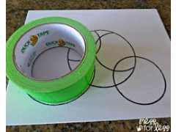  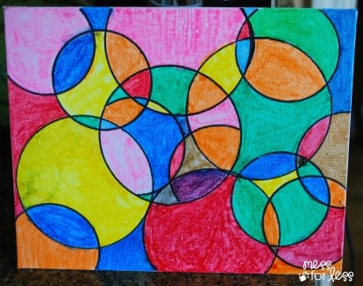 | 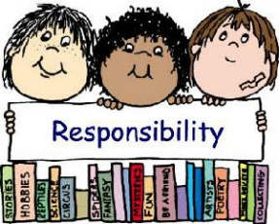  Rule for the month of May is Taking Responsibility for our environment and for our Actions too!  Ask your mum and dad what else you could do to take responsibility and help out more at home. Tell your mum and dad you want to take responsibility and do two extra jobs around your house and they get to choose what the jobs are! | This is a special year for the International Space Station. This is the 20th year of astronauts living and working there. The first three moved in on Nov. 2, 2000, and lived and worked there for almost five months. Since then, more than 200 people have visited the station. Click on the link to find out who is on the space station today.  https://www.nasa.gov/specials/kidsclub/nowinspace/expedition63/index.html
Create your own comic strip by visiting  https://www.storyboardthat.com/storyboard-creator | Try this coding game  https://blockly.games/ | Match the rhythm and become the rhythm master on  https://www.classicsforkids.com/games/rhythm_master.php | Make some Pancakes for your family (only under adult supervision)  Ingredients  250g of flour  2 eggs  600ml milk  Pinch of salt  Oil for frying  Method:  1. Sieve the flour and salt into the bowl.  2. Make a well in the centre of the flour and break in the two eggs and add about one third of the milk  3. Beat well with a whisk, gradually pouring in the rest of the milk  4. Pour batter into a jug and leave to stand for 30 mins.  5. Put oil on the pan and when it is hot stir your batter. Then pour a thin layer of batter onto your pan.  6. Fry until golden brown, turn and fry the other side also.  7. Serve with toppings of your choice!  8. Enjoy!!  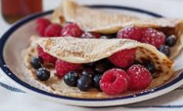 | RTE 10@10  Why not look back and join in for some exercises on RTE 10@10.
Listen to the Lego Story on  https://www.literacyshed.com/legostory.html  Create an advertisement for one of the early toys in the story. Put a photo of your advertisement up on Seesaw. | 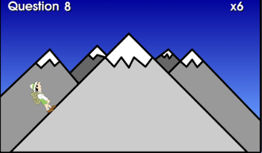  Why not practice your times tables at  https://teachingtables.co.uk/  You decide whether you want to do a steady climb up the mountain or if you’re feeling brave enough you can take the table Mountain Challenge but be careful a single mistake sends you right back to the very bottom!! |  |  | Mindfulness  Slow Down and Calm Down 5, 4, 3, 2, 1,  First off take three slow and quiet deep breaths  5. List 5 things you can see  4. List 4 things you can hear  3. List 3 things you can feel  2. List 2 things you can smell  1. List something positive about yourself  Finished now? Take three more slow and quiet deep breaths.
Sometimes the most interesting and enjoyable stories are the ones people tell us.  Ask an adult to tell you a story from when they were young. Remember this can be done over the phone or video conferencing if you can’t visit them right now. Write the story down to record it. You could add pictures and show it to them the next time you see them.  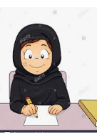 | Why not impress your family and friends with this cool maths trick….  Step 1: Think of a number  Step 2:Multiply it by 3  Step 3: Add 6  Step 4: Divide by 3  Step 5: Subtract the number chosen in Step 1 from your answer in step 4.  And the answer is  Try a few different numbers, the answer is always 2!!! | 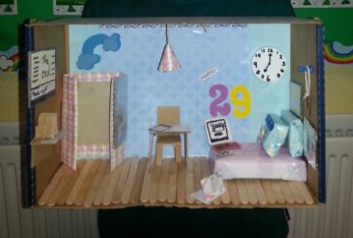  Design and make your own shoebox diorama of your ideal bedroom i.e. a 3D version of your dream bedroom.  You will need a shoebox, other pieces of cardboard, paper, scissors, glue. You could also use old pieces of material to make your curtains etc.  See above for an idea of what it might look like. | Help to clean out a press in the kitchen. Take everything out of the press, clean the shelves, put all the items back so that everything is tidy and in the right place!  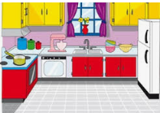 | Kicking Challenge- GAA  Stand three metres away from a wall and attempt to kick the ball against the wall as many times as possible in 30 seconds. To increase the difficulty  -use both feet  - use two balls – one in each hand  Good Luck!
Gaeilge: Tune in to a 5th/6th class Gaeilge lesson on The Home School Hub at 11.00 am on RTÉ 2. You can also catch it at a later time on  https://www.rte.ie/player/ | How long can you make an a4 sheet? Using an a4 sheet of paper some scissors and some sellotape see how long you can make an a4 sheet. | 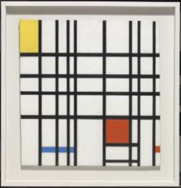  Famous Artists  https://www.tate.org.uk/kids/explore/whos-who  Why not take some time and explore some famous artists and their amazing artworks |  | Check out your knowledge on mini-beasts. Look at the ant and the bee and the ladybird in detail.  COOL 360˙ VIEWS OF EACH MINI BEAST.  https://education.abc.net.au/minibeast-games/
For further activities and ideas please see https://padlet.com/catmstokes/ok6zkpyog3in

Section three: Geography Project
For this project you will be choosing one natural or man-made feature from around the world and complete a PowerPoint presentation on it. Your presentation should not exceed 10 slides and the focus should be on putting the most important information into your own words. Here is a list of suggested areas to look at. (Cover each area in one/two slides):
- Location – What country
- When was it built/discovered
- Why is it famous
- How has it changed over the years
- What are its most popular features/attractions
- Is it open to the public to visit
- Interesting facts about the natural/man made feature
- Short quiz on what you have covered
- Pictures Slide

To give you some inspiration here is a link to two videos. The first is on the Seven Wonders of the Modern World and the second is on twenty two of the world’s finest natural features.
- https://www.youtube.com/watch?v=_00CC7BIHhg Examples of Man-made features
- https://www.youtube.com/watch?v=w7VbIXBCMbA Examples of Natural Features

You can complete PowerPoint presentation (No longer than 10 slides). Again the focus here is on the most interesting information to keep those listening interested. Try to label all of your pictures and link audio files and videos to your PowerPoint.
The following are some helpful links that may help you in your research.
- https://www.dkfindout.com/uk/
- https://www.kiddle.co/
- https://www.alarms.org/kidrex/
- https://kids.nationalgeographic.com/search-results/

Due Date: Friday 29th May
You can email an attachment of the PowerPoint to us at ruthandcatriona@letns.org or feel free to record yourself presenting the project and upload it to Seesaw. We will reply with some feedback. Best of luck!

