Suggested Table of Work - 4th Class - 30/03/20-03/04/20

 | Monday | Tuesday | Wednesday | Thursday | Friday
Date: | 30/03/20 | 31/03/20 | 01/04/20 | 02/04/20 | 03/04/20
New Wave  Mental Maths - continue  Next Week | Monday and Problem from problem solving section from this week | Tuesday and Problem from problem solving section from this week | Wednesday  and Problem from problem solving section from this week | Thursday  and Problem from problem solving section from this week | Friday Review
New Wave English – continue with the next week | Monday  Questions  1-15 | Tuesday  Questions  1-15 | Wednesday  Questions 1-15 | Thursday  Questions 1-15
Léigh Sa Bhaile | Lch 86  An Cháisc  Read the story. Do q 1 & 2 in your copy. | Lch 86.  Read the story again  Do q 3, 4 & 5  in your copy | Lch 87  Ócádí Speisialta Read the story. Do q 1 & 2 | Lch 88.  Read the story again and do questions 3, 4, 5
Bua Na Cainte  (available free to download if you wish instructions below lots of games, stories, songs etc.) | Ócadí Speisialta – An Cháisc  Ceacht 1 Listen and read along  Cómhrá 1.1.  (see instructions below) | Tasc Tuisceanna  Scríobh an Scéal (can be find by clicking the controller icon)  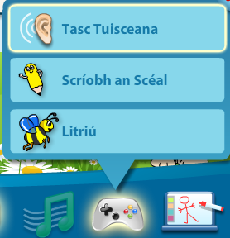 | Ócadí Speisialta – An Cháisc  Ceacht 1 Listen and read along  Cómhrá 1.2. | Ócadí Speisialta – An Cháisc  Ceacht 2 Listen and read along | Games and challenges click on controller icon
Starlight page 176  It’s Your Environment, so Get Involved! | Read the story on pages 176-178  Write out full answers in your copy A.(1-5) | Read the story on pages 176-178  Write out full answers in your copy B.(1-5) | Complete the vocabulary challenge C on page 179 | Chose the most suitable word to compete each sentences D on page 180 | Write sentences using the words preserving  ultimately  council  encourage  hollow  ensure
English Spellings  See below | Learn 3 spellings from spellings list | Learn 3 spellings from spellings list | Learn 3 spellings from spellings list | Learn 4 spellings from spellings list | Spelling Test
Litriú  See below | Learn two spellings and one sentence  Practice saying the sentences out loud | Learn two spellings and one sentence | Learn two spellings and one sentence | Learn one spelling and one sentence | Litriú test
Tables | Revise x2 x4 x8 |  |  |  | Tables Test

Challenge Activities
- Bright Sparks Creative Writing Bursts Number 1 . Creative writing burst are created by Sarah Webb, a famous author and supported by MoLI (Museum of Literature Ireland). To get lost in a Creative Burst all you need is a pencil or pen and a notebook or piece of paper. The writing games and prompts are aimed at around age 9+ Included are some more challenging story prompts for older or more experienced writers of around 11+ Download the resources or watch the video.
Go to: https://moli.ie/bright-sparks-creative-bursts/bright-sparks-creative-bursts-1-lets-play-with-words/

- Easter Rabbit Art: Go to https://www.teachstarter.com/au/teaching-resource/fun-easter-bunny-craft-template/ Look at the video and draw the rabbit outline yourself on paper , no need to purchase anything.
- Scratch: Scratch is a free online resource that teaches children coding skills at an age-appropriate level. With Scratch you can program your own interactive stories, games and animations. Scratch helps young people to think creatively and reason systematically.

Spellings 30th March – 3rd April 2020. ‘Words with ‘nd’
 | Gaeilge | Volga | Nile
1 | Domhnach Cásca Easter Sunday | splendid | absentminded
2 | laethanta saoire holidays | endeavour | ponder
3 | faigheann siad they get | candle | beforehand
4 | uibheacha Cásca Easter eggs | mindful | commander
5 | lán de sheacláid full of chocolate | island | battleground
6 |  | School friend | comprehend
7 |  | mend | abandon
8 |  | blender | bandages
9 |  | anaconda | anaconda
10 |  | bandage | pandemonium
- Domhnach Cásca atá ann. It is Easter Sunday
- Bíonn laethanta saoire ó na páistí ón scoil. The children are on holidays from school
- Faigheann na páistí uibheacha Cásca. The children get Easter Eggs
- Bíonn na páistí ag súil go mór leis an gCáisc. The children are really looking forward to Easter!

BUA NA CAINTE – INSTRUCTIONS

To access Bua na Cainte’s interactive programme at home, for a limited period, please follow the instructions below.
1. Go to www.edco.ie/bua
2. Select the file which suits your computer PC or MAC
3. Select the Class Level you require, and then click on it to start the download.
4. Once the download has completed, click on the file to install and follow the on-screen instructions.
5. A Bua na Cainte icon will appear on your desktop. Once you select this icon a login page will open where you will need to enter the details included below. The login details below can be used for all class levels. Login: trial Password: trial
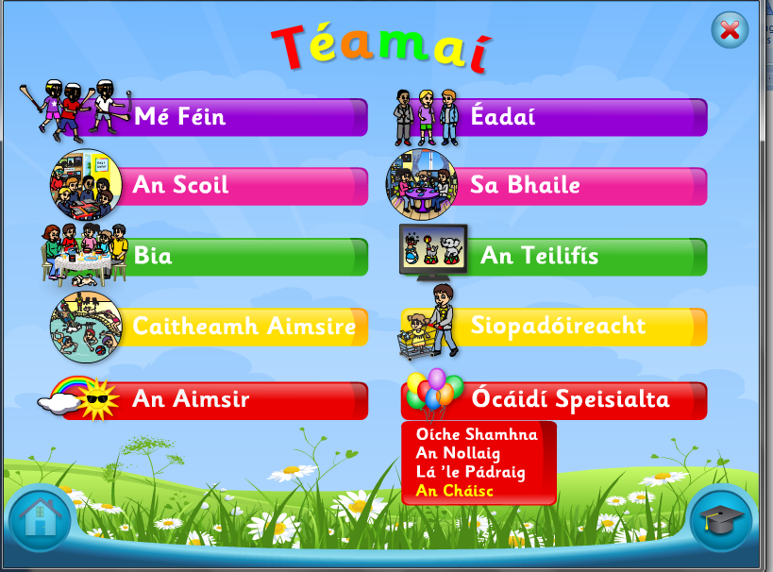
Click on ócáidí speisialta
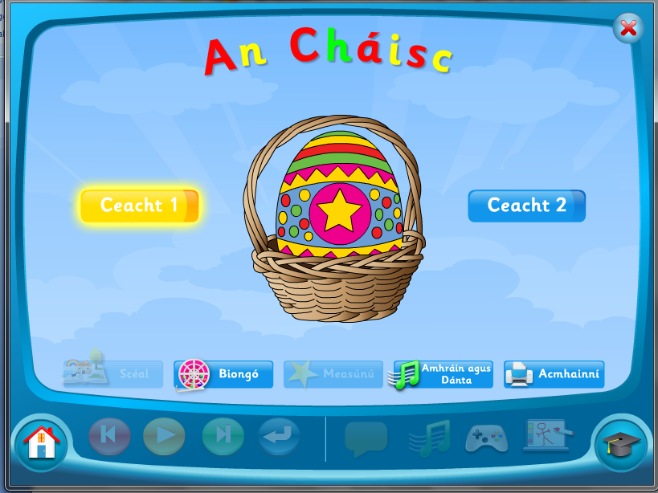
Click on Ceacht 1
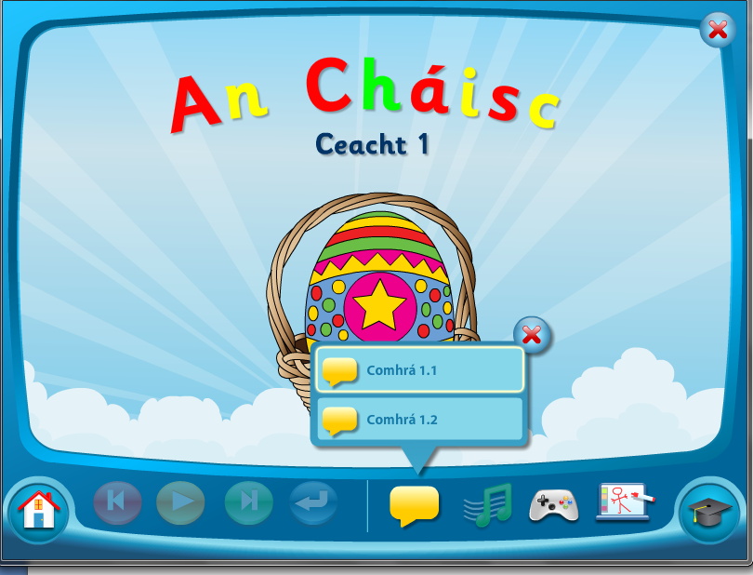
Click on Comhrá 1.1
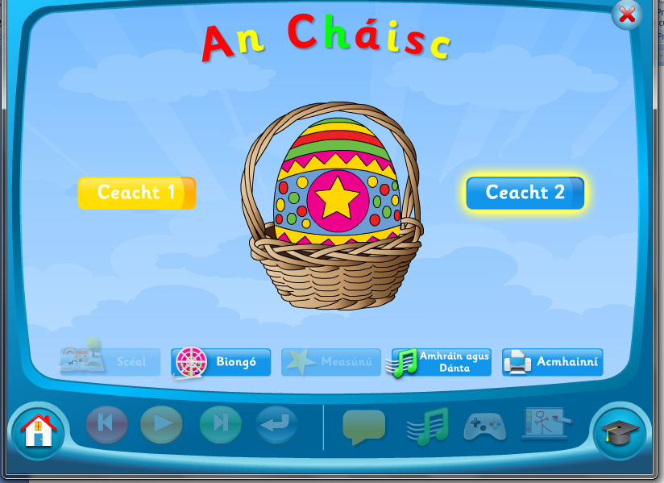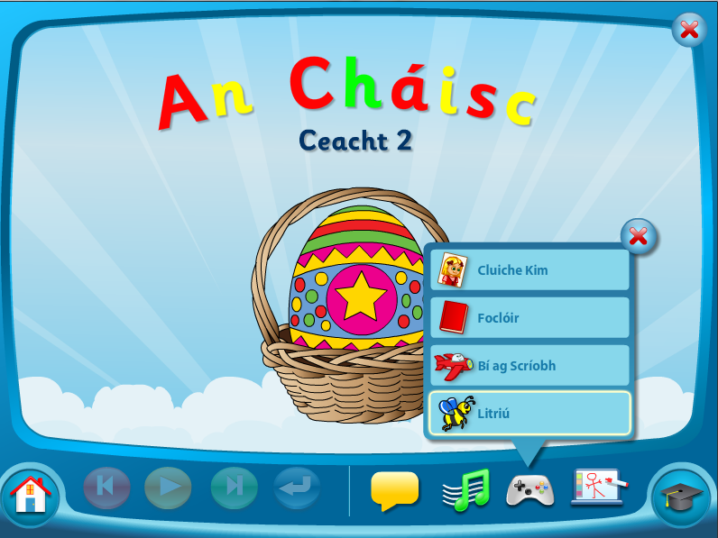 Click on this icon to access activities

