Pick 3 activities to share. Tasks will be assigned on Seesaw each day also.
- A video of yourself reading out a piece of your free writing
- A photo of your Garden drawing with the names of the things in the garden labelled in Gaeilge
- A photo of a piece of artwork you would like to share or a photo of this week’s art lesson Abstract face
- A photo of a page you have completed in your Weaving Well Being journal
- A photo of your Bua na Cainte answers from this week’s story
- A pattern you have created using Seesaw or a photo of a pattern you have created (there are lots of ideas below for creating patterns)
- A photo of a page you have completed from your New Wave English or Maths
- A photo of some of your freewriting
- A video of yourself reading this week’s Léigh sa Bhaile story
- A photo of your completed Léigh sa Bhaile sentences
- A video of yourself reading your Irish sentences for this week
- A video of yourself naming the capital cities you have learned from this week’s spellings (no peeking!!)

Suggested Table of Work - 4th Class – 05/05/20-08/05/20

 | Tuesday | Wednesday | Thursday | Friday
Date: | 05/05/20 | 06/05/20 | 07/05/20 | 08/05/20
New Wave  Mental Maths - continue  Next Week | Tuesday and Problem from problem solving section from this week | Wednesday  and Problem from problem solving section from this week | Thursday  and Problem from problem solving section from this week | Friday Review
New Wave English – continue with the next week | Tuesday  Questions  1-15 | Wednesday  Questions 1-15 | Thursday  Questions 1-15
Maths  Pattern | See list of suggested activities  below | See list of suggested activities  below | See list of suggested activities  below | See list of suggested activities  below
Léigh Sa Bhaile  -useful to access the book online and listen to the stories being read aloud – see instructions below | Léirmheas ar Scannán page 94  Read and answer questions 1, 2 & 3 in your copy  Read the story aloud, listen to Audiobook if unsure of prononcuiation | Re-read Léirmheas ar Scannán page 94  Answer questions 4 & 5  Practice reading the story aloud | Read Foirgnimh Cháiliúla page 100 and answer questions 1, 2 & 3 in your copy. Read the story aloud. | Read Foirgnimh Cháiliúla page 100 and answer questions 4 & 5 in your copy. Read the story aloud.
Bua Na Cainte  (available free to download if you wish instructions below lots of games, stories, songs etc., instructions are outlined below) | Page 152  Aonad 3 – Ceacht 1  Read the story Sa Ghairdín ar Chúl an Tígh either from the book or online (see instructions below) | Page 152 (if you do not have the book see instructions below)  Re-read the story answer the questions 1-8 in your copy.  Remember the answer to Cá raibh is always Bhí or ní raibh  Cén fáth is why  Remember to use the techniques we learned in class – follow the grammar rules, look for the word in the story. | Page 152 (if you do not have the book see instructions below)  Re read the story and fill in the blanks in Bí ag Scríobh | Draw a picture of a garden (it can be your own garden if you like!) then label your picture with all of your Gaeilge spellings from this week. You can add in as many labels as you like. The more the merrier. This is a great way to build your vocabulary. Your book, Bua na Cainte online and online dictionaries will have lots of words you can use
Starlight page 164-166  Babe the Blue Ox | Read the story on pages 158-160  Write out full answers in your copy to the questions in A.(1-5) & B.(1-5) on pg 167 | Complete the vocabulary challenge C on page 167 | Chose the most suitable word to compete each sentences D on page 168 | Grammar – Adverbs – write the sentences and replace the underlined words with adverbs – E on page 168
English Spellings  See below | Learn 2 spellings from spellings list | Learn 2 spellings from spellings list | Learn 2 spellings from spellings list | Spelling Test
Litriú  See below | Learn two spellings and one sentence  Practice saying the sentences out loud | Learn two spellings and one sentence | Learn two spelling and one sentence | Litriú test
Tables | Revise division – 5 and 10 | Revise division – 5, 10 | Revise division – 5, 10 | Tables Test
 | SESE: Project work  Famine Project (see below)  See can you learn off all the Capital Cities from this weeks spellings! | SPHE Complete another worksheet from your Weaving Well Being at Home Journal  ART  https://artprojectsforkids.org/abstract-face-tutorial-2/  Follow the step by steps instructions to Draw an Abstract Face | PE  PE with Joe  Go Noodle  Cosmic Kids Yoga – Yoga https://www.youtube.com/user/CosmicKidsYoga  mindfulness and relaxation designed especially for kids aged 3+, used in schools and homes all over the world. | LETS GOT TALENT!  Today we will have our LETS Got Talent show! Record a video of yourself showcasing a talent and share it on Seesaw.  It can be any talent you would like to share such as singing, dancing, reading a poem, telling jokes, doing a dance, gymnastics, football skills, hurling skills, skipping, tennis. You decide. Have fun!
Free writing Many pupils will be familiar with the concept of “free writing” and may have a special notebook or journal in which they write freely about any topic of choice, and in any genre. This is a simple idea that can be continued in the home setting. Children have the autonomy to decide what they wish to write about and there are a variety of different styles that they can practice:
- Diary writing (personal accounts)
- Recount writing (a report of an event)
- Fiction (short stories)
- Instructional writing (e.g. rules of a game *the children can even come up with a new idea and create their own game!)
- Poetry (Limericks, acrostic poems etc.)
https://storybird.com/member-family-plan (offer a free 7-day trial)
https://www.mystorybook.com/

Spellings 05/05/20-08/05/20. Countries and Capital Cities of Europe
 | Gaeilge | Volga | Nile
1 | Trampailín trampoline | Greece & Athens | Bulgaria & Sofia
2 | nead nest | Latvia & Riga | Germany & Berlin
3 | barra rotha wheel barrow | Lithuania & Vilnius | Netherlands & Amsterdam
4 | éiníní birds | Italy & Rome | Romania & Bucharest
5 | bláthanna flowers | Hungary & Budapest | Finland & Helsinki
6 | canna uisce watering can
7 | bord éan bird table
8 | fiailí weeds
- Bhí an chlann sa ghairdín The family were in the garden
- Bhí na páistí ag léim ar an trampailín The children were jumping on the trampoline
- Bhí Mamaí ag cur uisce ar na bláthanna Mammy was watering the flowers
- Bhí Daidí ag baint fiailí Daddy was pulling the weeds

SUGGESTED MATHS ACTIVITIES – 05/05/20-08/05/20 – PATTERNS

Pattern and sequences: Children need to know the mathematical language associated with pattern and sequences: copy, extend, devise, predict, repeated pattern, element of the pattern.

Game: What is missing? Devise a pattern with your child using any material you have to hand at home, such as pasta shapes, coloured clothes pegs, socks, etc. Invite your child to close his/ her eyes. Remove one item from the pattern and tell your child to open his/her eyes. Your child must decide what is missing and explain his/her reasoning. For example, make a pattern out of socks: red, red, blue, green, purple, purple, red, red, blue, green…

Pattern detective: Ask your child to examine patterns from his/her environment around the home or garden, such as wallpaper, gift-wrapping paper, bathroom/kitchen tiles, striped jumpers, etc. Discuss them and draw attention to the way each pattern is repeated.

Integrate patterns: Have fun copying, extending and devising the following patterns. Always invite the children to say what comes next and to explain their reasoning for their answer.
- P.E.: Long step, short step, long step; clap hands, touch knees, touch toes.
- Visual Arts: Matchbox dipped in paint: vertical, horizontal, vertical, etc. Design a necklace with three to four different coloured beads.
- Nature: Life cycle of animals
- Science: Use rough and smooth materials to make rough, smooth, rough, smooth, etc. patterns.
- Music: Create a pattern with two or three percussion instruments, e.g. hit a triangle, drum, tambourine, triangle, drum, tambourine. Children take turns repeating the same sounds. Make singing patterns, e.g. doh ray me fa, doh ray me fa.

Extension: Invite your child to close his/her eyes. As with earlier patterns, remove one item from these patterns. Ask your child to open his/her eyes, decide what is missing and explain his/her reasoning.

Time patterns Days of the week: Discuss the days of the week pattern with your child. Ask him/her what day comes after Tuesday, Friday, etc. Ask similar questions about the patterns for the months of the year and the seasons.

Your child’s day: Examine the pattern for a typical day for your child and discuss it, e.g. before breakfast, after breakfast, at school, when I go home, after dinner, etc.
Money patterns Your child can copy, extend and devise patterns with 5c, 10c, 20c and 50c coins.
Extension: Ask your child to predict what the 10th/15th, etc. coin will be in the pattern. Skip counting in 2s, 3s, 4s…10s Ask your child to fi nd things in the local environment, home or garden that come in 2s, 3s, 4s…10s. S/he could also research this on the internet under your guidance.

Calculator fun Ask your child to press 6 + = = = on the calculator to show counting in 6s. This can be done for all tables. Ask your child to key in 108, then press – 9 = = = on the calculator to show counting back in 9s. This can be done for all division tables. Hundred square detective work Using the hundred square on page 123 of the textbook, ask your child questions such as: How many rows are on the hundred square? How many numbers begin with 7? Where are they? What is the first number in the second row? What is the last number in the eighth row?

Hundred square detective work Using the hundred square on page 123 of the textbook, ask your child questions such as:
How many rows are on the hundred square?
How many numbers begin with 7?
Where are they?
What is the first number in the second row?
What is the last number in the eighth row?

Busy at Maths (Pages 122-124). is available online (https://my.cjfallon.ie/dashboard/resources) should you wish to reinforce the concepts that have been covered. The children could view the pages online and you could choose a few different questions and ask your child to write the answers in their homework copy each day. This is merely as extension work to complement the activities above but it is not necessary to complete each page.

4th Class Project Work.

A few weeks ago we were learning about The Great Famine-An Gorta Mór when we were reading our novel Under the Hawthorn Tree. It was set in Ireland in the 1840s which is devastated by the famine. We saw how when tragedy strikes their family, Peggy, Eily and Michael were left to fend for themselves. Following on from what we learned about the famine in class I thought you might like to create your own project/book/folder on The Great Famine.

As we are not in school, I would like you to present your project either
through a video presentation on Seesaw or
take pictures of your project and share it on Seesaw.
You can work on the project over the next month and share it on see saw between June 1st- 5th. Use the internet or books you may have at home to help you. Here are some brilliant websites and links that you will find useful.

1.This Scoilnet website has fantastic resources including:
- The Great Irish Famine Online
- The Hunger Times-A Short film aimed at children aged 10-13. It was the first time that a Famine story has been told on film through the eyes of children.
- There are links to other great resources for you to research too
https://www.scoilnet.ie/go-to-primary/theme-pages/history/famine/

2. Ask About Ireland.com
A fantastic website where you can find information, videos and phots all about The Great Famine.
http://www.askaboutireland.ie/learning-zone/primary-students/3rd-+-4th-class/history/history-the-full-story/ireland-in-the-19th-centu/the-great-famine-an-gorta/index.xml

3. DCU Libraries
This page provides links to lesson plans for primary and secondary classes on the Famine and primary sources freely available on the web; it also points to relevant resource packs in our Reserve Collection
https://dcu.libguides.com/c.php?g=496476&p=3415712

4.Twinkl
You may be aware of Twinkl by now, here is a link to a great lesson pack on The Great Famine.
https://www.twinkl.ie/resource/roi2-h-052-the-great-famine-lesson-pack

5. Mr.O Bróin`s website
Resources on the Famine from a school website. Very good information created by students. This website has links to lots of great information that can be used to research the Great Famine.
http://www.mrobroin.stcronans.ie/the_great_famine.html

6. Starlight
Page 104 Michael’s Workhouse Diary contains a first hand account of life in the workhouse that might be useful for ideas for your project

Your Project

These are some ideas you may like to think about. Please include the first 10 items from this list in your project book. (I think all the below topics are very important aspects of The Great Famine and I would be so impressed if you included them all!)

- Cover and contents page – you must have this as part of your project.
- What is a famine? Why was Ireland so affected by the Famine?
- Potatoes and Ireland. Why were people do dependent on potatoes?
- What Caused the Famine?
- The Blight 1845
- 1846
- Black 47.
- What did the Government do to help?
- Soup Kitchens
- Workhouses
- Eviction from houses
- Emigration
- Coffin ships
- Effects/Results of the Great Famine in Ireland

Remember to think about how you present your work. Writing should be on lined writing paper. Drawings can be on plain drawing paper(if you have some!). Use your own creativity and imagination to have a fact wheel, a lift the flap question and answer section, or a tracing of a Workhouse or Coffin Ship. You could also write a recount from the day in the life of a child during the famine . Good luck with your research and remember to do your best work. I can’t wait to see all your projects!

Muireann

BUA NA CAINTE – INSTRUCTIONS
To access Bua na Cainte’s interactive programme at home, for a limited period,
1. Go to www.edco.ie/bua
2. Select the file which suits your computer PC or MAC
3. Select the Class Level you require, and then click on it to start the download.
4. Once the download has completed, click on the file to install and follow the on-screen instructions.
5. A Bua na Cainte icon will appear on your desktop. Once you select this icon a login page will open where you will need to enter the details included below. The login details below can be used for all class levels. Login: trial Password: trial

LESSON 1
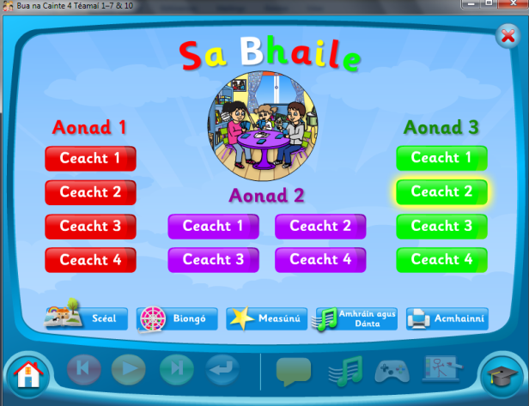 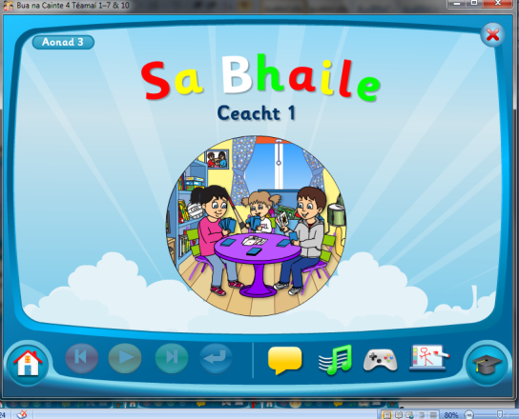 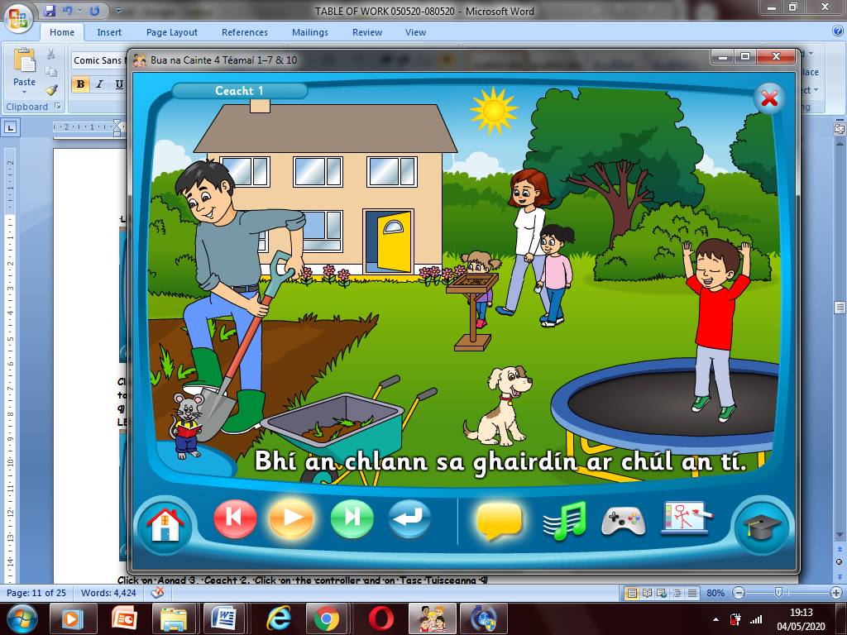
Click On Aonad 3 Ceacht 1 Click on the yellow box. Pause after each sentence and practice saying it aloud. (Click on the mouse to see the words!)

LESSON 2
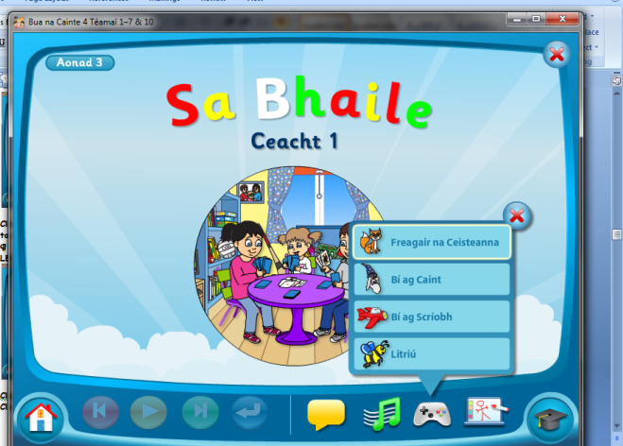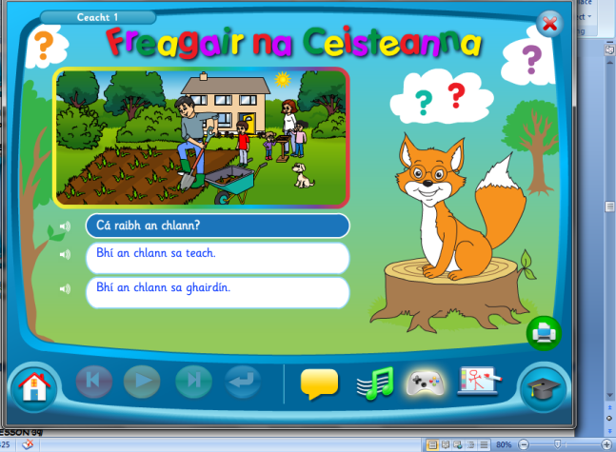
Click on Aonad 3, Ceacht 1. Click on the controller and on Fregair na Ceisteanna, click on the correct answer and write out the answer in your copy

LESSON 3

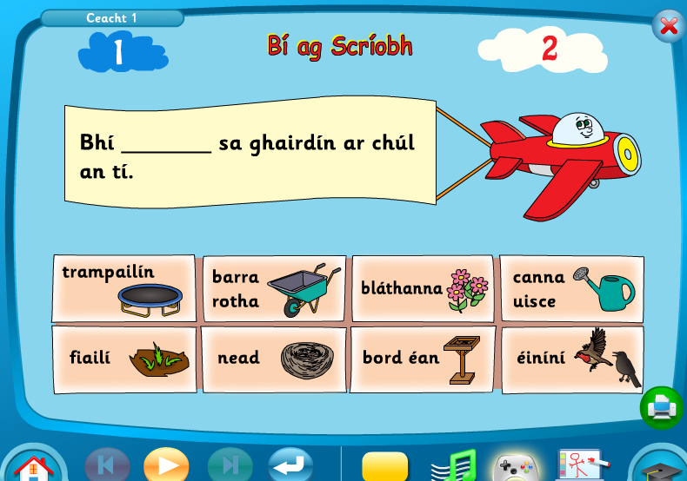
Click on Aonad 3 – Ceacht 1 Click on Bí ag Caint Fill in the blanks

TO ACCESS LÉIGH SA BHAILE AND BUSY AT MATHS
To access CJ Fallon you’ll need to register your name and email address. When you log in you can select the book required. Below are the steps for Léigh sa Bhaile, follow the same steps for Busy at Maths.
