Seesaw Activities: Please pick any FIVE of the activities below and if possible share them on Seesaw. You can post one thing a day or post them all in one day it is up to you.
- A photo of a page you have completed from your New Wave English or Maths
- A photo of some of your freewriting
- A photo of your recyclable materials artwork
- A video of yourself reading this week’s Léigh sa Bhaile story
- A photo of your completed Léigh sa Bhaile sentences
- A video of yourself reading your Irish sentences for this week
- A video of yourself reading the poem you wrote for National Poetry Day
- A photo of your poem
- A photo of our Seomra Folchta drawing
- A photo of a piece of artwork you would like to share.
- A photo of a page you have completed in your Weaving Well Being journal
- A photo or video of a project you have completed

Suggested Table of Work - 4th Class – 27/04/20-01/05/20

 | Monday | Tuesday | Wednesday | Thursday | Friday
Date: | 27/04/20 | 28/04/20 | 29/04/20 | 30/04/20 | 01/05/20
New Wave  Mental Maths - continue  Next Week | Monday and Problem from problem solving section from this week | Tuesday and Problem from problem solving section from this week | Wednesday  and Problem from problem solving section from this week | Thursday  and Problem from problem solving section from this week | Friday Review
New Wave English – continue with the next week | Monday  Questions  1-15 | Tuesday  Questions  1-15 | Wednesday  Questions 1-15 | Thursday  Questions 1-15
Maths | Activity 1  See list of suggested activities below | Activity 2  See list of suggested activities  below | Activity 3  See list of suggested activities  below | Activity 4  See list of suggested activities  below | Activity 5 See list of suggested activities  below
Léigh Sa Bhaile  -useful to access the book online and listen to the stories being read aloud – see instructions below | Read the story Ag Bogadh Tí 1 page 103 answer question 1 & 2 in your copy | Re-read the story Ag Bogadh Tí 1 page 103 answer question 3, 4 & 5 in your copy | Read the story Ag Bogadh Tí 2 page 104 answer question 1 & 2, in your copy | Re-read the story Ag Bogadh Tí 2 page 104 answer question 3 & 4 in your copy | Re-read the story Ag Bogadh Tí 2 page 104  answer question 5 in your copy
Bua Na Cainte  (available free to download if you wish instructions below lots of games, stories, songs etc., instructions are outlined below) | An Seomra Folctha  Lesson 1  (see step by step instructions below)  1.Listen and read along  2.Pause the story after each sentence and read the sentence aloud | An Seomra Folctha Lesson 2  Go back over sentences from yesterday and see if you can remember any of the new words that you learned yesterday.  3.Click on Tasc Tuisceanna to move the items to the correct place. | An Seomra Folctha  Lesson 3  1.Click on Foclóir to play the game (see instructions below)  2.Go to your bathroom and practice describing the things you see – tá an doras in aice leis an leithreas (the door is beside the toilet). You can use your sentences from this week too. | An Seomra Folctha  Lesson 4  1.Click on Scríobh an Scéal) and fill in the gaps.  2.Write the completed sentences out in your copy | Draw a picture of your own bathroom in your copy and label as many items as possible using the new vocabulary you have learned.  Go to your bathroom and practice describing the things you see – tá an doras in aice leis an doras (the door is beside the toilet). You can use your sentences from this week too.
Starlight page 158-160 Miss Trunchbull | Today is National Poetry Day.  Write a poem about Spring in your copy and decorate it. Remember to brainstorm words first. You could record yourself reading your poem or send me a picture of it on Seesaw | Read the story on pages 158-160  Write out full answers in your copy to the questions in A.(1-5) & B.(1-5) on pg 161 | Complete the vocabulary challenge C on page 161 | Chose the most suitable word to compete each sentences D on page 162 | Grammar – Adverbs – write the sentences and replace the underlined words with adverbs – E on page 162
English Spellings  See below | Learn 2 spellings from spellings list | Learn 2 spellings from spellings list | Learn 2 spellings from spellings list | Learn 2 spellings from spellings list | Spelling Test
Litriú  See below | Learn two spellings and one sentence  Practice saying the sentences out loud | Learn two spellings and one sentence | Learn two spellings and one sentence | Learn two spelling and one sentence | Litriú test
Tables | Revise division – 3, 6, 9 | Revise division – 3, 6, 9 | Revise division – 3, 6, 9 | Revise division – 3, 6, 9 | Tables Test
 | PE  PE with Joe  Go Noodle  Cosmic Kids Yoga – Yoga https://www.youtube.com/user/CosmicKidsYoga  mindfulness and relaxation designed especially for kids aged 3+, used in schools and homes all over the world. | SESE: Project work  Children can work on a longer-term project based on a theme of their choice. A scrap book is ideal, and children can cut and paste articles, pictures, diagrams and pieces of writing. Other children may prefer to use their IT skills and create a PowerPoint presentation. The project can be shared on Seesaw using video or pictures. | SPHE Complete another worksheet from your Weaving Well Being at Home Journal | Art Most homes will have a “bits-and-bobs” box somewhere with buttons, lids, coins, wrapping paper etc. You can also use cereal boxes, toilet roll inserts, cardboard boxes etc. Now is a good time to use those recyclables and create a piece of artwork. Children should be encouraged to be original, be creative – and don’t forget to take a picture and post your creation to Seesaw! | Music  Dabbledoo music is the music programme we use in our classroom. It is a wonderful resource with lots of different ideas/lessons for teaching, playing, listening to and composing music. They are offering parents a free subscription should you wish to look at some different lessons. The children will be familiar with the layout of the site as we use it in class. Click on this link to see more https://dabbledoomusic.com/p/parents-subscription-full-access?utm_campaign=2020%20Campaign&utm_source=hs_email&utm_medium=email&utm_content=86699941&_hsenc=p2ANqtz-9VnlvFWbvJ5P0zUIEwV0bjt_Ijub692zC2TREvYCIynr1gFvJpzdI4c2VXwPnS7QeEx6F38klU67gJByrFL4KiPSu5Wa3-Xg1roGkmOXA79gEQhvs&_hsmi=86699941
Free writing Many pupils will be familiar with the concept of “free writing” and may have a special notebook or journal in which they write freely about any topic of choice, and in any genre. This is a simple idea that can be continued in the home setting. Children have the autonomy to decide what they wish to write about and there are a variety of different styles that they can practice:
- Diary writing (personal accounts)
- Recount writing (a report of an event)
- Fiction (short stories)
- Instructional writing (e.g. rules of a game *the children can even come up with a new idea and create their own game!)
- Poetry (Limericks, acrostic poems etc.)
https://storybird.com/member-family-plan (offer a free 7-day trial)
https://www.mystorybook.com/

Spellings 27thApril – 1st May 2020. High Frequency Words 2
 | Gaeilge | Volga | Nile
1 | dallóg – blind | around | garden
2 | tuáille – towel | because | clothes
3 | cithfholcadh – shower | best | everyone
4 | cuirtiní - curtains | buy | anything
5 | taos fiacal - toothpaste | both | through
6 | scuab fiacal – toothbrush | call | interesting
7 | doirteal - sink | children | found
8 | sconna - taps | birthday | celebration
- Tá dallóg agus cuirtíní ar an bhfuinneog. There are blinds and curtains on the window.
- Tá scuab fiacal agus taos fiacal ar leac na fuinneoige. There is toothpaste and a toothbrush on the window sill.
- Tá sconna ar an doirteal There are taps on the sink .
- Tá cithfholcadh sa chúinne. The shower is the corner.

SUGGESTED MATHS ACTIVITIES – 27/04/20-01/05/20 - LENGTH

Length
Centimetres and metres Your child will be learning about centimetres and metres over the coming days. Your child needs to know some of the mathematical language associated with the metric system: length, centimetres (cm), metres (m), measure, longer, shorter, total, decimals, fractions, metre stick, more/less than, long, longer, equal, distance, high, tenth, hundredth, decimal point.

Activity 1 - Get Measuring!
Centimetres and metres. Use ruler or a tape measure. You can make a metre stick, a metre strip or metre string using a metre on a tape measure. Or you may prefer to just use the tape measure! Ask your child to examine both the ruler and the metre by asking such questions as:
- How many centimetres are on the ruler?
- How many centimetres are in a metre?
- How many centimetres are in 1/2 / 1 /4 / 3 /4 of a metre?

Your child needs to know the best measuring length or tool to use when measuring different items. Ask him/ her questions such as: Would you use a ruler or a metre measure to measure the height (or length or width) of a mug/radiator/door/plant/shoe/car/door/window/ garden/football pitch?

Extension 1: Gather a selection of household items and ask your child to measure the length/height or width of each one.
Extension 2: Invite your child to arrange the household items in order from shortest to longest.

Activity 2 - Long jump
Set up a long jump area in the your hall or garden. Make sure that your child will not be in any danger from traffic, stones or sharp objects. Mark a start position. Invite the members of your family (or friends) to jump in the long jump. Using a metre measure (or extended measuring tape), encourage your child to measure the length of each jump. Encourage him/her to record the lengths in centimetres and metres in both decimal and fraction form, e.g. 1m 59cm or 1 59/100m or 1·59m.

Activity 3 - Chalk drawings
Give your child a bar of chalk, a ruler and a metre measure. Set your child different lengths that s/he must measure out on the patio area of your garden or on a path (ensuring that your child is not in any danger from traffic). Alternatively, you can use long strips of paper and pencils or crayons. Ask your child to:
- Draw a line that is 9cm long.
- Draw a line that is 1·04m long.
- Draw a line that is 8 /10 of a metre long.
- Draw a line that is 2m 26cm long.
- Draw a line that is 73/100 of a metre long.

Activity 4 - Family height chart
Help your child measure the height of each family member. Encourage your child to predict how tall each person is before using a tape measure to find their exact height.
Extension: Using the tape measure, your child could also measure the length of each family member’s leg, arm, distance around the waist/shoulders/wrist/ankle, etc.

Busy at Maths is available online (https://my.cjfallon.ie/dashboard/resources) should you wish to reinforce the concepts that have been covered. Pages 111-114 covers addition, subtraction, multiplication of length. The children could view the pages online and you could choose a few different questions and ask your child to write the answers in their homework copy each day. This is merely as extension work to complement the activities above but it is not necessary to complete each page.

BUA NA CAINTE – INSTRUCTIONS
To access Bua na Cainte’s interactive programme at home, for a limited period,
1. Go to www.edco.ie/bua
2. Select the file which suits your computer PC or MAC
3. Select the Class Level you require, and then click on it to start the download.
4. Once the download has completed, click on the file to install and follow the on-screen instructions.
5. A Bua na Cainte icon will appear on your desktop. Once you select this icon a login page will open where you will need to enter the details included below. The login details below can be used for all class levels. Login: trial Password: trial

LESSON 1
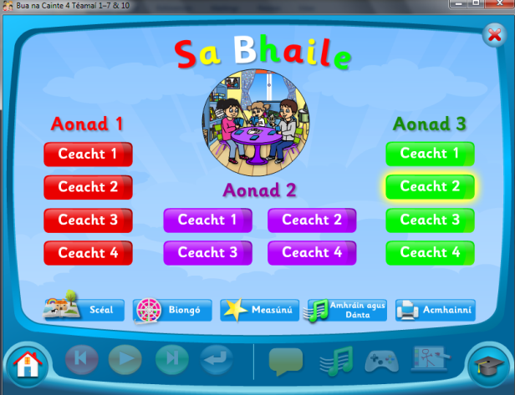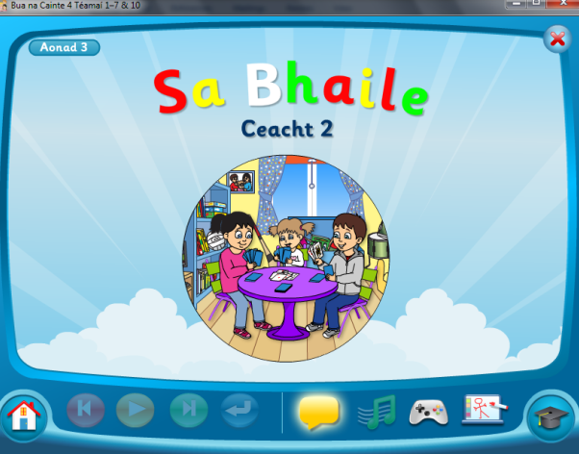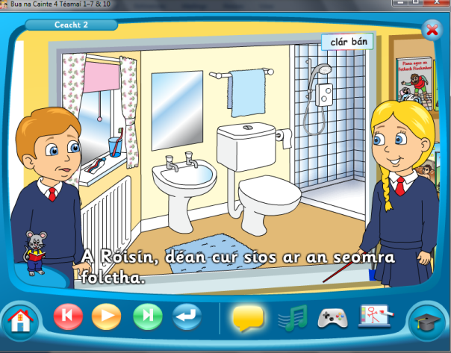
Click On Aonad 3 Ceacht 2 Click on the yellow box. Pause after each sentence and practice saying it aloud. (Click on the mouse to see the words!)

LESSON 2
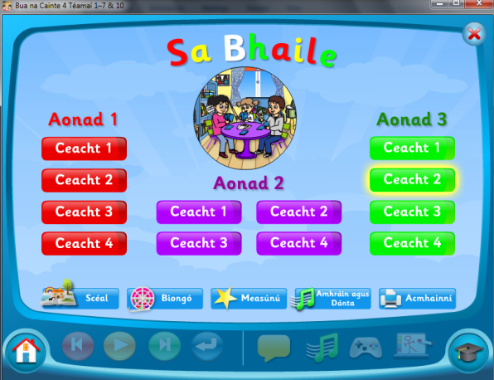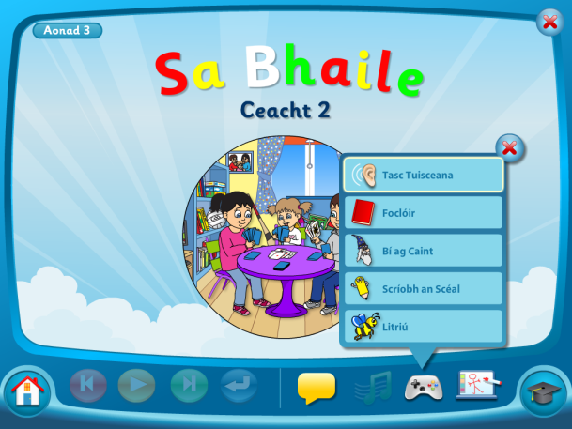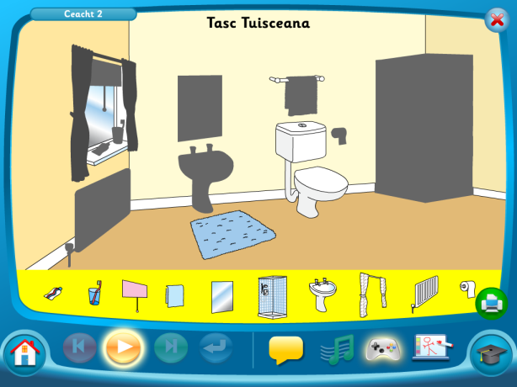
Click on Aonad 3, Ceacht 2. Click on the controller and on Tasc Tuisceanna
Click and drag the words to the correct place
LESSON 3
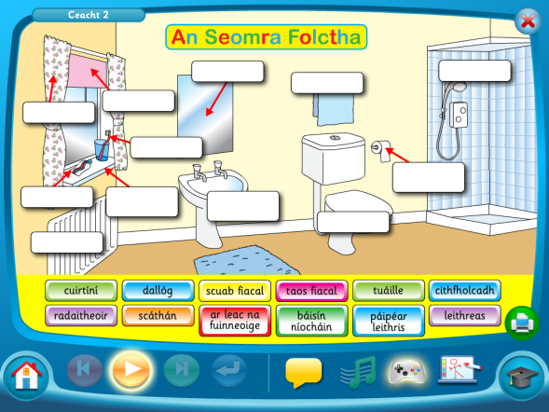
Click on Aonad 3 Ceacht 2, Click on the controller, click on foclóir and match the words
LESSON 4
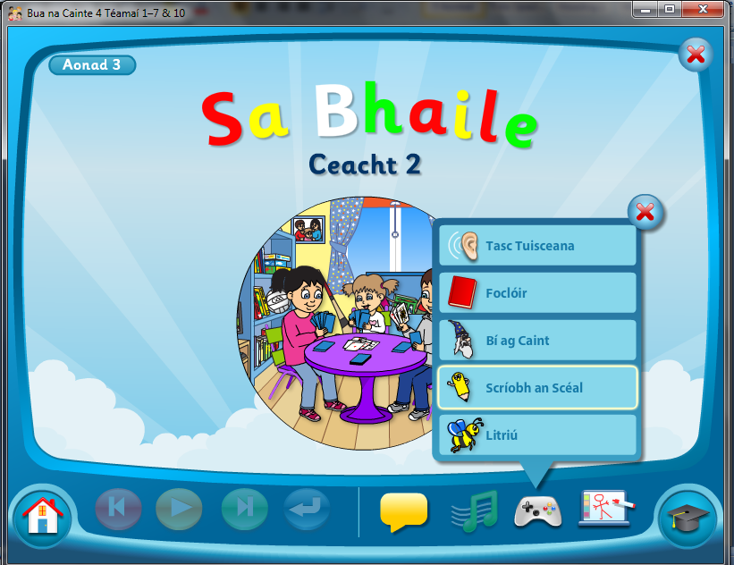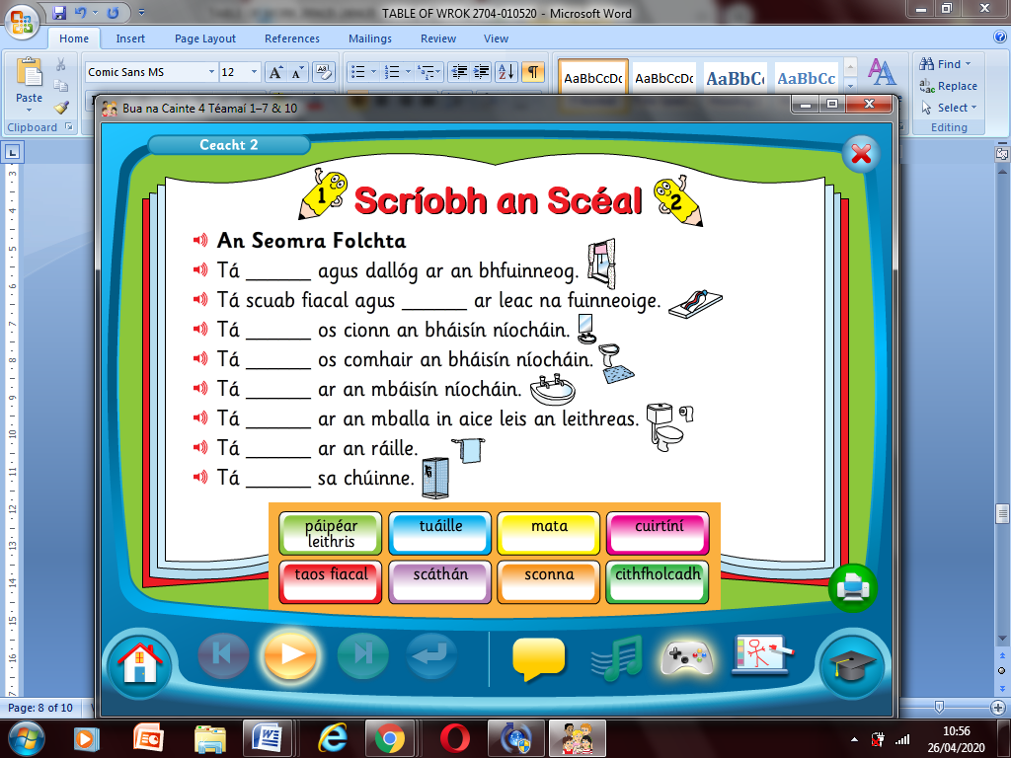
Click on Aonad 3 Ceacht 2 then click on Scríobh an Scéal. Fill in the blanks then write the sentences out in your copy.

TO ACCESS LÉIGH SA BHAILE AND BUSY AT MATHS
To access CJ Fallon you’ll need to register your name and email address. When you log in you can select the book required. Below are the steps for Léigh sa Bhaile, follow the same steps for Busy at Maths.
