Hi boys and girls
I hope you are keeping well and enjoying the nice weather. I hope you all had a lovely weekend. I know some of you were celebrating Eid so I hope you enjoyed all the celebrations with your family. Thank your for all your brilliant posts. You are all working so hard at home so well done and keep it up! I love getting all your posts on Seesaw. The Great Lucan Make/Bake Off was a huge success with so many wonderful posts. Thank you so much for all the effort you went to. You all made such yummy dishes and did a fantastic job of sharing them and explaining the steps involved. Well done!
Again this week, I will be posting some activities every morning linked to this week’s learning that you might like to try along with a Good Morning message. The activities can be responded to at any time. I will try my best to give you feedback as soon as I can. I will assign the activities before 10am so check in then. They will be linked to the learning we will be doing this week. Remember as well to read everyday. This week in maths we will be revising long multiplication. Don’t forget the magic zero! I’ve also attached a powerpoint on Eid that you might like to have a look at. This weeks art activity is from the art hub on youtube I think you’ll enjoy it.
I hope the famine projects are going well. I am looking forward to you presenting your project through Seesaw between June 1st- 5th. Project guidelines are attached to the Table of Work for you. Have a great week, keep staying positive and keep up the hard work! I can’t wait to see all your posts! I look forward to hearing from you all.

Muireann

PICK 5 THINGS FROM THIS LIST TO POST ON SEESAW
- Any of the activities assigned each morning this week (see table below) or
- A photo of a piece of artwork you would like to share
- A video of yourself reading out a piece of your free writing
- A photo of your Bua na Cainte answers from this week’s story
- Any of your work on Multiplication
- A video of you reading the poem from this week
- A photo of a page you have completed from your New Wave English or Maths
- A photo of some of your freewriting
- A video of yourself reading this week’s Léigh sa Bhaile story
- A photo of your completed Léigh sa Bhaile sentences
- A video of yourself reading your Irish sentences for this week
- A video of a talent you would like to share with the class

 | Suggested Table of Work - 4th Class – 25/05/20-29/05/20
 | MONDAY | TUESDAY | WEDNESDAY | THURSDAY | FRIDAY
Date: | 25/05/20 | 26/05/20 | 27/05/20 | 28/05/20 | 29/05/20
New Wave  Mental Maths - continue  Next Week | Monday and Problem solving section from this week. | Tuesday and Problem from problem solving section from this week | Wednesday  and Problem from problem solving section from this week | Thursday  and Problem from problem solving section from this week | Friday Review
New Wave English – continue with the next week | Monday Questions 1-15 | Tuesday  Questions  1-15 | Wednesday  Questions 1-15 | Thursday  Questions 1-15
Maths – Multiplication 3 | See list of suggested activities below or/and  Page 139 Busy at Maths | See list of suggested activities below or/and  Page 140 Busy at Maths  Click on this link to access online tutorial  http://data.cjfallon.ie/resources/20691/BAM4_Tutorial_095/lessons/BAM4_Tutorial_095/index.html | See list of suggested activities below or/and  Page 141 Busy at Maths  Click on this link to access online tutorial  http://data.cjfallon.ie/resources/20691/BAM4_Tutorial_096/lessons/BAM4_Tutorial_096/index.html | See list of suggested activities below or/and  Page 142 Busy at Maths  Click on this link to access online tutorial  l | See list of suggested activities below or/and Page 143 Busy at Maths
Léigh Sa Bhaile  -useful to access the book online and listen to the stories being read aloud – | Carr Nua page 83 Read and answer questions 1 & 2 in your copy. Read the story aloud | Carr Nua page 83 Re-read and answer questions 3, 4 & 5 in your copy. Read the story aloud | Read page 88 – Hansel agus Gretel  Answer questions 1 & 2 Practice reading aloud | Re-read page 88 Hansel agus Gretel  Answer questions 3 and 4 and 5 Practice reading aloud | Re-read page 88 Hansel agus Gretel and answer question 5. Practice reading aloud
Bua Na Cainte  (available free to download if you wish instructions below lots of games, stories, songs etc., instructions are outlined below) | Page 168  An Teilifís  Aonad 2 – Ceacht 3 (in book or online)  Bí ag Caint  and see can you answer questions in Obair Bheirte. Go to Bua na Cainte online to help you (see step by step instructions below). Record yourself answering the questions and post to Seesaw (see instructions for Lesson 1 below) | Bí ag léamh –  An Teilifís  page 169  Aonad 2 Ceacht 4  1.Read An Nuacht – Watch Bua na Cainte online to help you (see instructions below) | Bí ag léamh  An Teilifís  Aonad 2 – Ceacht 4  Page 169 – Tuar na hAimsire  Go to Bua na Cainte online to help you | Bí ag scríobh – Scríobh do nuacht – use an Nuacht page 169 so help you write your own news in your copy! Remember to use your past tense verbs  Chuaigh mé – I went  D’féach mé – I watched  Rinne mé – I made  D’ith mé – I ate  D’ól mé – I drank | Bí ag scríobh  Scríobh tuar na haimsire  Write the weather forecast use the Tuar na Haimsire on page 169 to help you.  This time use your future tense verbs!  Beidh sé – It will be …  Tirim – warm  Teocht – temperature  Grianmhar – sunny  Scamallach – cloudy  Go to Bua na Cainte online to help you!
Starlight  Persuasive Article  Make sure you are keeping up your reading and reading for at least 10 minutes each day.  Join David Walliams  online as he reads a new book each day at 11.00am.  https://www.worldofdavidwalliams.com/elevenses/ | Read the poem – Blake’s Tyger – Revisited on page 182  Answer the comprehension questions A on page 183 | Re-read the poem on page 182 answer B on page 183 | Re-read the poem on page 183 and complete the vocabulary exercise on C page 183 | Complete the vocabulary revision D on page 184 | Complete the grammar work on Verbs E page 184
English Spellings  See below | Learn 2 spellings from spellings list | Learn 2 spellings from spellings list | Learn 2 spellings from spellings list | Learn 2 spellings from spellings list | Spelling Test
Litriú  See below | Learn two spellings and one sentence  Practice saying the sentences out loud | Learn two spellings and one sentence  Practice saying the sentences out loud | Learn two spellings and one sentence | Learn two spelling and one sentence | Litriú test
Tables | Revise all multiplication tables using https://www.arcademics.com/ or your homework journal, play the tables game at home! | Revise all multiplication tables using https://www.arcademics.com/or or your homework journal, play the tables game at home. | Revise all multiplication tables using https://www.arcademics.com/ or your homework journal, play the tables game at home! | Revise all multiplication tables using https://www.arcademics.com/ or your homework journal, play the tables game at home. | Test
Other | ECC – Watch this powerpoint all about Rmmadan & Eid  This will be one of todays Seesaw activities | SESE: Project work  The famine project is due any day during the week beginning the 1st of June. I can’t wait to see all the brilliant projects  Science – See today’s Seesaw activity | SPHE page 22 – Weaving Wellbeing Journal  This will be on of today’s Seesaw Activities file:///C:/Users/User/Desktop/At-Home-with-Weaving-Well-being-A-Mental-Health-Journal-for-Kids%202.pdf | PE  PE with Joe  Go Noodle  Cosmic Kids Yoga – Yoga https://www.youtube.com/user/CosmicKidsYoga  mindfulness and relaxation designed especially for kids aged 3+, used in schools and homes all over the world. | Art – see today’s Seesaw activity – go to Art Hub on youtube, https://www.youtube.com/user/ArtforKidsHubselect a step by step drawing to draw and share it on Seesaw!
Free writing Many pupils will be familiar with the concept of “free writing” and may have a special notebook or journal in which they write freely about any topic of choice, and in any genre. This is a simple idea that can be continued in the home setting. Children have the autonomy to decide what they wish to write about and there are a variety of different styles that they can practice:
- Diary writing (personal accounts)
- Recount writing (a report of an event)
- Fiction (short stories)
- Instructional writing (e.g. rules of a game *the children can even come up with a new idea and create their own game!)
- Poetry (Limericks, acrostic poems etc.)
https://storybird.com/member-family-plan (offer a free 7-day trial)
https://www.mystorybook.com/

words with similar sound – compound words.
 | Gaeilge | Volga | Nile
1 | deireadh seachtaine – weekend | carpark | keyhole
2 | scannán – film | roundabout | sunshine
3 | an ghreannmhar – very funny | playground | headache
4 | lig mé mo scíth – I relaxed | basketball | pillowcase
5 | d’fhéach mé – I watched | eyesight | notebook
6. |  | anyone | fingernail
7. |  | everyone | grasshopper
8. |  | downstairs | gingerbread
 |  | Fingernail | Rattlesnake
 |  | postcard | sunglasses
An deireadh seachtaine seo caite lig mé mo scíth. Last weekend I relaxed.
D’fhéach mé ar scannán ar an teilifís. I watched a film on the TV
Bhí sé an-ghreannmhar. It was very funny..
Thaitin an scannán go mór liom. I really liked the film

SUGGESTED MATHS ACTIVITIES – 25/05/20-29/05/20
This week we will be learning about multiplication. Your child needs to know the mathematical language associated with multiplication: multiply, multiplication symbol (x), skip count, pattern, relationships, double, near double, two for the price of one, buy one get one free (commutative property), bigger/greater than, addition/multiplication sentence, inverse, smaller than, less than, pattern, list, grid, repeated addition/equal grouping, half, rectangular arrays, rows, columns, equation, represent, digits, extended tables, vertical, horizontal, product, factor, multiples, common multiple, strategy, estimate, rounding.
.What’s the product? Call out a random series of products for each separate multiplication table. Your child and one other player must answer by offering the correct factors for that table. For example, using the 3 times table, call out the product 24. Your child offers 8 as the missing factor and then offers the 8 x 3 = 24 number sentence as the solution
Multiplying a two-digit number by a one digit number Present your child with a real-life problem, such as: There are 16 marbles in a box. How many marbles are in three boxes? Ask your child to represent the 16 marbles using one 10c coin and six 1c coins. Invite him/ her to put one 10c coin and six 1c coins on each of the three plates.
- How many single 1c coins (units) do I have now? Yes, 18! What can I swap the 18 single coins (units) for? Yes, one 10c coin and eight 1c coins.
- How many single coins (units) do I have left? Yes, eight single coins (units).
- How many tens do I have now? 3 tens + 1 ten = 4 tens.

- Long multiplication Your child may use different types of strategies when inventing his/her own strategies.
- 1. Repeated addition
- 235 x 3
- 235
- 235
- +235
- 705

- 2. Break up the numbers
- 235 x 3 = ?
- (5 x 3) + (30 x 3) + (200 x 3)
- = 15 + 90 + 600
- ➞ 705

- 3. Compensation method In this method, you make one number bigger and subtract to compensate. For example:
- 235 x 3 = (250 x 3) – (15 x 3)
- ➞ 750 – 45 = 705
- You could also make one number smaller and add to compensate. For example:
- 235 x 3 = (200 x 3) + (35 x 3)
- ➞ 600 + 105 = 705

Introduce the traditional method Always begin with a real-life multiplication problem. Demonstrate the multiplication method using the approach outlined on page 141 of the Busy at Maths 4 textbook.

4th Class Project Work.

A few weeks ago we were learning about The Great Famine-An Gorta Mór when we were reading our novel Under the Hawthorn Tree. It was set in Ireland in the 1840s which is devastated by the famine. We saw how when tragedy strikes their family, Peggy, Eily and Michael were left to fend for themselves. Following on from what we learned about the famine in class I thought you might like to create your own project/book/folder on The Great Famine.

As we are not in school, I would like you to present your project either
through a video presentation on Seesaw or
take pictures of your project and share it on Seesaw.
You can work on the project over the next month and share it on see saw between June 1st- 5th. Use the internet or books you may have at home to help you. Here are some brilliant websites and links that you will find useful.

1.This Scoilnet website has fantastic resources including:
- The Great Irish Famine Online
- The Hunger Times-A Short film aimed at children aged 10-13. It was the first time that a Famine story has been told on film through the eyes of children.
- There are links to other great resources for you to research too
https://www.scoilnet.ie/go-to-primary/theme-pages/history/famine/

2. Ask About Ireland.com
A fantastic website where you can find information, videos and phots all about The Great Famine.
http://www.askaboutireland.ie/learning-zone/primary-students/3rd-+-4th-class/history/history-the-full-story/ireland-in-the-19th-centu/the-great-famine-an-gorta/index.xml

3. DCU Libraries
This page provides links to lesson plans for primary and secondary classes on the Famine and primary sources freely available on the web; it also points to relevant resource packs in our Reserve Collection
https://dcu.libguides.com/c.php?g=496476&p=3415712

4.Twinkl
You may be aware of Twinkl by now, here is a link to a great lesson pack on The Great Famine.
https://www.twinkl.ie/resource/roi2-h-052-the-great-famine-lesson-pack

5. Mr.O Bróin`s website
Resources on the Famine from a school website. Very good information created by students. This website has links to lots of great information that can be used to research the Great Famine.
http://www.mrobroin.stcronans.ie/the_great_famine.html

6. Starlight
Page 104 Michael’s Workhouse Diary contains a first hand account of life in the workhouse that might be useful for ideas for your project

Your Project

These are some ideas you may like to think about. Please include the first 10 items from this list in your project book. (I think all the below topics are very important aspects of The Great Famine and I would be so impressed if you included them all!)

- Cover and contents page – you must have this as part of your project.
- What is a famine? Why was Ireland so affected by the Famine?
- Potatoes and Ireland. Why were people do dependent on potatoes?
- What Caused the Famine?
- The Blight 1845
- 1846
- Black 47.
- What did the Government do to help?
- Soup Kitchens
- Workhouses
- Eviction from houses
- Emigration
- Coffin ships
- Effects/Results of the Great Famine in Ireland

Remember to think about how you present your work. Writing should be on lined writing paper. Drawings can be on plain drawing paper(if you have some!). Use your own creativity and imagination to have a fact wheel, a lift the flap question and answer section, or a tracing of a Workhouse or Coffin Ship. You could also write a recount from the day in the life of a child during the famine . Good luck with your research and remember to do your best work. I can’t wait to see all your projects!

Muireann

BUA NA CAINTE – INSTRUCTIONS
To access Bua na Cainte’s interactive programme at home, for a limited period,
1. Go to www.edco.ie/bua
2. Select the file which suits your computer PC or MAC
3. Select the Class Level you require, and then click on it to start the download.
4. Once the download has completed, click on the file to install and follow the on-screen instructions.
5. A Bua na Cainte icon will appear on your desktop. Once you select this icon a login page will open where you will need to enter the details included below. The login details below can be used for all class levels. Login: trial Password: trial

MONDAY
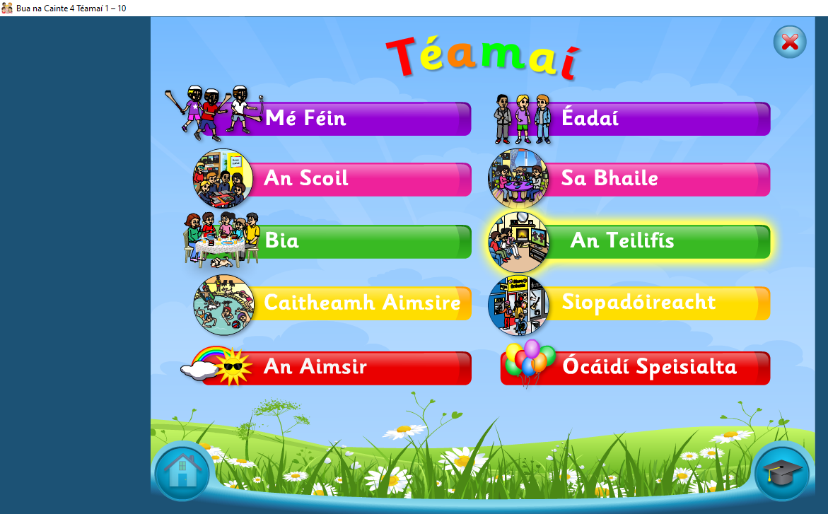 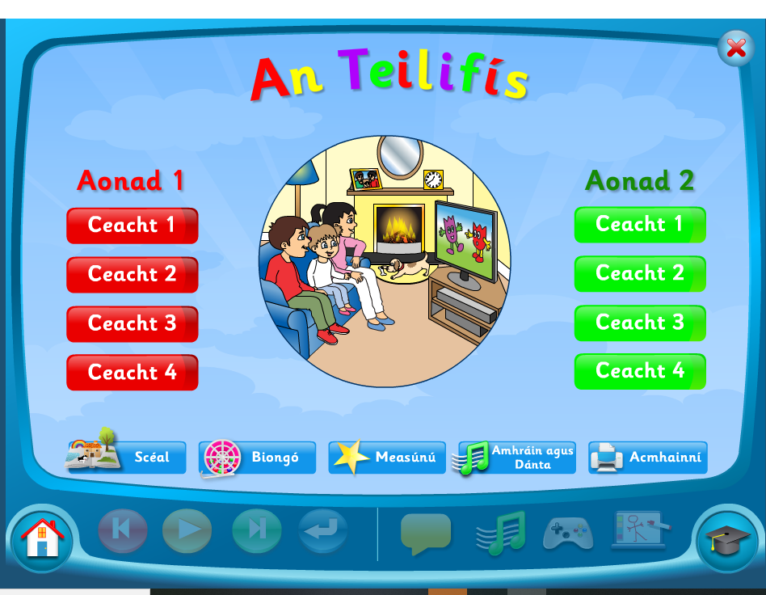 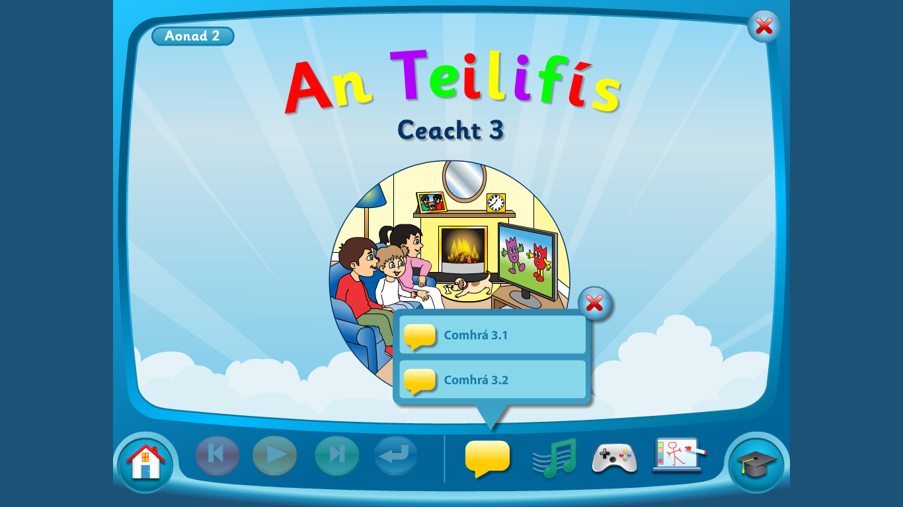 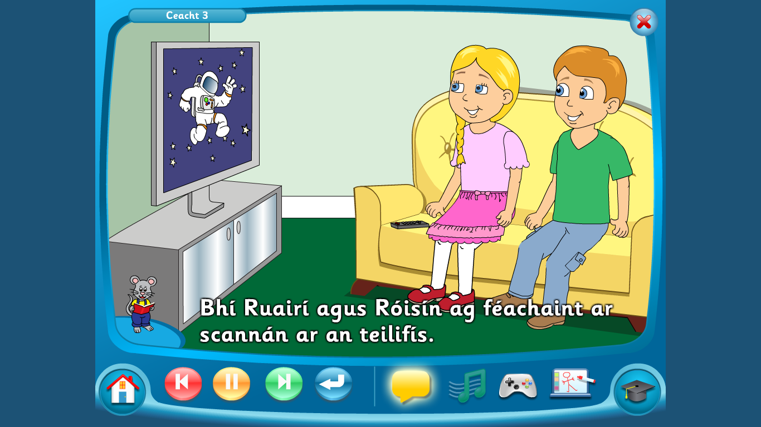
Click On An Teilifis Click on Aonad 2 Ceacht 3 Click on the yellow box – Comhrá 2.1.
Pause after each sentence and practice saying it aloud. (Click on the mouse to see the words!)

TUESDAY

Click on Teilifis Click on Aonad 3 Ceacht 4 Comhrá 4.1 Listen to An Nuacht
Pause after the Nuacht

WEDNESDAY
Repeat the steps for Tuesday but listen to the second part of Comhrá 4.1 – Tuar na hAimsire

TO ACCESS LÉIGH SA BHAILE AND BUSY AT MATHS
To access CJ Fallon you’ll need to register your name and email address. When you log in you can select the book required. Below are the steps for Léigh sa Bhaile, follow the same steps for Busy at Maths.
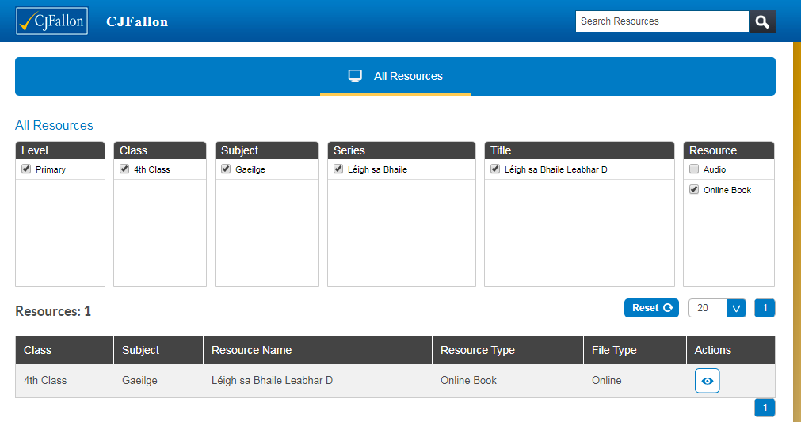
TO ACCESS NEW WAVE ENGLISH AND MATHS ANSWER BOOKS click the links below. This could be a good way for the children to correct and check their work. If they have any questions about any answers they can send me a message on Seesaw and I will explain it to them.
New Wave English in Practice
https://www.prim-ed.ie/contentfiles/41648_NWEIP_TG_4th_Class.pdf

New Wave Mental Maths
https://www.prim-ed.ie/contentfiles/41634_NWMM_TM_4th_Class.pdf

LEARNING SUPPORT GROUP – WORK FROM AMANDA

Alternative Reading activities for Amanda’s 4th class groups.
Hi all, here are some reading challenges for the week ahead. How many can you do? Enjoy yourselves and only do as much as you like. Amanda
 | Monday, 24th May | Tuesday, 25th May | Wednesday, 26th May | Thursday, 27th May | Friday, 28th May
Reading | Record yourself reading aloud for 3 minutes. Listen to it back. | Time yourself reading a page of your book aloud. | Read the lyrics of a song you like. | Read some facts about your favourite animal online or maybe you have a book about it at home. | Pick 5 words from your book and look up their meanings in the dictionary. Read the meanings aloud.
Fun reading activities | How many words can you read in one minute/two minutes?  See Dolch word list below. | Choose a page in your book and find a word with 1 letter, 2 letters and so on; e.g.  I,  be,  now,  four,  house, etc.  See you high you can go. | Look at a map of the world. Find as many places as you can that start with the first letter of your name. | Listen to a book online and read along if you have it.  Harry Potter books (and more) are on http://stories.audible.com/start-listen

All 220 Dolch sight words
the | did | right | never | ate
to | what | put | seven | full
and | so | too | eight | those
he | see | got | cold | done
a | not | take | today | use
I | were | where | fly | fast
you | get | every | myself | say
it | them | pretty | round | light
of | like | jump | tell | pick
in | one | green | much | hurt
was | this | four | keep | pull
said | my | away | give | cut
his | would | old | work | kind
that | me | by | first | both
she | will | their | try | sit
for | yes | here | new | which
on | big | saw | must | fall
they | went | call | start | carry
but | are | after | black | small
had | come | well | white | under
at | if | think | ten | read
him | now | ran | does | why
with | long | let | bring | own
up | no | help | goes | found
all | came | make | write | wash
look | ask | going | always | show
is | very | sleep | drink | hot
her | an | brown | once | because
there | over | yellow | soon | far
some | your | five | made | live
out | its | six | run | draw
as | ride | walk | gave | clean
be | into | two | open | grow
have | just | or | has | best
go | blue | before | find | upon
we | red | eat | only | these
am | from | again | us | sing
then | good | play | three | together
little | any | who | our | please
down | about | been | better | thank
do | around | may | hold | wish
can | want | stop | buy | many
could | don’t | off | funny | shall
when | how | right | warm | laugh

Hi guys, here’s a few quick ideas for making reading more fun and interesting. Remember, you don’t have to do everything! It just might be something different that you could try if you have some spare time. Enjoy! Amanda

 | Friday, 1 May | Tuesday, 5 May | Wednesday, 6 May | Thursday, 7 May | Friday, 8 May
Reading | Read your book aloud using different emotions; e.g. angry, sad, excited. | Pick something different to read like a comic or a magazine. | Read some facts about your favourite sport or hobby online. | Read a story you wrote in one of your school copies. | Read the rules of a board game that you have at home.
Fun reading activities | Ask your family to write clues for you and leave them around the house. They might even give you a treat if you read them all. | Pick a page from a book and find a word beginning with each letter of the alphabet. | Read the riddles below for your family. Can you catch them out? | Read a poem and change all the adjectives to funny ones. | Play a board game that involves reading; e.g. Scrabble, Monopoly, Trivial Pursuit, Boggle.

