PICK 5 THINGS FROM THIS LIST TO POST ON SEESAW
- Any of the activities assigned each morning this week (see table below) or
- A photo of a piece of artwork you would like to share
- A video of yourself reading out a piece of your free writing
- A photo of your Bua na Cainte answers from this week’s story
- Any of your work on Time
- A video of you reading your Persuasive Narrative
- A picture of your Persuasive Narrative
- A photo of a page you have completed from your New Wave English or Maths
- A photo of some of your freewriting
- A video of yourself reading this week’s Léigh sa Bhaile story
- A photo of your completed Léigh sa Bhaile sentences
- A video of yourself reading your Irish sentences for this week
- A video of a talent you would like to share with the class

 | Suggested Table of Work - 4th Class – 18/05/20-22/05/20
 | Monday | Tuesday | Wednesday | Thursday | Friday
Date: | 18/05/20 | 19/05/20 | 20/05/20 | 21/05/20 | 22/05/20
New Wave  Mental Maths - continue  Next Week | Monday and Problem solving section from this week. | Tuesday and Problem from problem solving section from this week | Wednesday  and Problem from problem solving section from this week | Thursday  and Problem from problem solving section from this week | Friday Review
New Wave English – continue with the next week | Monday Questions 1-15 | Tuesday  Questions  1-15 | Wednesday  Questions 1-15 | Thursday  Questions 1-15
Maths – Time  https://my.cjfallon.ie/preview/index/19847/437 | See list of suggested activities below or/and  Page 125 Busy at Maths | See list of suggested activities below or/and  Page 126 Busy at Maths  Click on this link to access online tutorial  http://data.cjfallon.ie/resources/20691/BAM4_Tutorial_088/lessons/BAM4_Tutorial_088/index.html | See list of suggested activities below or/and  Page 127 Busy at Maths  Click on this link to access online tutorial  http://data.cjfallon.ie/resources/20691/BAM4_Tutorial_089/lessons/BAM4_Tutorial_089/index.html | See list of suggested activities below or/and  Page 128 Busy at Maths  Click on this link to access online tutorial  http://data.cjfallon.ie/resources/20691/BAM4_Tutorial_089/lessons/BAM4_Tutorial_089/index.html | See list of suggested activities below or/and Page 129 Busy at Maths
Léigh Sa Bhaile  -useful to access the book online and listen to the stories being read aloud – see instructions below | An Teilifís page 120 Read and answer questions 1 & 2 in your copy. Read the story aloud | An Teilifís page 120 Re-read and answer questions 3, 4 & 5 in your copy. Read the story aloud | Read page 20 – Clár Ama Scannán  Answer questions 1 & 2 | Re-read page 20 – Clár Ama Scannán  Answer questions 3 and 4 and 5
Bua Na Cainte  (available free to download if you wish instructions below lots of games, stories, songs etc., instructions are outlined below) | Page 160  An Telifis  Aonad 1 – Ceacht 1 (in book or online)  Bí ag Caint  Look at the picture of the Seomra Suí and see can you answer questions. Go to Bua na Cainte online to help you (see step by step instructions below). Record yourself answering the questions and post to Seesaw (see instructions for Lesson 1 below) | Bí ag scríobh –  1.Scríobh faoi do seomra suí – write about your own seomra suí using the vocabulary from yesterday to help you. | Tarraing pictiúr den seomra suí  -Draw a picture of a sitting room and include label everything in the room using the new vocabulary we have learned  Share your picture on Seesaw! | Bí ag Léamh – page 163 Sceideal Teilifíse  Read the television schedule and answer the questions.  Go to Bua Na Cainte online An Telifis – Aonad 1, Ceacht 3 – to listen to the questions and to help you answering the questions  Cén t-am é? Complete the online activity  (see instructions below) | Bí ag Léamh – Aonad 1 – Ceacht 4  An Clár is Fearr Liom – My favourite programme  Read the story and answer the questions  Go to Bua Na Cainte online – An Telifís – Aonad 1 – Ceacht 4 – to listen to the conversation  (see instructions below)
Starlight  Persuasive Article  Make sure you are keeping up your reading and reading for at least 10 minutes each day.  Join David Walliams  online as he reads a new book each day at 11.00am.  https://www.worldofdavidwalliams.com/elevenses/ | Planning a Persuasive Article – Plan a persuasive article . Create a mindmap to help you with your plan  See Page 175 G Starlight to help you. | Continue with your plan, go back over it to ensure you are happy with it or edit it if you need to  Oral Language – click on the link to see a poster with different questions  https://content.folensonline.ie/programmes/Starlight/4th_class/resources/activities/SL_04_ACT_CH15_001/index.html | Writing a Persuasive article – Go back you to our mind map to help you to write your persuasive narrative  See page 181  Write your first draft  Read your story to someone and ask for feedback (remember how helpful this was in our writers workshop!) | Writing Skills – page 175 Complete the task on Describing Atmosphere  See if this activity gives you some more ideas for your own story | Write your final draft, correcting any mistakes and making any improvements you can or based on feedback you received.  Record yourself reading your story and share it with me on Seesaw, or take a photo of your story.
English Spellings  See below | Learn 2 spellings from spellings list | Learn 2 spellings from spellings list | Learn 2 spellings from spellings list | Learn 2 spellings from spellings list | Spelling Test
Litriú  See below | Learn two spellings and one sentence  Practice saying the sentences out loud | Learn two spellings and one sentence  Practice saying the sentences out loud | Learn two spellings and one sentence | Learn two spelling and one sentence | Litriú test
Tables | Revise multiplication – 8 | Revise Multiplication 8 | Revise Multiplication 8 | Revise Multiplication 8 | Test
Other | Music – see the link to Dabbledoo Music in todays Seesaw activity | SESE: Project work  Famine Project (see below)  Science – See today’s Seesaw activity | SPHE page 19 – Being Brave – this links in with our Value of the Month – Courage  This will be on of today’s Seesaw Activities | PE  PE with Joe  Go Noodle  Cosmic Kids Yoga – Yoga https://www.youtube.com/user/CosmicKidsYoga  mindfulness and relaxation designed especially for kids aged 3+, used in schools and homes all over the world. | The Great Lucan Make/Bake Off. As you may know from the T.V Show, the challenge is to bake or make whatever you like and then post either a picture or video of what you made to your journal today  ART Click on the link below to Learn about Salvador Dali, and examine his painting – The Persistence of Time  Create your own version of it  This will be one of today’s Seesaw activities  https://content.twinkl.co.uk/resource/52/d9/ROI2-A-012-The-Persistence-of-Memory-by-Dali-Art-Appreciation-Activity-Sheet_ver_2.pdf?__token__=exp=1589529085~acl=%2Fresource%2F52%2Fd9%2FROI2-A-012-The-Persistence-of-Memory-by-Dali-Art-Appreciation-Activity-Sheet_ver_2.pdf%2A~hmac=34aca903d8185f5699c36fe87de6cd4625fedec705a3b648d6283344db05ced5
Free writing Many pupils will be familiar with the concept of “free writing” and may have a special notebook or journal in which they write freely about any topic of choice, and in any genre. This is a simple idea that can be continued in the home setting. Children have the autonomy to decide what they wish to write about and there are a variety of different styles that they can practice:
- Diary writing (personal accounts)
- Recount writing (a report of an event)
- Fiction (short stories)
- Instructional writing (e.g. rules of a game *the children can even come up with a new idea and create their own game!)
- Poetry (Limericks, acrostic poems etc.)
https://storybird.com/member-family-plan (offer a free 7-day trial)
https://www.mystorybook.com/

words with similar sound - homophones.
 | Gaeilge | Volga | Nile
1 | cianrialtán remote control | throne thrown | straight strait
2 | cúisín cushion | here hear | aisle isle
3 | cuirtíní curtains | their there | stationary stationery
4 | teasaire radiator | heel heal | principal principle
5 | grianghraf photograph | stare stair | creak creek
6. | bláthchuach vase
7. | matal – mantlepiece
8. | tolg - sofa
Tá an ciannrialtán ar an mbord. The remote control is on the table
Tá grianghraf ar an matal. There is a photograph on the mantlepiece.
Tá cúisín ar an tolg. There is a cushion on the sofa
Tá teasaire faoin fuinneog. There is a radiator under the window.
See the activities on Bua Na Cainte – Telifis – Aonad 1 – Ceacht 1 – Controller – Foclóir for fun games to help you with this weeks spellings see below
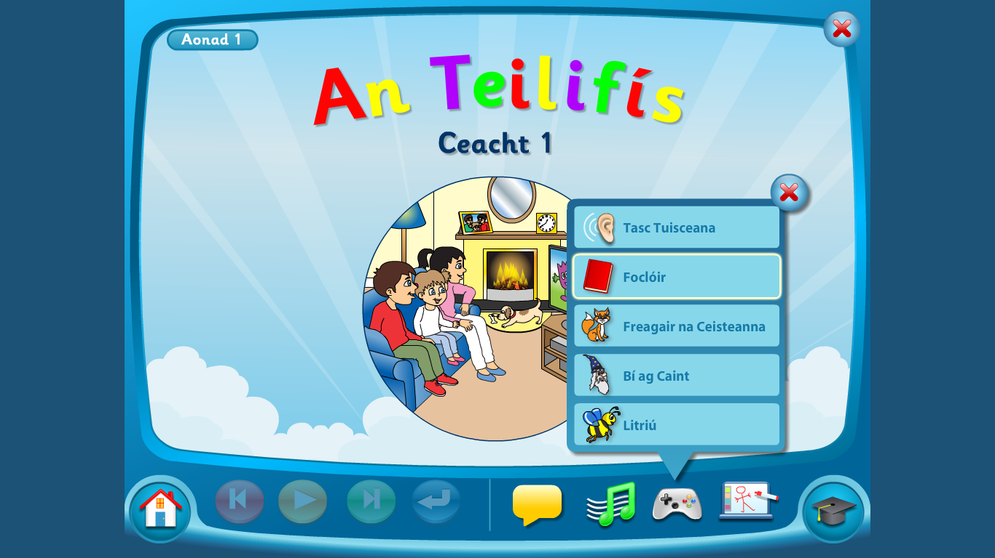

SUGGESTED MATHS ACTIVITIES – 18/05/20-22/05/20

This week we will learning about time. We will be learning to convert hours to hours and minutes and vice versa. S/he will be learning to add and subtract amounts of time. S/he will also look more closely at bus, train and TV timetables and real-life problems based around time. Your child will need to know the mathematical language associated with time: hours, minutes, digital/ analogue form, addition, subtraction, regroup minutes to hours, television, guide, timetable.

Reading the time on an analogue clock – revision Source an analogue clock that you and your child can manipulate (move and change the hands). There are also lots of interactive clocks online that you could use. Show different times on the clock and ask your child to read these times, e.g. 10 past 6, 7 o’clock, 1 /4 to 9, 25 past 2, 13 minutes to 11. Similarly, you can call out a specific time and ask your child to show that time on the clock.

Reading the time on a digital clock – revision Source a digital clock that your child can manipulate, e.g. a mobile phone clock, watch or an alarm clock. The digital clock is used very often in our daily lives and children often find it easier to read than the analogue clock. Ask your child to read the time, remembering that the hour comes first and the minutes come after.

Extension 1: Call out specific times and ask your child to show these digital times on his/her digital clock.
Extension 2: Show a specific time on your analogue clock, e.g. 22 minutes past 7, and ask your child to show the equivalent time on the digital clock, e.g. 7:22. Extension 3: Look through timetables in magazines, newspapers or online (e.g. television timetables, bus and rail timetables, cinema guides) and ask your child to read these times.

Hours and minutes Encourage your child to convert minutes into hours and minutes, e.g. 94 minutes = 1 hour 34 minutes. Similarly, ask your child to convert hours and minutes into minutes, e.g. 2 hours 1 minute = 121 minutes.

Extension: Encourage your child to revise his/her 6 times table. Once this is mastered, s/he will find it easy to count in 60s, as they are obviously linked, e.g. 6, 12, 18, 24, 60, 120, 180, 240. This will help your child to quickly convert minutes to hours and minutes and vice versa.

Timetables Ask your child to look through timetables in magazines, newspapers or online, e.g. TV timetables, bus and rail timetables, cinema guides. Ask questions to make sure your child understands how to read a timetable, such as:
- What time does the first train leave at?
- How long does it take the train to travel from Newbridge to Limerick Junction?
- If the second train was delayed in Templemore for 17 minutes, at what time did it arrive in Limerick Junction?
- Extension: Give a timetable to your child. Ask him/her to write four or five questions about the timetable that you or another family member could answer.
- Real-life word problems Set simple but meaningful little problems for your child to solve on a regular basis. For example:
- If we leave for swimming at 4:20 and the journey takes us 17 minutes, what time will we arrive?
- If I walk into the supermarket at 11:04 and leave at 11:48, how long did I spend inside?
- If we go horse riding at 3:45 and the lesson lasts 1 hour and 28 minutes, what time will it end?
- Football training starts at 10:45. It lasts for 70 minutes. What time will football training end?

Fantasy timetable Invite your child to make up a fantasy timetable for a ‘Family Fun Day’. Your child must choose at least five activities (e.g. bowling, swimming, baking, archery, etc.) for the family to complete and decide the start and end times of each activity. The times must be written in digital form. When the timetable is completed, ask your child questions based on the timetable, e.g. ‘How long does ‘bowling’ last for?’, etc.

Busy at Maths (Page 125-128). is available online (https://my.cjfallon.ie/dashboard/resources) should you wish to reinforce the concepts that have been covered. The children could view the pages online and you could choose a few different questions and ask your child to write the answers in their homework copy each day. This is merely as extension work to complement the activities above but it is not necessary to complete each page.

4th Class Project Work.

A few weeks ago we were learning about The Great Famine-An Gorta Mór when we were reading our novel Under the Hawthorn Tree. It was set in Ireland in the 1840s which is devastated by the famine. We saw how when tragedy strikes their family, Peggy, Eily and Michael were left to fend for themselves. Following on from what we learned about the famine in class I thought you might like to create your own project/book/folder on The Great Famine.

As we are not in school, I would like you to present your project either
through a video presentation on Seesaw or
take pictures of your project and share it on Seesaw.
You can work on the project over the next month and share it on see saw between June 1st- 5th. Use the internet or books you may have at home to help you. Here are some brilliant websites and links that you will find useful.

1.This Scoilnet website has fantastic resources including:
- The Great Irish Famine Online
- The Hunger Times-A Short film aimed at children aged 10-13. It was the first time that a Famine story has been told on film through the eyes of children.
- There are links to other great resources for you to research too
https://www.scoilnet.ie/go-to-primary/theme-pages/history/famine/

2. Ask About Ireland.com
A fantastic website where you can find information, videos and phots all about The Great Famine.
http://www.askaboutireland.ie/learning-zone/primary-students/3rd-+-4th-class/history/history-the-full-story/ireland-in-the-19th-centu/the-great-famine-an-gorta/index.xml

3. DCU Libraries
This page provides links to lesson plans for primary and secondary classes on the Famine and primary sources freely available on the web; it also points to relevant resource packs in our Reserve Collection
https://dcu.libguides.com/c.php?g=496476&p=3415712

4.Twinkl
You may be aware of Twinkl by now, here is a link to a great lesson pack on The Great Famine.
https://www.twinkl.ie/resource/roi2-h-052-the-great-famine-lesson-pack

5. Mr.O Bróin`s website
Resources on the Famine from a school website. Very good information created by students. This website has links to lots of great information that can be used to research the Great Famine.
http://www.mrobroin.stcronans.ie/the_great_famine.html

6. Starlight
Page 104 Michael’s Workhouse Diary contains a first hand account of life in the workhouse that might be useful for ideas for your project

Your Project

These are some ideas you may like to think about. Please include the first 10 items from this list in your project book. (I think all the below topics are very important aspects of The Great Famine and I would be so impressed if you included them all!)

- Cover and contents page – you must have this as part of your project.
- What is a famine? Why was Ireland so affected by the Famine?
- Potatoes and Ireland. Why were people do dependent on potatoes?
- What Caused the Famine?
- The Blight 1845
- 1846
- Black 47.
- What did the Government do to help?
- Soup Kitchens
- Workhouses
- Eviction from houses
- Emigration
- Coffin ships
- Effects/Results of the Great Famine in Ireland

Remember to think about how you present your work. Writing should be on lined writing paper. Drawings can be on plain drawing paper(if you have some!). Use your own creativity and imagination to have a fact wheel, a lift the flap question and answer section, or a tracing of a Workhouse or Coffin Ship. You could also write a recount from the day in the life of a child during the famine . Good luck with your research and remember to do your best work. I can’t wait to see all your projects!

Muireann

BUA NA CAINTE – INSTRUCTIONS
To access Bua na Cainte’s interactive programme at home, for a limited period,
1. Go to www.edco.ie/bua
2. Select the file which suits your computer PC or MAC
3. Select the Class Level you require, and then click on it to start the download.
4. Once the download has completed, click on the file to install and follow the on-screen instructions.
5. A Bua na Cainte icon will appear on your desktop. Once you select this icon a login page will open where you will need to enter the details included below. The login details below can be used for all class levels. Login: trial Password: trial

MONDAY/TUESDAY
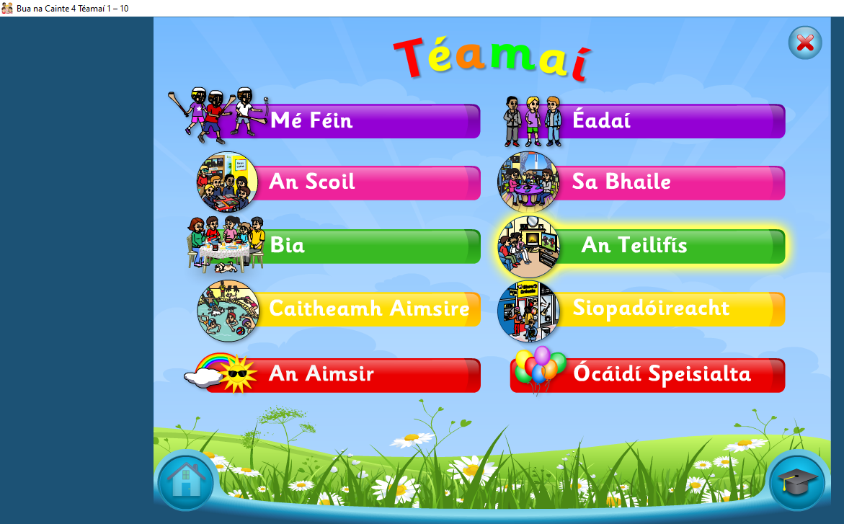 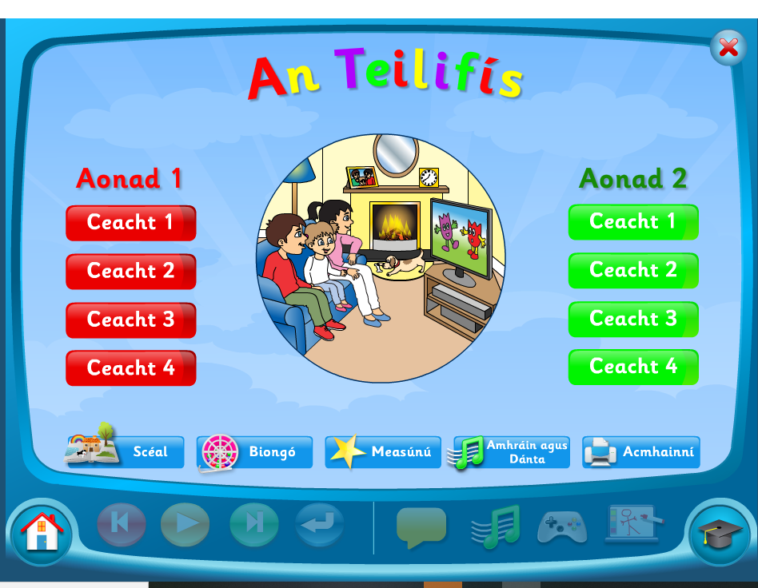 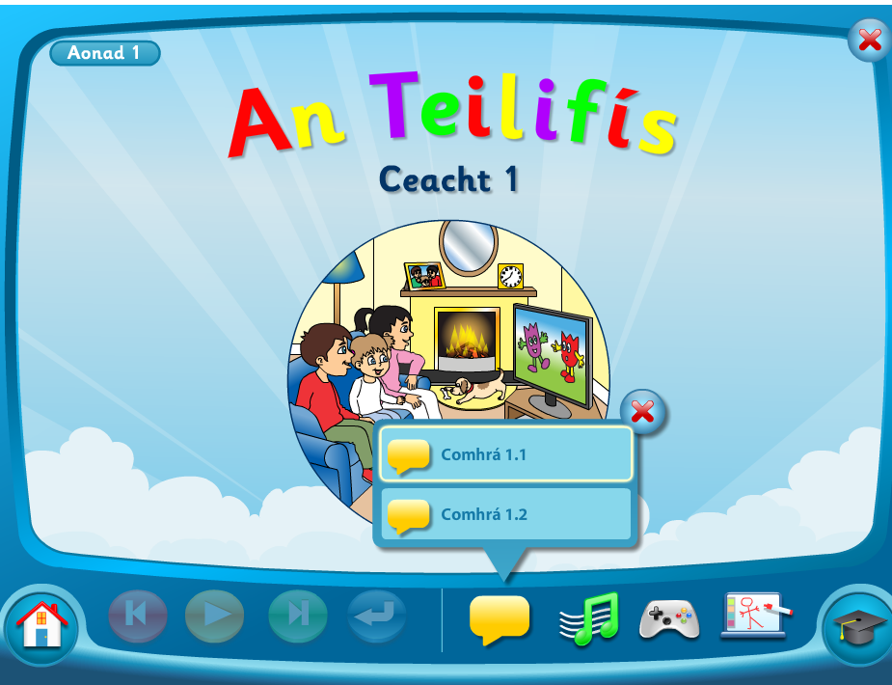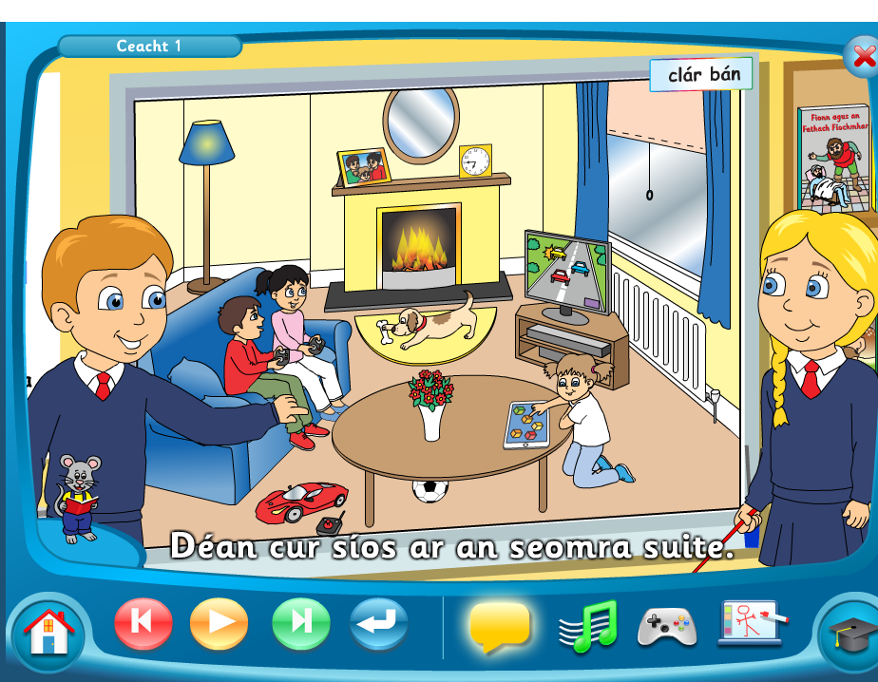
Click On An Teilifis Click on Aonad Ceacht 1 Click on the yellow box – Comhrá 1.1.
Pause after each sentence and practice saying it aloud. (Click on the mouse to see the words!) When this is complete listen to Comhrá 1.2

THURSDAY
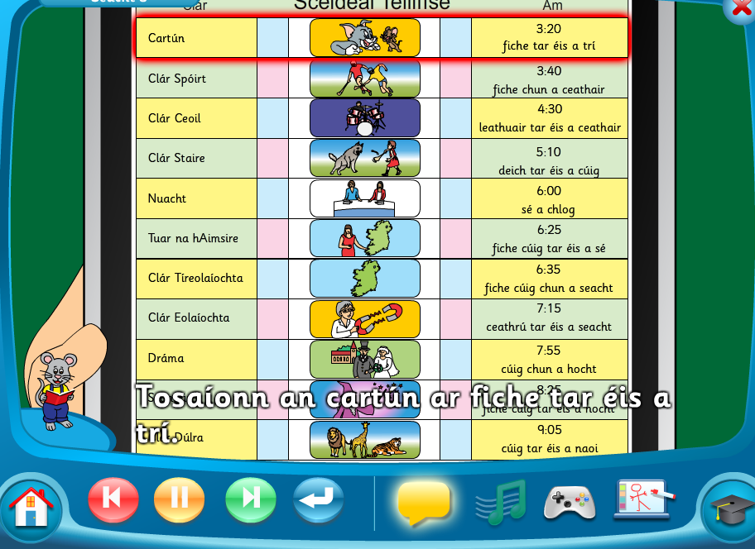
Click On An Teilifis Click on Aonad Ceacht 3 Click on the yellow box – Comhrá 3.1.
Pause after each sentence and practice saying it aloud. (Click on the mouse to see the words!) When this is complete listen to Comhrá 3.2

FRIDAY
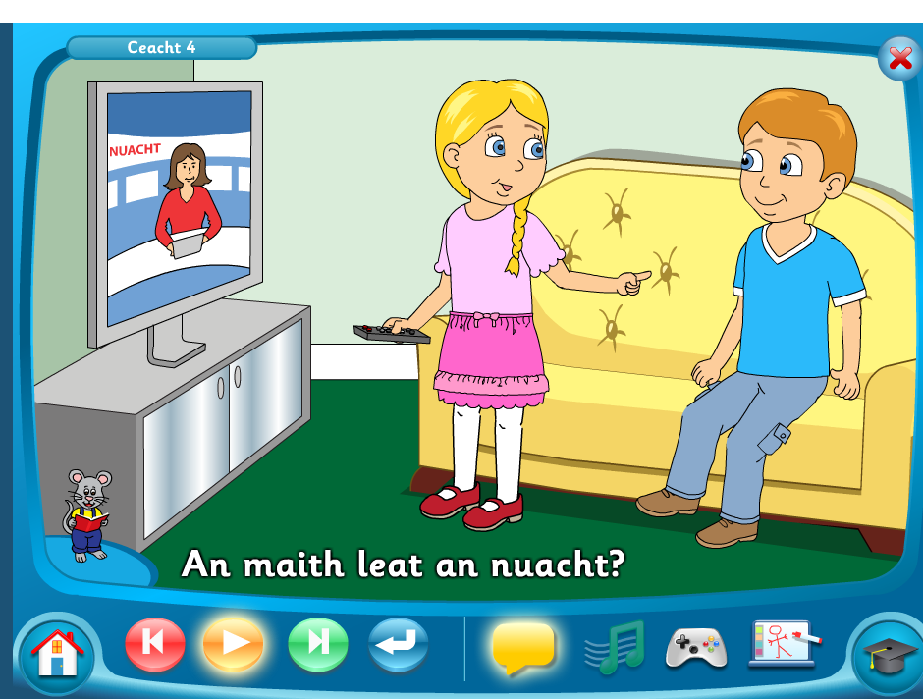

Click On An Teilifis Click on Aonad Ceacht 4 Click on the yellow box and listen to the story.

TO ACCESS LÉIGH SA BHAILE AND BUSY AT MATHS
To access CJ Fallon you’ll need to register your name and email address. When you log in you can select the book required. Below are the steps for Léigh sa Bhaile, follow the same steps for Busy at Maths.
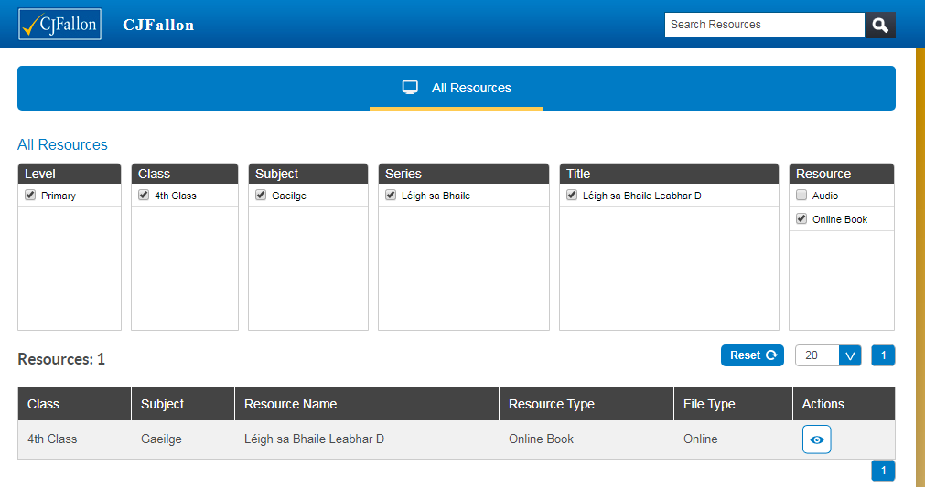
TO ACCESS NEW WAVE ENGLISH AND MATHS ANSWER BOOKS click the links below. This could be a good way for the children to correct and check their work. If they have any questions about any answers they can send me a message on Seesaw and I will explain it to them.
New Wave English in Practice
https://www.prim-ed.ie/contentfiles/41648_NWEIP_TG_4th_Class.pdf

New Wave Mental Maths
https://www.prim-ed.ie/contentfiles/41634_NWMM_TM_4th_Class.pdf

LEARNING SUPPORT GROUP – WORK FROM AMANDA
Hi guys, here’s a few quick ideas for making reading more fun and interesting. Remember, you don’t have to do everything! It just might be something different that you could try if you have some spare time. Enjoy! Amanda

 | Friday, 1 May | Tuesday, 5 May | Wednesday, 6 May | Thursday, 7 May | Friday, 8 May
Reading | Read your book aloud using different emotions; e.g. angry, sad, excited. | Pick something different to read like a comic or a magazine. | Read some facts about your favourite sport or hobby online. | Read a story you wrote in one of your school copies. | Read the rules of a board game that you have at home.
Fun reading activities | Ask your family to write clues for you and leave them around the house. They might even give you a treat if you read them all. | Pick a page from a book and find a word beginning with each letter of the alphabet. | Read the riddles below for your family. Can you catch them out? | Read a poem and change all the adjectives to funny ones. | Play a board game that involves reading; e.g. Scrabble, Monopoly, Trivial Pursuit, Boggle.

