Section One - Daily Work (Please remember to keep up your reading everyday)
Tuesday  05.05.2020 | - New Wave Maths – Week 19 Tuesday  - New Wave English – Day 110  - Novel Holes – Read Chapter 29  - Busy at Maths Pg. 145 Tip: Odd = 1,3,5,7,9 Even = 2,4,6,8,10 When you add two odd numbers you will get an even number. This is also the same when you add two prime numbers.  - Gaeilge – Revise questions on ‘Siopadóireacht’ in Gaeilge copy.  - Word of the Day: encountered (Write out definition and put it into a sentence)https://kids.wordsmyth.net/we/
Wednesday  06.052020 | - New Wave Maths –Week 19 Wednesday  - New Wave English – Day 111  - Novel Holes – Read Chapter 30  - Busy at Maths Pg. 146 Tip: Rectangular number Example: 6 x 2 = 12 which is two rows of six so the number 12 can be laid out in a rectangular shape.  - Word of the Day: rendition (Write out definition and put it into a sentence)https://kids.wordsmyth.net/we/
Thursday  07.052020 | - New Wave Maths – Week 19 Thursday  - New Wave English – Day 112  - Novel Holes – Read Chapter 31 out loud to somebody (If possible)  - Busy at Maths Pg. 147 Tip: Square numbers example: 4² is 4 x 4 = 16. So we can say 16 is a square number. It looks like this.  5. Gaeilge – Revise ‘An Chlog’ using the link below. To use click on question first and the speaker symbol. https://www.rewardinglearning.org.uk/An%20Clog%20Cainteach/clock%203%20south/web/clock3s.html  6. Word of the Day: rejection (Write out definition and put it into a sentence)https://kids.wordsmyth.net/we/
Friday  08.05.2020 | - New Wave Maths – Week 19 Friday Review. (Correct answers for the week using link below and write your answers in pupil record sheet at the front of the book)  - New Wave English – Day 113 (Correct answers for the week using link below and write your answers in pupil record sheet at the front of the book)  - Novel Holes – Read Chapter 32 and Do questions 1 -8 from page 25 on activity sheet in your English copy.  - Busy at Maths – Correct answers for the week using the link below.  - Word of the Day: knowledgeable (Write out definition and put it into a sentence)https://kids.wordsmyth.net/we/
Links for New Wave and Busy at Maths corrections | https://www.prim-ed.ie/contentfiles/41635_NWMM_TM_5th_Class.pdf New Wave Maths 5th class  https://www.prim-ed.ie/contentfiles/41649_NWEIP_TG_5th_Class.pdf New Wave English 5th class  https://my.cjfallon.ie/ebooks/20783-PCMs201-233.pdf Busy at Maths 5

Section Two – Menu of Activities
Language | Numeracy | Be creative! | Help at home | Miscellaneous!
Visit the Roald Dahl museum and story centre. Record yourself on a device reading some of your favourite story.  http://www.roalddahl.com/museum/visit/virtual-museum-tour  Listen to stories being read https://www.roalddahl.com/roalddahl.com/things-to-do-indoors/video-stanley | https://nrich.maths.org/6499  Try playing an online version of the countdown game, using 6 cards and the four operations to reach the target number.  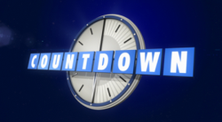 | Collect some stones and using any markers or paints, decorate them with positive phrases : smile, Be kind, stay happy etc. and pictures Display your ‘positivity Rocks’ around your home or area where you live  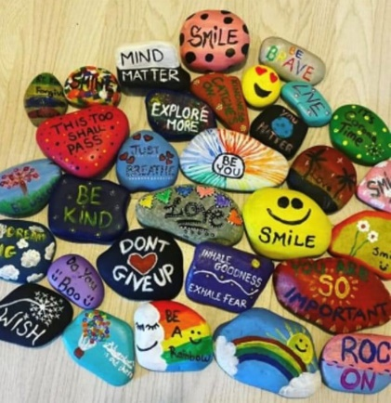 | Make a smoothie or fruit salad if you have some fruit at home. Banana, berries, yoghurt and juice.  Caution: ask an adult for help when using a knife or blender.  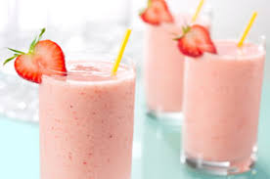 | Go on a virtual tour of the 7 wonders of the world https://www.scoilnet.ie/search/resource/entity/show/Lre/10915/  Click on virtual tours then check out The Colosseum, Machu Pichu, Rio De Janeiro, Petra, The Taj Mahal, The Great Wall.
 |  | Pressed flower Art  Flowers are growing everywhere now and you could make a card for someone special with them. Collect some flowers and stems and flatten them under a heavy book. Leave them to dry for a day or so, then gently peel them off the pages and glue them to a blank card,  Draw a Tiger with Don Conroy  https://www.youtube.com/watch?v=k1YV_Y6dQUk | Rule for the month of May is Taking Responsibility for our environment and for our Actions too!  Take the recycling rubbish out to the recycling bin.  Wash and dry the dishes after meals and sweep up the floor in your house using a dustpan and brush. | https://learning.gaa.ie/gogamesskillchallenges  Try some GAA challenges with a ball or hurl.
Make a Time capsule- a container that holds present day items such as photos, letters, newspaper headlines. Usually a time capsule is hidden away for a number of years and in the future you can open it and see how life has changed since it was made.  Write a letter to put into it to your 21 year old self. Choose a container and decorate the outside before filling it and hiding it away. | A mental exercise for you:  T-shirts are put into packs of four. A box contains 16 packs. How many boxes will be made from 704 t-shirts. |  |  | Exercises -Count from 10 – 1  X 10 star jumps  X9 reach high to the sky and touch toes  X 8 sit ups X 7 squats  X 6 air punches  X 5very high jumps  X 4 sit ups X 3 lunges  X 2 press ups x 1 good stretch on each arm and leg.
Positive Emotions – write one sentence about what makes you feel calm, happy, grateful, amazed and interested. Explain in as much detail and draw a picture to illustrate talk to your family about them. | https://www.transum.org/Maths/Puzzles/Hexagram/ These are like magic squares where all columns have to have the same total, but are shaped like a hexagon. | Construct a Marble run from Lego or from recyclable materials. If you don’t have marbles use a small ball and set up a maze for it to go through. 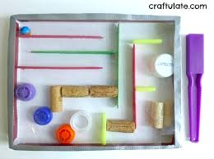  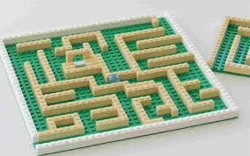 | Sort out the dry laundry, fold it and put it away.
Gaeilge: Spend some time on Cúla4. Have fun through Irish.  www.cula4.com | https://www.transum.org/Maths/Activity/without/  Shape puzzles |  | Help to keep your younger siblings occupied. Teach them to play a card game or board game. Read them a story or listen to www.storylineonline.net with them. | Capillary action-Science. Using some cut flowers or pieces of celery and containers of water with a few drops of food colouring. Place the ends of the flowers or celery into the water and observe what happens.
For further activities and ideas please see https://padlet.com/catmstokes/ok6zkpyog3in

