My Weekly Work Record Week 33 25/05/2020
Monday  25/05/2020  Oral Language (Starlight)  FolensOnline.ie  See how to register in ‘Useful info for Weekly Work Record, Menu of Activities’  Derek’s email, 25/04/20 | Léigh Sa Bhaile Lch 112 Read the story, listening to SeeSaw. Write out questions 1 and 2, and answers in your copy.  Bua Na Cainte Lch 83 - Read the whole page. Fill in the missing words. The Fóclóir and SeeSaw will help you.  Litriú: brón, áthas, fearg. Learn spellings, and write once in copy. [browe in, aw has, far ug].  **YOU WILL FIND THIS WEEK’S GAEILGE SPELLINGS ON PAGE 133, BnaC.**  New Wave Maths Week 33 – Monday & Monday problem.  Busy at Maths 2 – p. 152. Extension work: Master Your Maths 2, Week 9, Monday.  **Busy at Maths 2 this week:- Subtraction Part 4**  ** My SeeSaw maths videos will help you this week with subtractions **  Tables to learn this week: -4  Starlight Unit 7b p. 58, read the narrative ‘The Magic Faraway Tree’. P.59, write out full answers in your copy A. (1-5, and star).  English Spellings: shook, often, picture. Pick 2 words, and put into two sentences.  Well Being p.14, create some crazy creatures in your copy https://indd.adobe.com/view/5237deef-2311-469f-9e2d-b5ee89c2000f  ** Extension: Please choose at least one activity from this week’s Menu of activities. **
Tuesday  26/05/2020  Oral Language  “Adventures with Authors“ from the Starlight Digital Poster 15, Story 2 and Labelling.  Copy + Paste website | Léigh Sa Bhaile Lch 112. Read the story again. Write out questions 3 and 4, and answers in your copy.  Bua Na Cainte Lch 84 - Read the whole page. Fill in the news, and draw (Tarraing) picture. The Fóclóir page/SeeSaw will help you.  Litriú: tart, ocras. Learn spellings, and write once in copy. [taw urt. uc ras].  New Wave Maths Week 33 – Tuesday & Tuesday problem.  Busy at Maths 2 – p. 153. Extension work: Master Your Maths 2, Week 9, Tuesday.  Starlight Unit 7b p.58, read ‘The Magic Faraway Tree’ again. Do B, C, on p.59 in your book. Star activity, bottom page in your copy.  English Spellings: future, nature, creature. Pick 2 words, and put into two sentences.  https://content.folensonline.ie/programmes/Starlight/2nd_class/resources/posters/SL_02_ACT_CH15_013/index.html  Ready Steady Write 1! Cursive Handwriting birthday card p.50 + nt ng sn p.51.  Art: Create your own Henri Matisse cut-out collage https://watchkin.com/57339f61f9?script=WKize See below for some ideas!  Find any used paper, plastic, card if you have none. Colour with your crayons/markers if it is not colourful. Cut out some cool shapes, and glue/sellotape/staple them to another recycled card/page. YOU MUST HAVE ADULT HELP WITH SCISSORS/STAPLER.  ** Extension: Please choose at least one activity from this week’s Menu of activities. **
Wednesday  27/05/2020  Oral Language  Starlight Combined  Unit 7 online Grammar – 7b Magic Faraway Tree  Comparing Words.  Website -> | Léigh Sa Bhaile Lch 113 Read the story, listening to SeeSaw.. Write out questions 1 and 2, and answers in your copy.  Bua Na Cainte Lch 85 - Read the words on the page. The Fóclóir and SeeSaw will help you. Dathaigh an pictiúr.  Litriú: Tá brón orm. Tá tart ort. Learn spellings, and write once in copy. [Taw browe in urm. Taw uc ras urt].  New Wave Maths Week 33 – Wednesday & Wednesday problem.  Busy at Maths 2 – p.154, Q.1. Extension work: Master Your Maths 2, Week 9, Wednesday.  Starlight Unit 7b p.60, Grammar. Comparing words.  English Spellings: fracture, adventure. Put the two words into two sentences [fracture means to break.]  https://content.folensonline.ie/programmes/Starlight/2nd_class/resources/activities/SL_02_ACT_CH15_007/index.html  Well Being p.15+16, Worries. Do this with someone, in your copy. https://indd.adobe.com/view/5237deef-2311-469f-9e2d-b5ee89c2000f  ** Extension: Please choose at least one activity from this week’s Menu of activities. **
Thursday  28/05/2020  Oral Language  “Adventures with Authors“ from the Starlight Digital Poster 15, Questions, Poem, Activity.  Use the same website as Tuesday. | Léigh Sa Bhaile Lch 113. Read the story again. Write out questions 3 and 4, and answers in your copy.  Bua Na Cainte Lch 86 - Read the whole page. Fill in the missing words. Listen to SeeSaw and use the Fóclóir.  Litriú: Tá fearg air. Tá ocras uirthi Learn spellings, and write once in copy. [Taw far ug err. Taw uc ras urhee]  New Wave Maths Week 33 – Thursday & Thursday problem.  SeeSaw Blog day today!  This week:- Post a picture of your Matisse art to Blog. Click on the globe!  Extension work: Master Your Maths 2, Week 9, Thursday.  Busy at Maths 2 – p.154, finish page  Starlight Unit 7b p.61, create a superhero.  English Spellings: mouse, mice. Put the two words into two sentences.  Ready Steady Write 1! Cursive Handwriting sh th wh p.52 + ck nk sk p.53.  ** Extension: Please choose at least one activity from this week’s Menu of activities. **
Friday  29/05/2020 | Litriú spelling test  English spelling test SeeSaw activities this week:- A).Getting silly/Brain break B).Favourite Story C).Make a Family Game  Tables -4 Test  Bua Na Cainte Lch 133 – Read the words at the top of the page. Write in everything in bottom half of page.  New Wave Maths Week 33 – Friday Review.  History: The First Moon Landing. Go to SeeSaw, and watch video of first moon landing, back in 1969. That’s 51 years ago! In SeeSaw, draw a picture of the first moon astronauts, Neil Armstrong and Buzz Aldrin, on the moon. Write a fact that you learnt from the video clip.  ** Extension: Please choose at least two other activities from this week’s Menu of activities. **

Henri Matisse collage art
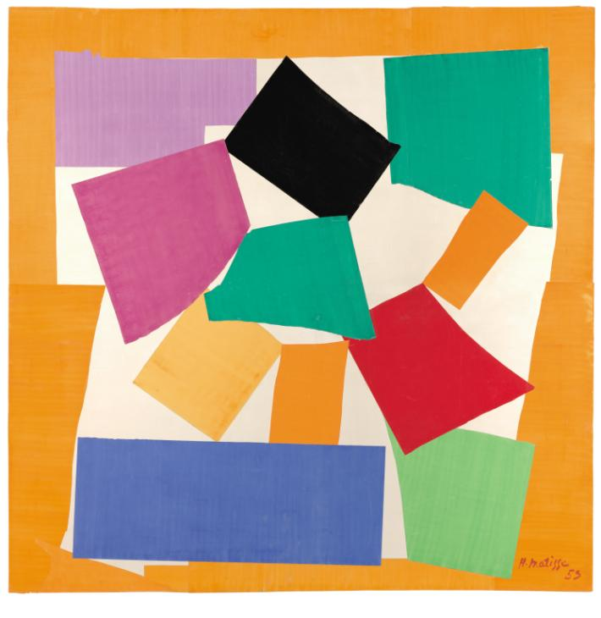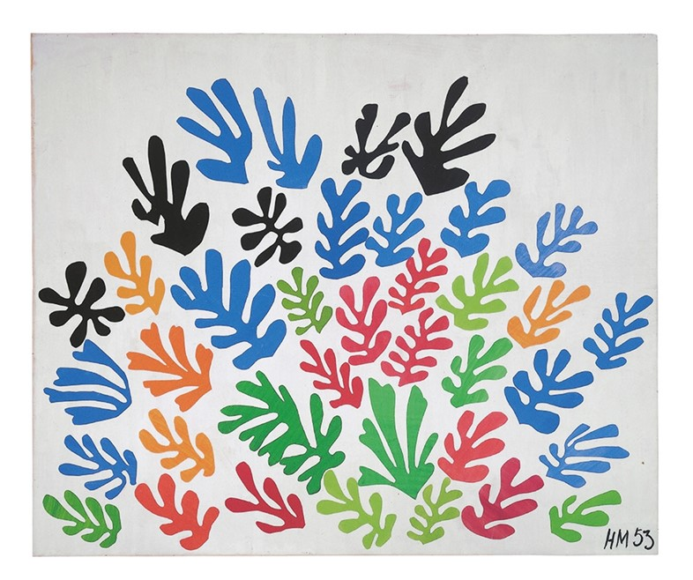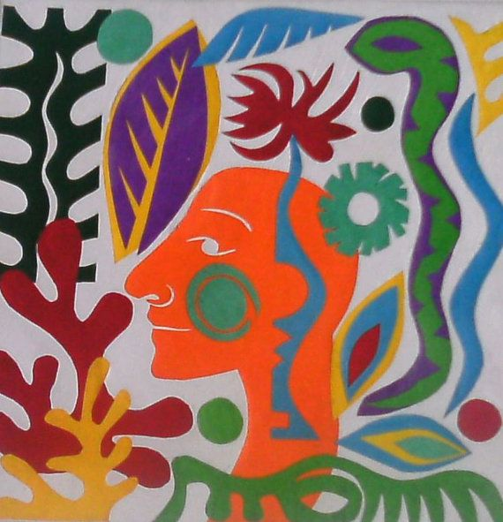

These artists got their ideas from Matisse!
