English Spellings
This week, I would like you to pick 10 words from your spelling list and put those words into a sentence. Write 2 sentences a day into your copies.
<a> for /o/
- swap
- waft (a scent passing through the air)
- swamp
- wand
- wallet
- squad
- swatch (a sample/piece of material)
- squat
- squalid
- quality
- wallaby (an Australian animal similar to a kangaroo)
- waddle
- squabble
- twaddle (nonsense)
- quandary (to be in some difficulty or to have a dilemma)
- wristwatch
- quantity
- qualification

English Novel
Read Chapter 16 and 17 of your novel The Lion the Witch and the Wardrobe
We will study the final chapter this week: The Hunting of the White Stag

Comprehension – Answer the following questions based on Chapter 17.

1. What had Edmund done that had kept the Witch from overpowering Aslan’s forces?

2. What did Aslan do in the midst of the celebration?

3. What names were given to the children as they grew and changed over the years?

4. How did they happen to find the lamp post in the wood?

5. Why did they decide not to turn back at that point?

6. How did the Professor react to their story?

Writing
Write a journal entry for one of the children after their return to England, describing Narnia.

Maths homework
This week children, we will take a look at chapter 25 in our Maths book: Multiplication 3
Below you will find W.A.LT’s for pages 132 - 136.

- We Are Learning To develop mental strategies to multiply by 0, 1 or 10 (page 132)

- We Are Learning To understand the commutative properties of multiplication PAGE 133 (that numbers may be multiplied in any order e.g. 3 $×4=12$ and 4$×3=12$)
Watch the link for example.
http://data.cjfallon.ie/resources/20684/BAM3_Tutorial_079/lessons/BAM3_Tutorial_079/index.html
- We Are Learning To write short multiplication in two ways, horizontally and vertically
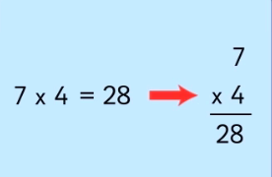

- We Are Learning To understand the distributive property of multiplication PAGE 134 You can multiply bigger numbers by breaking the first number into two parts Example on page 134 and take a look at this link to explain it:
http://data.cjfallon.ie/resources/20684/BAM3_Tutorial_081/lessons/BAM3_Tutorial_081/index.html
- We Are Learning To: understand the link between multiplication and repeated addition. Take a look at this link to help you:
http://data.cjfallon.ie/resources/20684/BAM3_Tutorial_082/lessons/BAM3_Tutorial_082/index.html
- We Are Learning To: multiply a two-digit number by a one-digit number. Have a look at these links:
http://data.cjfallon.ie/resources/20684/BAM3_Tutorial_083/lessons/BAM3_Tutorial_083/index.html
http://data.cjfallon.ie/resources/20684/BAM3_Tutorial_084/lessons/BAM3_Tutorial_084/index.html

Tables Learn $×$ 10 and $÷10$

Irish homework
Téama: Sa bhaile
- Talk about the garden in this picture. Tá ….. os comhair an tí = …..is in front of the house. Write the sentences.
- Scríobh an dán An Gairdín = Write the poem An Gairdín (in your copy) Tarraing an pictúir = Draw the picture
Scríobh na focail in aice leis an bpictúir = write the words beside the picture
You can continue to read your Léigh sa Bhaile book children. Read page 54 – 58
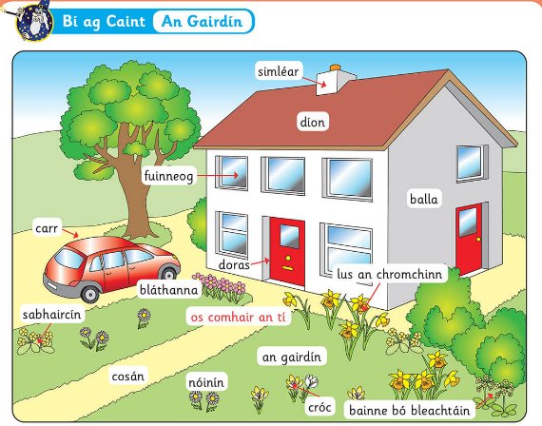

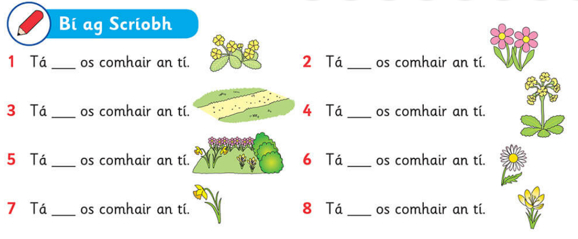 An Gairdín
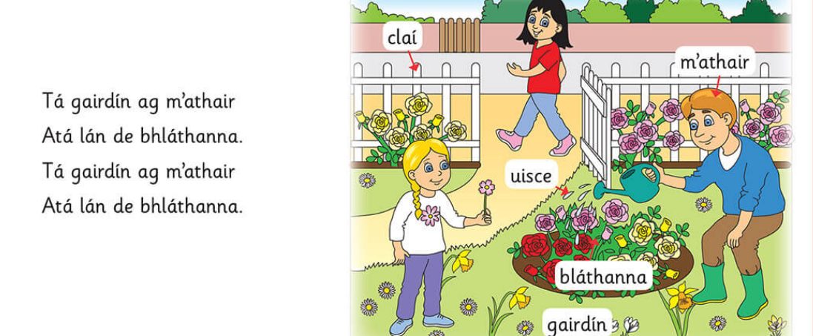
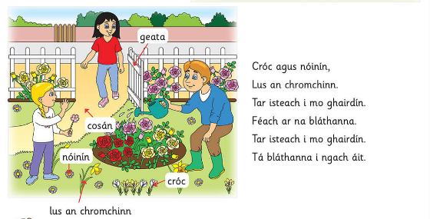

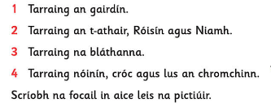

SPHE
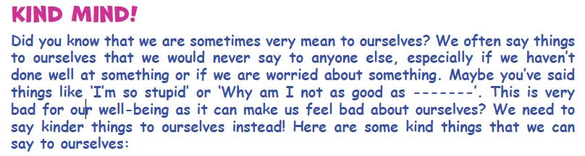
Draw a ‘Kind Mind’ selfie in your copy and write some of the above phrases in these bubbles around it or make up your own phrases!
Art
Henri Rousseau (1844 – 1910) was a self –taught artist, known for his colourful jungle paintings. (We already studied one of his paintings in class children Tiger in a tropical Storm where we painted the head of a tiger).
Henri Rousseau claimed his pictures were based on the rainforests he visited in Mexico. In reality, Rousseau had actually never even been to a jungle before.
Rousseau’s jungle scenes were inspired by strolls around Paris and its botanical gardens. He often visited the natural history museum to observe and draw the taxidermy animals.
Let’s take a look at some of his paintings!
Exotic landscape with lion and lioness in Africa (1903)
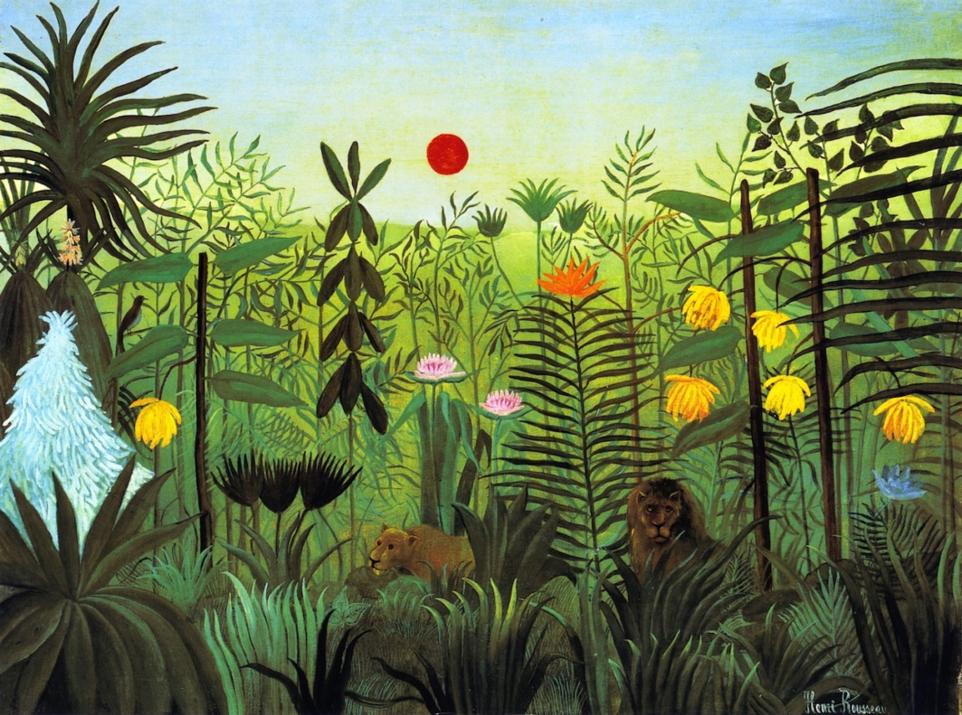
Exotic landscape with monkeys and parrot (1908)
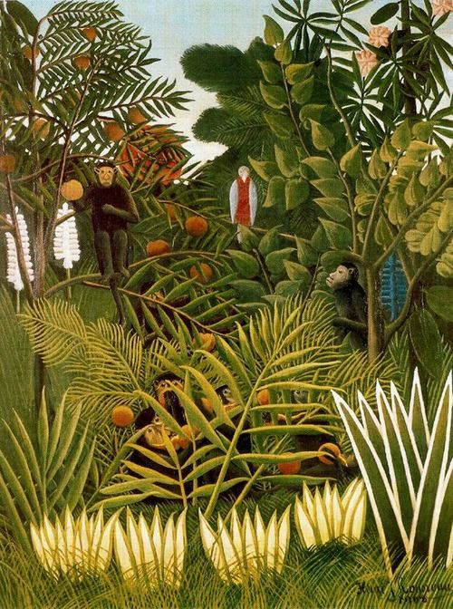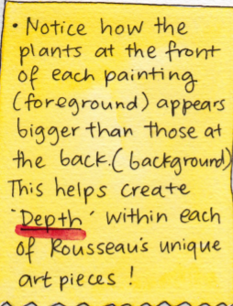

We will create a jungle piece that is inspired by Henri Rousseau’s paintings.
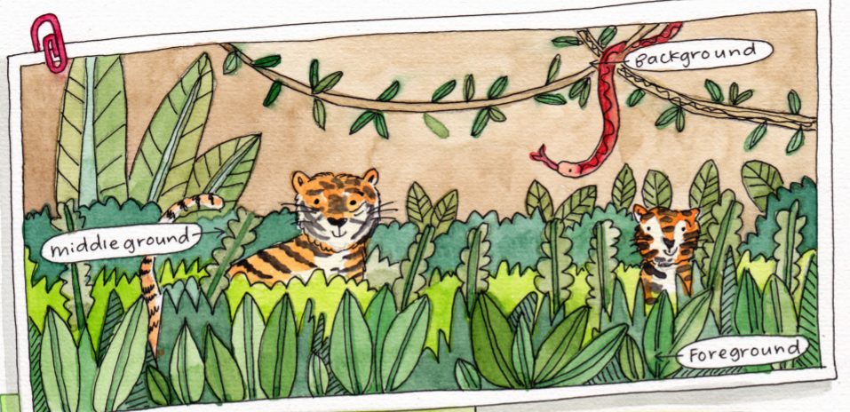

- Start by drawing 2 different leaves/plants of your choice. Make sure you work from the bottom of your page. Draw your plants big and go from one side of the paper to the other. (This part is called the foreground)
- With your foreground complete, it’s time to move on to the middle ground. Add in even more leaves/plants/bushes/trees. You can also add some animals too.
- Then move to the background, add in vines, trees and remember to draw them smaller because they are at the back.
- Complete your piece by colouring or painting it.

