English Spellings
This week children, I would like you to pick 10 words from your spelling list and put those words into a sentence. Write 2 sentences a day into your copies. I have given a definition for some of the words that you might find difficult.
<ie> for /ee/
- field
- chief
- piece
- brief
- shield
- grief
- relief
- frieze (painted decoration on a wall)
- fielder
- priest
- believe
- achieve
- diesel
- thieves
- besiege (surround a place with armed forces in order to capture it or force it to surrender)
- audience
- briefcase
- unbelievable

English Novel
This week we will focus on chapter 11 of your novel. I will give you vocabulary work, some comprehension questions and some critical thinking and creative activities to complete. You can write your answers into your writing copies.
Monday 11th May
Read Chapter 9, 10 and 11 of your novel The Lion the Witch and the Wardrobe
We will study chapter 11 this week: Aslan is Nearer
Read this glossary of new vocabulary from chapter 11 and complete the activities underneath it.
Chapter 11: Aslan is Nearer

Vocabulary:

repulsive disgusting
gaiety merry-making, celebration
vermin common harmful or unpleasant animals
gluttony excess in eating or drinking
glade an open space surrounded by woods
alighting landing

Vocabulary enrichment activity
Fill in the blanks with the words or expressions from the lists above that make the most sense based on the story.

1. When the party of animals saw the Witch, all the _________ went out of their faces.

2. The Witch called the animals ____________.

3. Edmund saw the ground covered with flowers as they came into a _____________ of birch trees, and birds _______________ on branches soon after that.

Tuesday 12th May
Comprehension – Answer the following questions based on Chapter 11.
1. What did the Dwarf bring Edmund to eat and drink?
2. What did the Witch order the wolf to do?
3. How did Edmund feel riding in the Witch’s sledge?
4. Why did the Witch stop suddenly?
5. What did she do to the party of animals?
6. Why did the sledge stop running well?
7. What did the Witch, the Dwarf, and Edmund do when the sledge couldn’t go any further?
8. What did the Dwarf say had happened?

Wednesday 13th May
Critical Thinking
1. Why do you think Edmund shouted out for the Witch not to harm the animals?
2. Why do you think his heart gave a great leap when he realized the frost was over?

Thursday 14th May
Create/ Write
Imagine you are a reporter for a newspaper. Write a short report about the sudden onset/beginning of spring in Narnia. (Remember in the last three pages of chapter 11 Edward notices all the signs of spring in Narnia).

Maths homework
This week children, we will take a look at chapter 23 in our Maths book: Multipication and Division by 7
Below you will find W.A.LT’s for pages 123 – 126. You can complete one page of chapter 23 Monday – Thursday and on Friday, you can complete page 127. On page 127, we have not done the decimal chapter, so you do not need to do questions 2, 3, 4, 5, 6!

- We Are Learning To develop an understanding of multiplication as repeated addition (page 123)
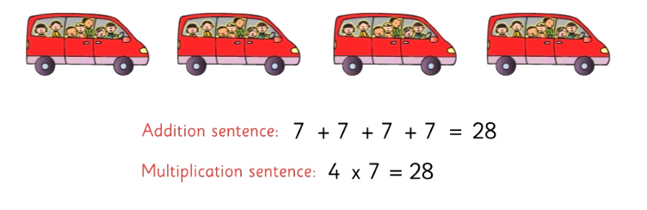
- We Are Learning To write multiples of 7 (page 123)
Multiples of 7 are: 7, 14, 21, 28, 35, 42, 49, 56, 63, 70

- We Are Learning To count on in 7’s (page 123)

- We Are Learning To use a mental strategy for counting on in 7’s.
Add 10, then fall back 3 places. (page 124)

- We Are Learning To develop an understanding of division as equal sharing (page 125)

Share 21 tropical fish equally among 7 fish bowls
Division sentence: 21 $÷$ 7 = 3
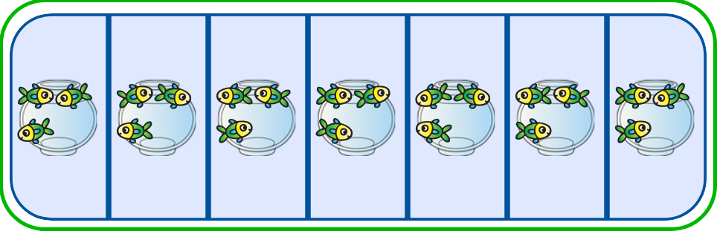
- We Are Learning To develop an understanding of division as repeated subtraction (page 125)

- We Are Learning To understand that division is the inverse/opposite of multiplication and vice versa
4 $×7 =28$ 7 $×4=28$
- $÷7=4$ 28 $÷4 =7$

- We Are Learning To solve problems involving multiplication and division (page 126)

Tables Learn $×$ 7 and $÷$ 7

Irish homework
Téama: Éadaí
You can continue to read your Léigh sa Bhaile book this week children. Read page 44 - 48.
When you are describing how a girl is dressed, use the pronoun ‘uirthi’. Mar shampla, tá Niamh gléasta go deas. Tá geansaí dearg uirthi. =Niamh is dressed nice. She is wearing a red jumper.
When you are describing how a boy is dressed, use the pronoun ‘air’. Mar shampla, tá Seán gléasta go deas. Tá geansaí dearg air.
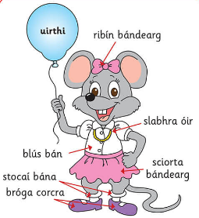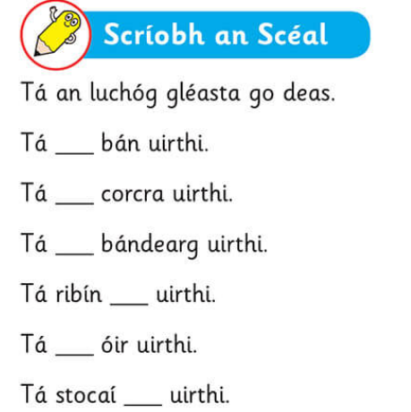

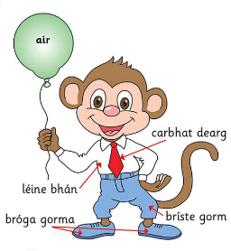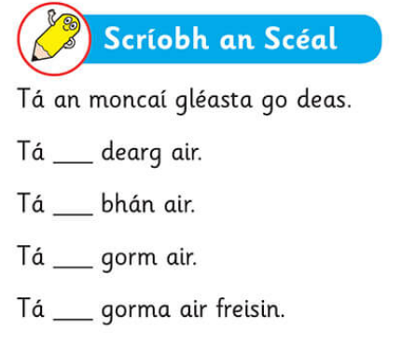

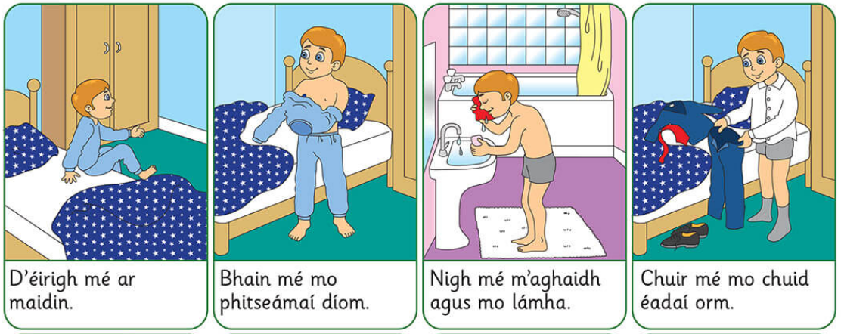
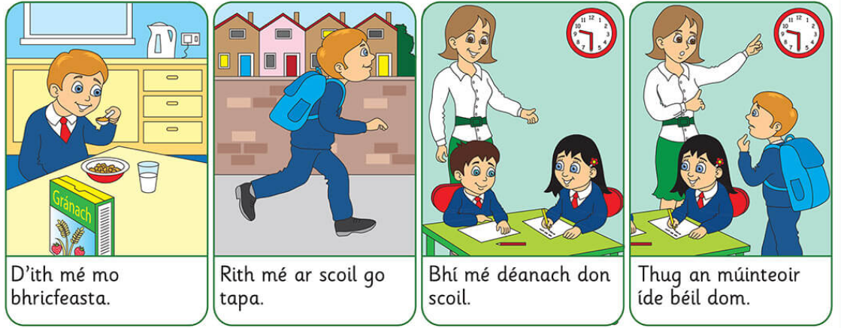
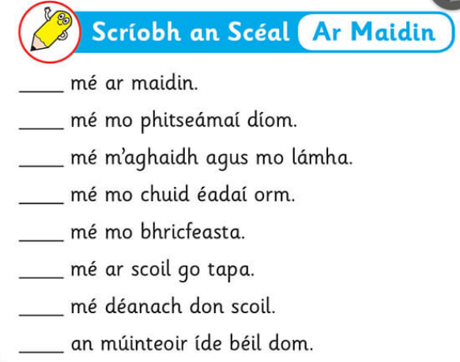
SPHE
Think about what well – being means to you. Read over some of the work you have done in your weaving well – being activities in the last few weeks. Write your own acrostic poem on well – being!
How to write an acrostic poem
- Write the word WELLBEING vertically in your copy
- On another page, write a Thought Shower about the topic ‘Well-being’. Think of words or phrases that describe your idea of Well-being.
- Place your words or phrases from your Thought Shower on the lines that begin with the same letters.
- Fill in the rest of the lines to create a poem.

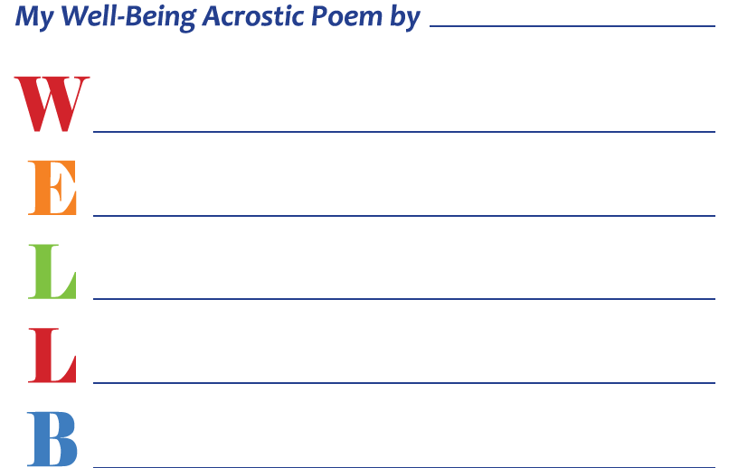

Art
Paul Klee was a Swiss German artist (1879 – 1940)
He liked Music and Art. When he was a teenager he decided to focus on becoming an artist. He excelled at drawing but felt he lacked colour sense. He studied in Italy. The colours of Italy really inspired him, but he felt he still had some way to go in order to use colour successfully in his art. Years later, he visited Tunisia. In Tunisia he finally felt comfortable with colour and embraced colour in his work.
Let’s take a look at some of Paul Klee’s artworks. While looking at these artworks, consider these questions!
Look at all the geometric shapes in his paintings (circles, squares, triangles, rectangles)!
Why do you think he used shapes to create his art?
What are the colours you see?
Did he use all the same size shapes?
Red Bridge 1928
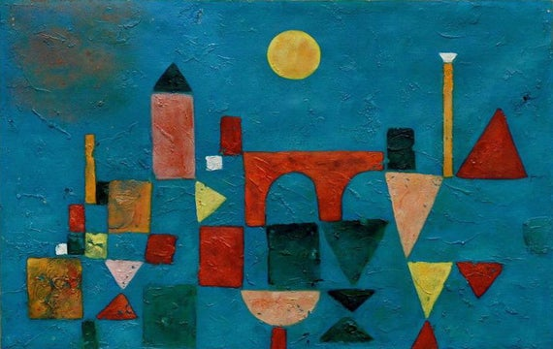
Castle and Sun 1928
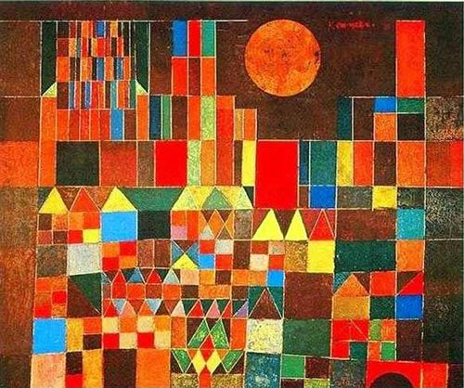

Inspired by Paul Klee’s ‘Castle and Sun’ painting, let’s create our own castle piece. Start by drawing some squares and rectangles on the bottom of your paper.
Slowly work your way up, use different shapes to ‘build your castle’. You can add in bridges using semi-circles! Make sure to draw different – sized shapes!
When you are happy with your castle, you can colour in your picture! You can use crayons, colouring pencils or paint to colour your picture. Finish your piece by colouring in the background with a single colour.

