My Animal Research Project
Do and activity and learn and write about an animal in Dublin Zoo
www.dublinzoo.ie/news/dublinzoofun/
Go to Animal Encycopedia to research the facts below:
Perhaps you could upload a video/Photo of your Animal Project on Seesaw

Name of animal: ______________________
Scientific Name of animal: ______________________

Describe the appearance of the animal (height, skin/fur, size etc.) __________
________________________________________________________________
________________________________________________________________
________________________________________________________________
Describe the habitat (where the animal lives – rainforest, ocean, etc.): _______
________________________________________________________________
________________________________________________________________
________________________________________________________________
How long does the animal live for?
________________________________________________________________
Write two interesting facts that you learned about the animal: (What does he eat)
1) ______________________________________________________________

2) ______________________________________________________________

My Animal Research Project
Please colour in the location(s) of where your animal is found:

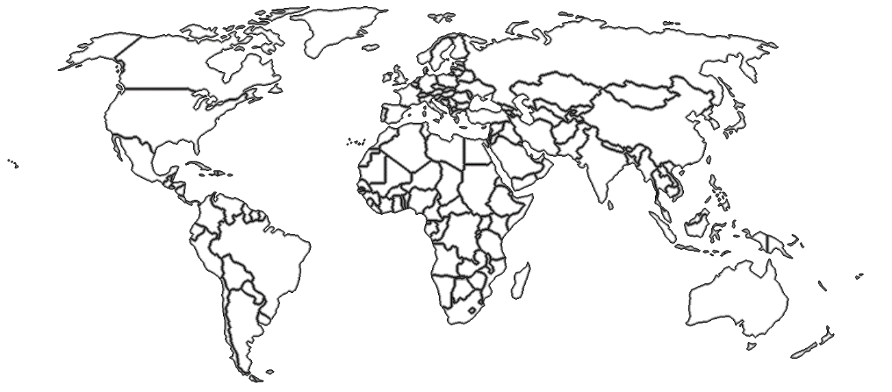

Please draw or print a picture of your animal below:

Please return your project by Thursday 28th of May.

