Suggested Table of Work - 4th Class – 27/04/20-01/05/20

 | Monday | Tuesday | Wednesday | Thursday | Friday
Date: | 27/04/20 | 28/04/20 | 29/04/20 | 30/04/20 | 01/05/20
Talk Time | escape  apartment | refugee  crammed | bland  doubtful | fragrant  tangy | Revise words
New Wave  Mental Maths - continue  Next Week | Monday and Problem from problem solving section from this week | Tuesday and Problem from problem solving section from this week | Wednesday  and Problem from problem solving section from this week | Thursday  and Problem from problem solving section from this week | Friday Review
New Wave English – continue with the next week | Monday  Questions  1-15 | Tuesday  Questions  1-15 | Wednesday  Questions 1-15 | Thursday  Questions 1-15
Maths  -Complete activity for the day and then complete Maths Seesaw activity. | Activity 1  See list of activities below  Look at Seesaw Maths activity | Activity 2  See list of activities below  Look at Seesaw Maths activity | Activity 3  See list of activities below  Look at Seesaw Maths activity | Activity 4  See list of activities below  Look at Seesaw Maths activity | Activity 5  See list of activities below  Look at Seesaw Maths activity
Léigh Sa Bhaile  -useful to access the book online and listen to the stories being read aloud – see instructions below | Read the story  Eadaí Tradisiúnta  On page 50 answer question 1 & 2 in your copy. | Re-read the story  Eadaí Tradisiúnta  on page 50 answer question 3, 4 & 5 in your copy. | Read the story  Lá Sneachta  page 62 answer question 1 & 2, in your copy. | Re-read the story Lá Sneachta  answer question 3 & 4 in your copy. | Re-read the story Lá Sneachta page 62  answer question 5 in your copy.
Bua Na Cainte  (available free to download if you wish instructions below lots of games, stories, songs etc., instructions are outlined below) | Aonad 2-Éadaí  Lesson1(Ceacht 1)  (see step by step instructions below) | Aonad 2-Eadaí  Lesson 2(Ceacht 2)  (see step by step instructions below) | Aonad 2-Eadaí  Lesson 3(Ceacht 3)  (see step by step instructions below) | Aonad 2-Eadaí  Lesson 4(Ceacht 4)  (see step by step instructions below) | Record your comhrá sentences on Seesaw and post to your journal.
Starlight page  98,99+100 | Today is National Poetry Day.  See Seesaw activity:  Write a poem about a favourite character in a book you are reading in your copy and decorate it. Remember to brainstorm words first. You could record yourself reading your poem or send me a picture of it on Seesaw. | Read the story on pages 98,99+100  Write out full answers in your copy to the questions in A.(1-5) | Complete the vocabulary challenge C on page 101 | Choose the most suitable word to complete each sentence. D on page 102 | Grammar - Verbs  Read examples and complete 1-5 in your copy
English Spellings  See below | Learn 2 spellings from spellings list | Learn 2 spellings from spellings list | Learn 2 spellings from spellings list | Learn 2 spellings from spellings list | Spelling Test
Litriú  See below | Learn two spellings and one sentence  Practice saying the sentences out loud | Learn two spellings and one sentence | Learn two spellings and one sentence | Learn two spelling and one sentence | Litriú test
 | PE with Joe/Go Noodle | SESE: Project work  Children can work on a longer-term project based on a theme of their choice. A scrap book is ideal, and children can cut and paste articles, pictures, diagrams and pieces of writing. Other children may prefer to use their IT skills and create a PowerPoint presentation. The project can be shared on Seesaw using video or pictures. | SPHE Complete Day 1 from your Weaving Well Being at Home Journal | Art Most homes will have a “bits-and-bobs” box somewhere with buttons, lids, coins, wrapping paper etc. You can also use cereal boxes, toilet roll inserts, cardboard boxes etc. Now is a good time to use those recyclables and create a piece of artwork. Children should be encouraged to be original, be creative – and don’t forget to take a picture and post your creation to Seesaw! | Cosmic Kids Yoga – Yoga https://www.youtube.com/user/CosmicKidsYoga  mindfulness and relaxation designed specially for kids aged 3+, used in schools and homes all over the world.
Tables | Revise Division 3, 6, 9 |  |  |  | Tables Test
Challenge Activities-Week 5
I would absolutely love to see a picture of one of your challenge activities on Seesaw! Here are some ideas of how you may like to do this:
- Take a picture of your art and post it to your journal.
- Take a picture of your creative writing copy page.
- Record a one minute piece of creative writing you completed using the record button on the Seesaw app!
- Bright Sparks Creative Writing Bursts Number 3. Creative writing burst are created by Sarah Webb, a famous author and supported by MoLI (Museum of Literature Ireland). To get lost in a Creative Burst all you need is a pencil or pen and a notebook or piece of paper.
Go to: https://moli.ie/bright-sparks-creative-bursts/bright-sparks-creative-bursts-3-jellyfish-and-using-your-senses/

- Landscape Art:
Two choices or do both, it’s up to you!
Draw a city with one point perspective
https://artprojectsforkids.org/draw-a-city-with-one-point-perspective/
or
Draw a landscape
https://artprojectsforkids.org/draw-a-landscape/
- Record a podcast on Seesaw called: You are not Stuck at Home, You are Safe at Home.
Record a podcast on Seesaw. The title of the podcast is You are not Stuck at Home, you are safe at home. Introduce yourself, welcome your audience to the podcast and tell your listeners 5 things that you enjoy doing to keep busy at home. Encourage your listeners to stay safe and stay at home too. Remind them why we all need to stay at home.
- .Free writing Many pupils will be familiar with the concept of “free writing” and may have a special notebook or journal in which they write freely about any topic of choice, and in any genre. This is a simple idea that can be continued in the home setting. Children have the autonomy to decide what they wish to write about and there are a variety of different styles that they can practice:
- Diary writing (personal accounts)
- Recount writing (a report of an event)
- Fiction (short stories)
- Instructional writing (e.g. rules of a game *the children can even come up with a new idea and create their own game!)
- Poetry (Limericks, acrostic poems etc.)
https://storybird.com/member-family-plan (offer a free 7-day trial)
https://www.mystorybook.com/

Spellings April 27th -May 1st Countries and Capitals 2020.
 | Gaeilge | Volga | Nile
1 | Cuirim-I put | Greece & Athens | Bulgaria & Sofia
2 | Bainim-I take off | Latvia & Riga | Germany & Berlin
3 | Rithim. -I run | Lithuania & Vilnius | Netherlands & Amsterdam
4 | Ithim. -I eat | Italy & Rome | Romania & Bucharest
5 | Glanaim. -I clean | Hungary & Budapest | Finland & Helsinki
6 | Canaim-I sing
7
8
9
10
Comhrá-Eadaí

Buaileann an clog ar a hocht a chlog ar maidin. -The alarm rings at 8 in the morning.
Éirím ansin.-I get up then.
Bainim mo phitseámaí díom. -I take off my pajamas.
Ním m’aghaidh agus mo lámha-I wash my face and hands.
Cuirim mo chuid éadaí orm.-I put on my clothes.
Ithim mo bhricfeasta. -I eat my breakfast.
Rithim ar scoil.-I run to school.

SUGGESTED MATHS ACTIVITIES – 27/04/20-1/05/20 – Fractions 2

Notes for parents:
Your child will be learning about equivalent fractions (fractions that have the same value as each other, e.g. 1 /2 = 2 /4) over the coming days. S/he will also be learning how to express a number as a fraction of another number and s/he will be solving real-life problems based on fractions. Your child needs to know some of the mathematical language associated with fractions: fractions, equivalence, equal, the same value, fraction wall/chart, signs (), bigger/smaller amount, above/below the line, number line/strip

Monday-Activity 1:The fraction wall – revision
Revise the work done earlier in the year using the following sets: halves, quarters, eighths and tenths; thirds, sixths, ninths and twelfths; and halves, fifths and tenths. Print a fraction wall from the internet(if you have a printer) or make a copy of this fraction wall and fill in the missing spaces.

Ask your child to cut out each fraction strip. Ask him/ her to manipulate the fractions to show equivalence (fractions that are equal) by placing them on top of each other, e.g. place two quarters over one half to show that they are equivalent/equal/the same. Place six eighths over three quarters in the same way.
Tuesday: Activity 2-Comparing Fractions
a) Using you fraction wall that you made, Call out two different fractions. Encourage your child to call out a fraction that is bigger than that. For example, if you call out 1 /2, your child can say 5 /8, 3 /4, 6 /8, 7 /8. Help your child to check the answer by comparing the specific fraction strips.
b): Encourage your child to add different fractions e.g. 1 /3 + 1 /6. To do this, s/he must convert 1 /3 into 2 /6. Then the fractions are easy to add
Wednesday:Activity 3- Finding the whole amount when given a fraction
For this activity, you will need an A4 sheet of paper divided into eight equal pieces and at least 32 cubes, marbles, pasta shells or whatever you may have to hand.
Pose a problem to your child, such as: One-eighth of my cubes is 3. Ask your child to place three cubes on one of the eight sections of the piece of paper. Ask him/her to come up with a strategy to find out how many cubes you have altogether. You may like to try this strategy:
- How many equal pieces has the paper been divided into?
- How many of the eighths contain cubes? Yes, just one!
- How many cubes are there on 1 /8? Yes, three!
- If we know that 1 /8 = 3, how can we find 8 /8? Yes, we just multiply the answer by 8. So 3 x 8 = 24. The total is 24!
Encourage your child to place three cubes on each section/eighth to verify the answer.
Thursday: Activity 4 -Finding a fraction of a whole amount
Using the same page and cubes, place four cubes on any three of the sections/eighths of the paper. Ask your child to come up with a strategy to find out how many cubes you have altogether. You may like to try this strategy:
- How many of the eighths contain cubes? Yes, three!
- How many cubes are in 3 /8? Yes, 3 /8 = 12.
- If we know that 3 /8 = 12, how can we find 1 /8? Yes, we simply divide the total by 3. So 12 ÷ 3 = 4. That means that 1 /8 = 4.
- If we know that 1 /8 = 4, how can we find 8 /8? Yes, we just multiply the answer by 8. So 4 x 8 = 32. The total is 32!
Encourage your child to place three cubes on each section/eighth to verify the answer. You can do this activity with different numbers.

BUA NA CAINTE – INSTRUCTIONS
To access Bua na Cainte’s interactive programme at home, for a limited period,
1. Go to www.edco.ie/bua
2. Select the file which suits your computer PC or MAC
3. Select the Class Level you require, and then click on it to start the download.
4. Once the download has completed, click on the file to install and follow the on-screen instructions.
5. A Bua na Cainte icon will appear on your desktop. Once you select this icon a login page will open where you will need to enter the details included below. The login details below can be used for all class levels. Login: trial Password: trial

LESSON 1
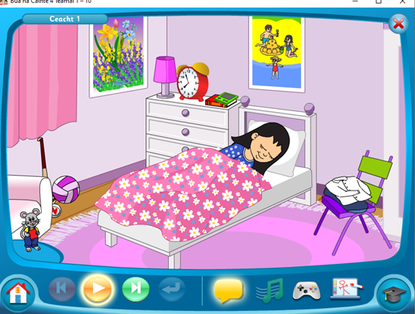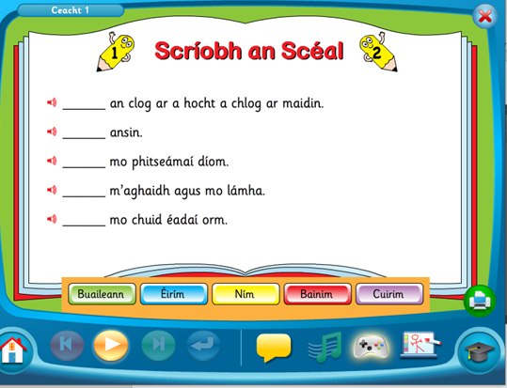
Click On Aonad 2 Ceacht 1 Click on the yellow box. Pause after each sentence and practice saying it aloud. (Click on the mouse to see the words!) Play all the games on the console symbol.

LESSON 2
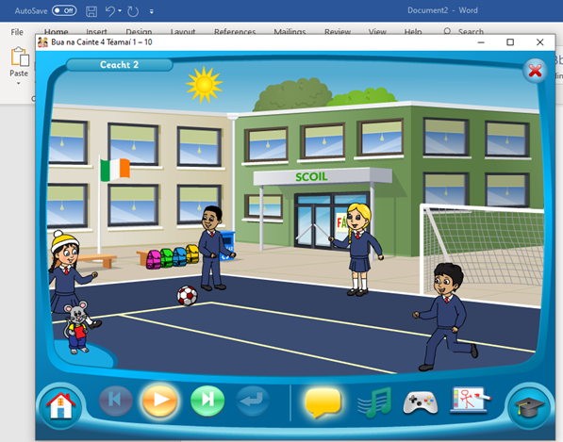
Click on Aonad 2, Ceacht 2. Click on the yellow bubble, pause after each sentence and practice saying it aloud. Then click on the controller and play all the games like we did in school.
LESSON 3
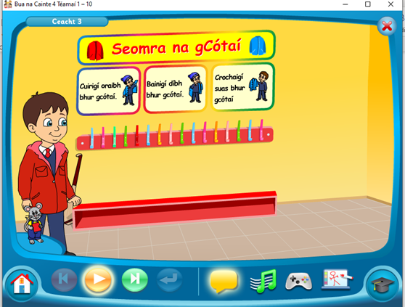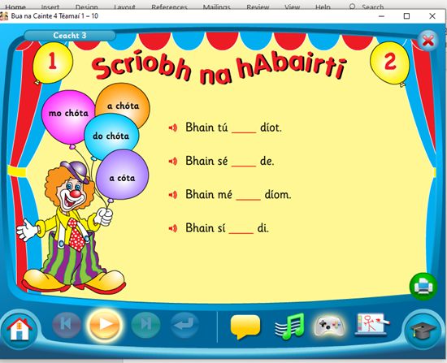
Click on Aonad 2 Ceacht 3, Click on the yellow bubble and pause after each sentence and practice saying it aloud. Click on the song and sing the song. Click on the controller, play each game like we did in school.
LESSON 4
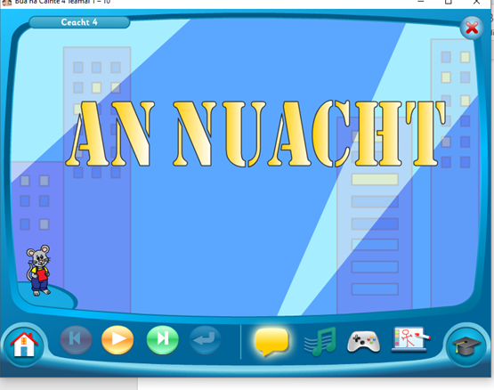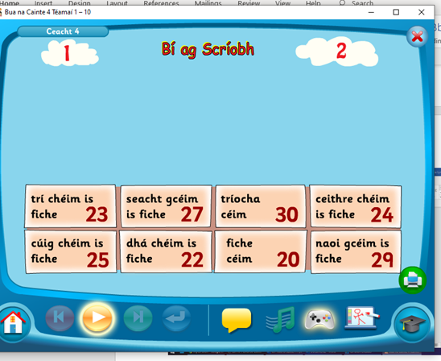
Click on Aonad 3 Ceacht 4 then click on the yellow bubble and pause after each sentence and practice saying it aloud. Click on the controller and play each game like we did in school.
TO ACCESS LÉIGH SA BHAILE AND BUSY AT MATHS
To access CJ Fallon you’ll need to register your name and email address. When you log in you can select the book required. Below are the steps for Léigh sa Bhaile, follow the same steps for Busy at Maths.
